Instruction for F13A1 result analysis
Your sequencing result will be available on the course website.
The file name will be: “Initial_F13A1.dna”
- Download Install “Snapgene Viewer” from the link (https://www.snapgene.com/snapgene-viewer/). This is a free software.
- Download the sequenceing result and open the result file using Snapgene Viewer. You will see windows below.
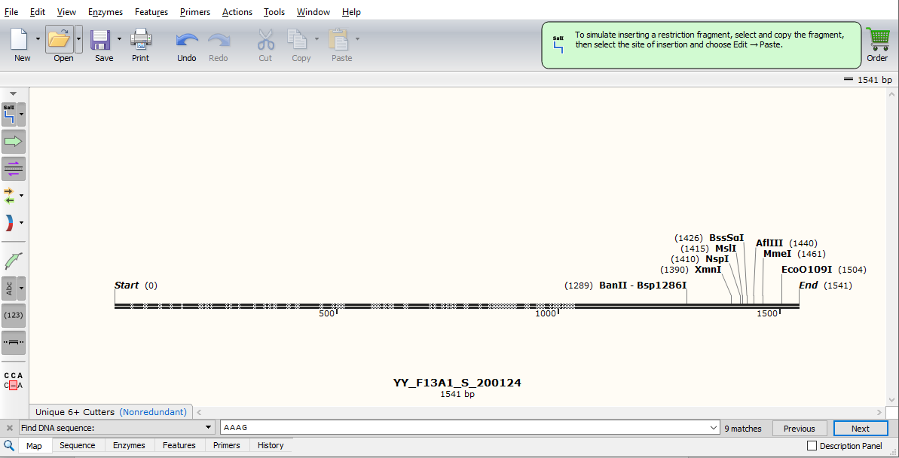
- Go to “Sequence” tab.
- Search (CTRL+f) “AAAG” which is the sequence of the short tandem repeat we are looking for.
- You may see multiple “AAAG” in the sequencing results. We need to count the consecutive repeat of “AAAG” as highlighted below.
