Square-Wave Oscillator
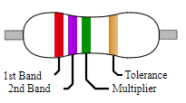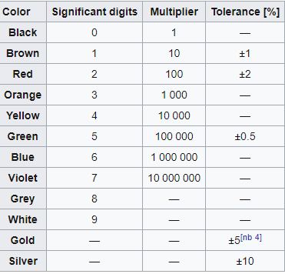
Source: Wikipedia

Background
In the Cloud Detector, we used a voltage divider that utilized a photoresistor to create a voltage that responds to the level of ambient light. An LED with a current-limiting resistor was used as an output to indicate passing shadows. We used an inverter (specifically, a Schmitt trigger) to both buffer the voltage divider from the LED so that both circuits worked as designed without “loading” the other in a way that compromised its design. In this exercise, we will again use the inverter but in a new way. By placing a capacitor at the input of the inverter (see Figure 1), charging the capacitor will cause the output of the inverter will be near 0 volts. Discharging the capacitor (at the input of the inverter) will cause the output of the inverter to approach the battery voltage. By inserting a resistor between the output and the input (where the capacitor sits), the output does the job of both providing a charging voltage and then a discharging path for the capacitor, thus forming an oscillator. An oscillator is a device that changes values over time in a periodic manner.
$$100 kΩ$$
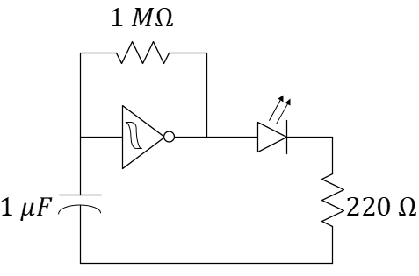
$$10 μF$$
$$1 kΩ$$
Figure 1: Circuit schematic of a square-wave oscillator producing a flashing beacon. The Schmitt-trigger IC is a powered device, but the battery connection between pins 7 and 14 are not explicitly shown in this schematic.

How it Works
To gain a deeper appreciation for the operation of the oscillator, we need to improve our understanding of the operation of the Schmitt trigger inverter. The datasheet for the CD40106 Schmitt Trigger Inverter will describe a hysteresis (a form of memory) within the device where the input/output relationship for changing input values will depend on the time history of the input. For example, if the input voltage $V_{IN}$ starts at 0 volts (ground) and climbs, the output voltage $V_{OUT}$ will remain high until the input voltage reaches the value $V_{p}$ as demonstrated in Figure 2. At this point, the output voltage will drop to 0 volts. As the input voltage then falls back below $V_{p}$, the output voltage persists in staying low (0 volts) until finally the input falls below a value of $V_{n}$. This means that there is not a one-to-one relationship between $V_{IN}$ and $V_{OUT}$ like we are mostly accustomed to in previous math courses. This relationship is graphed in Figure 2. We consider $V_{p}$ to be the positive-going threshold voltage and $V_{n}$ to be the negative-going threshold voltage of the Schmitt Trigger.
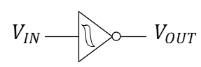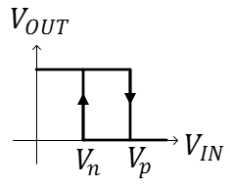
Figure 2: The input/output relationship of the Schmitt trigger from Texas Instruments, the TI 40106. The power connections to the inverter are often not explicitly shown in a circuit schematic.
Knowing that the input of the Schmitt trigger inverter has a high resistance, we can ignore it for purposes of determining how the capacitor and resistor of the oscillator interact. With this high-resistance model, the capacitor is attached to the resistor and the effects of the Schmitt-trigger input are gone. For the output of the Schmitt trigger, we will need two models, each will correspond with the two possible output voltages of Figure 2.
- When the input voltage, $V_{IN}$, is small, the output of the Schmitt trigger output is high (near the supply voltage, $V_{S}$). The output of the Schmitt trigger acts like an ideal voltage source. Therefore, for the charging cycle, the oscillator circuit can be modeled by Figure 3a.
- When the input voltage is high, the Schmitt trigger output is low (near ground voltage, 0 V) and behaves much like the ground node. The oscillator circuit can be modelled by Figure 3b.
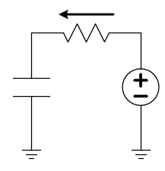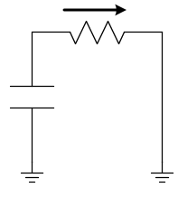
(a) (b)
Figure 3: Charging (a) and discharging (b) schematics for the oscillator circuit after making modeling assumptions for the Schmitt trigger (a voltage source and a short). The arrow shows the direction positive-valued current will flow as the capacitor charges and discharges, respectively.

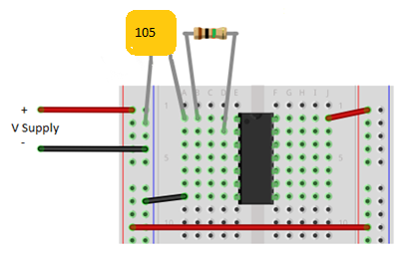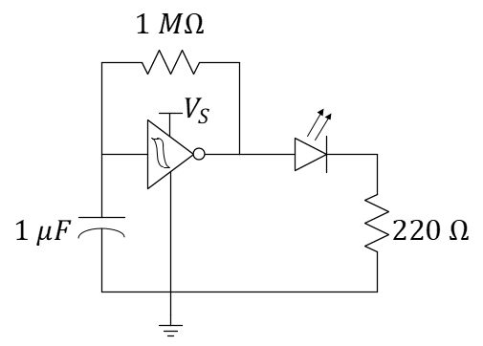
$$100 kΩ$$
$$10 μF$$
$$10 μF$$
$$1 kΩ$$
Capacitors often provide three or more numbers to indicate the capacitance in picoFarads (pF). The first digits are precision while the last digit represents a power of 10. For example, 104 means a capacitance of $10×{10}^{4} pF$ or, equivalently, $0.1 μF$. The electrolytic capacitor used here is physically large enough to write out the capacitance plus the unit in addition to its rated voltage. Note that it is polarized! You must place the negative side of the capacitor at the lower voltage…in this case, the negative end of the power supply.
Figure 4: Physical diagram and circuit schematic of a prototype oscillator circuit. The diode and current-limiting resistor are not shown in the prior. Note that you must place the negative side of the capacitor at the lower voltage if using an electrolytic capacitor (the one shown here is not polarized).
While working at the center tables, have each person in your team build an oscillator circuit as shown in Figure 4. Use a blue LED (actually, the color will not matter much) and $1 kΩ$ resistor to complete the design. The node between the LED and $1 kΩ$ resistor should be on an unused row of your breadboard. Finally, connect the battery + and – connections as shown. Your blue LED should be flashing every one to three seconds. Each student needs to complete the first 4 questions individually (but you can talk to each other) and then answer the last two questions together.

Learning Objectives
- Build a circuit by following the design specified on a circuit schematic
- Learn the applied definitions of synchronous and asynchronous, coherent and non-coherent.
- Use an LED as visible circuit output.
- Apply knowledge of time constants to a new application.
- Use the oscilloscope to record with precision our observations.

Summary
- The charging path and the discharging path are both through the resistor in the oscillator of Figure 4. Use your knowledge of time constants to estimate the period of the flashing light (the time between when the LED turns on until the time it next turns on). You do not need to be super accurate, just reasonable considering that the capacitor needs to charge and discharge each period.
- Use the [M2k] oscilloscope to plot and find the actual period of oscillation, $T$, of your device. Include a screenshot of the oscilloscope in your report. The frequency in flashes/second (units of Hertz) is found from $f_{osc}=\frac{1}{T}$ .

- Replace the $100 kΩ$ resistor with $50 kΩ$ by adding a second $100 kΩ$ resistor in parallel. You should still see the oscillation. How much did the period change? Use your understanding of RC time constants to explain it.
- Replace the two parallel $100 kΩ$ resistors with a single $1 kΩ$ resistor. What is different? Use the oscilloscope. What does the oscilloscope tell you that your eyes cannot? Include a screenshot of your oscillator including the settings of the horizontal and vertical scale.
- Your TA has a circuit challenge for you. Find your TA and complete the challenge. Briefly describe that challenge here and what solution you discovered for it.
- As a team…Prove (or disprove) that the resitance between the input of a Schmitt Trigger and ground is very large (say, $≥1 MΩ$). Hint: Use an ammeter to connect the battery’s positive terminal to the input pin of an inverter. Simultaneously use a voltmeter (from a teammate) to measure the voltage at the input pin (relative to the negative terminal). Think Ohm’s law. Explain anything that may surprise you about the measurement…

