M2k’s Voltmeter, Oscope, Voltage Source

The Scopy Voltmeter 
Recall that the Scopy voltmeter will allow us to use 1+ and 1- to measure one voltage differential on our circuit and to use 2+ and 2- to measure a second voltage differential. You should have already read https://wiki.analog.com/university/tools/m2k/scopy/voltmeter.
Now, let’s take our own voltage measurement. Connect the 1- probe to the negative side of the battery and the 1+ probe to the positive side. To achieve this, use one of the header pins to connect to 6 separate rows of your breadboard (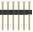for example, breadboard locations e1 through e6). See Figure 1. Connect the orange 1+ wire to e1 and the orange/white 1- wire to e2. Use a small red wire from your electronics kit to jump from d1 to the red power rail and a small black wire to jump from d2 to the black power rail. Do not attach your battery to the power rails yet.
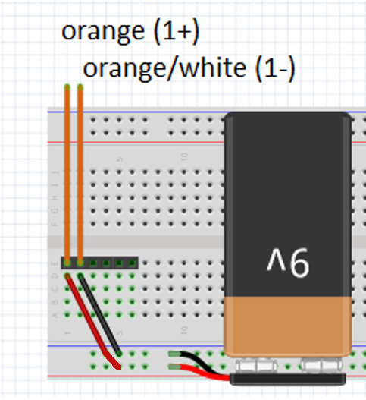
Figure 1: Using header pins to connect Channel 1 to the battery.
In Scopy, choose the voltmeter function on the left-side toolbar. Select Run to enable the voltmeter. Carefully check your connections and then attach the battery to the power rail. If the voltmeter does not immediately report a value in the range from 8-10 volts, you should disconnect power and search for an error in your construction.
Important Message!!: All questions are repeated on the last page so that you can fill it out there, print, and submit a single sheet of paper to GradeScope. Practice your ability to communicate. Provide an explanation where appropriate.

- Record your voltage reading using the proper number of digits. Explain how you determined the number of digits to record.

The Scopy Oscilloscope 
You may have noticed that the Scopy voltmeter not only displayed the voltage of your device, but also presented a brief time history of those voltage values. This is not typical of a low-cost handheld multimeter, but comes about as a convenience of having a more-sophisticated device (a computer!) involved. Plotting time-vs-voltage is typically the task performed by the oscilloscope. Scopy has an oscilloscope tool. With your battery still connected, click on the oscilloscope option and press the “Run” button. The voltmeter will cease to operate as you have moved the control of voltage measurements over to the oscilloscope. Channel 1 of the oscilloscope will be displaying the voltage of your battery vs. time. To confirm this, you can disconnect the positive side of your battery from the power rail and then reconnect it while watching the display. You should see the voltage fall to zero and then return.
With your teammates, read through the General section of https://wiki.analog.com/university/tools/m2k/scopy/oscilloscope, but stop there (unless you want the challenge!). Focus your attention on Time Base and Volts/Div. These will set the scale on the x and y axes. We will learn more about the oscilloscope as we procede.
Change the Time Base (Figure 2) by pressing the “+” button until it has reached 200 ms per time division. With one hand on the positive battery connection (red wire) at the breadboard and other on the “Single” option of the oscilloscope, press the Single option and you will have 200 ms/div times 16 time divisions on your scope display (3.2 seconds in total) to disconnect and reconnect your battery multiple times. After your scope has collected 3.2 seconds of data, it will display that on the oscilloscope plot. Can you see the recorded voltage change between 9 and 0 volts as you connected and disconnected it? If not, try again.
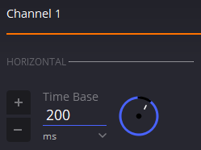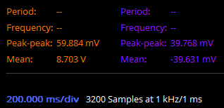
Figure 2: Changing the Time Base and reading the mean value.
Let’s use the oscilloscope’s mean (average) function to again record our battery’s voltage. With your time base still set to 200 ms/div (acquired by collecting 3200 Samples at 1000 Samples/second) , press “Run” and, in Question 2, record ten consecutive values of the mean voltage. The value is collected approximately every 3.2 seconds and you will know when a new value has been displayed because the scope will change from Waiting to Triggered on a regular interval.
- Record 10 consecutive values of your oscilloscope’s mean measurement. Each value should be recorded when Waiting changes to Triggered.
- Using your knowledge of instrument readings, what single value should be reported utilizing your 10 values?
There is much more to learn about the oscilloscope, but we will save that for another day!

The Scopy Voltage Source 
Remove your battery and all the wires of the M2k from the breadboard. Place a set of header pins not only in breadboard locations e1 through e6, but also in d1 through d6 (Figure 3). Connect the red V+ wire to e1 and either one of the black ground wires to e6. Attach a 1 kOhm resistor (brown, black, red, gold) between a1 and a4. Attach a 100 Ohm resistor (brown, black, brown, gold) between b4 and b6. You have essentially created a “voltage divider” across the power supply of your M2k using these two resistors. Let’s monitor the voltage across the 1 kOhm resistor by placing the orange 1+ “probe” at d1 and the orange/white 1- probe at d4. Monitor the voltage across the 100 Ohm resistor by placing the blue 2+ probe at e4 and the blue/white 2- probe at d6.
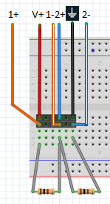
Figure 3: Taking two channels of voltage measurements.
In the voltmeter, press Run and turn on both channels. Now, go to the Power Supply tool and enable channel 1 with a 5 volt DC signal. The green “Enable” button will change to a red “Disable” button when the power supply is active.
- Return to the voltmeter and record the measurements of both channels.
- Verify that the sum of the two voltages is equal to the voltage supplied. Sketch a schematic with voltage polarities and explain your result using Kirchhoff’s voltage law.
- Verify using Ohm’s law that both (series) resistors carry the same current. What might have caused some slight deviance between the two current values?
- Record your voltage reading using the proper number of digits. Explain how you determined the number of digits to record.
- Record 10 consecutive values of your oscilloscope’s mean measurement.
- Using your knowledge of instrument readings, what single value should be reported utilizing your 10 values?
- Return to the voltmeter and record the measurements of both channels.
- Verify that the sum of the two voltages is equal to the voltage supplied. Sketch a schematic with voltage polarities and explain your result using Kirchhoff’s voltage law.
- Verify using Ohm’s law that both (series) resistors carry the same current. What might have caused some slight deviance between the two current values?

