ADALM2000 (M2k) Tutorial

What is the M2k?
Analog Devices manufactures the Active Learning Module 2000, also commonly referred to as the M2k. The M2k replaces several devices typically found in the lab environment, including voltage sources, voltmeters, oscilloscopes, and function generators. It does this by providing some very versatile hardware and a software backend to process and display it. In this tutorial, we’ll download a software called “Scopy” to provide an intuitive graphical user interface (GUI) to help us operate and interpret the M2k. We’ll also learn about the features and limitations of the M2k.
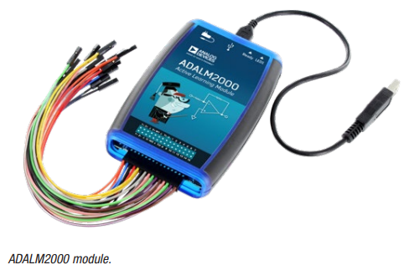
Source: https://www.analog.com/media/en/news-marketing-collateral/product-highlight/ADALM2000-Active-Learning-Module.pdf

Scopy
The open-source software we will be using to access the M2k is called Scopy. Go to https://wiki.analog.com/university/tools/m2k/scopy and download and install the version appropriate for your operating system (OS). There is a video on this link that may be very helpful. Make sure to install device drivers as appropriate or you will not see the M2k when you start Scopy!
Once installed, physically attach the M2k to your computer through the USB cord supplied in the box. The USB port from your computer should be able to power the M2k although there is also an auxiliary power USB input (top-left of Figure 1). Most, if not all, students should be able to ignore use of this USB port. If you suspect your computer’s USB port might not be powering the device sufficiently, you could add USB power from an AC adapter.
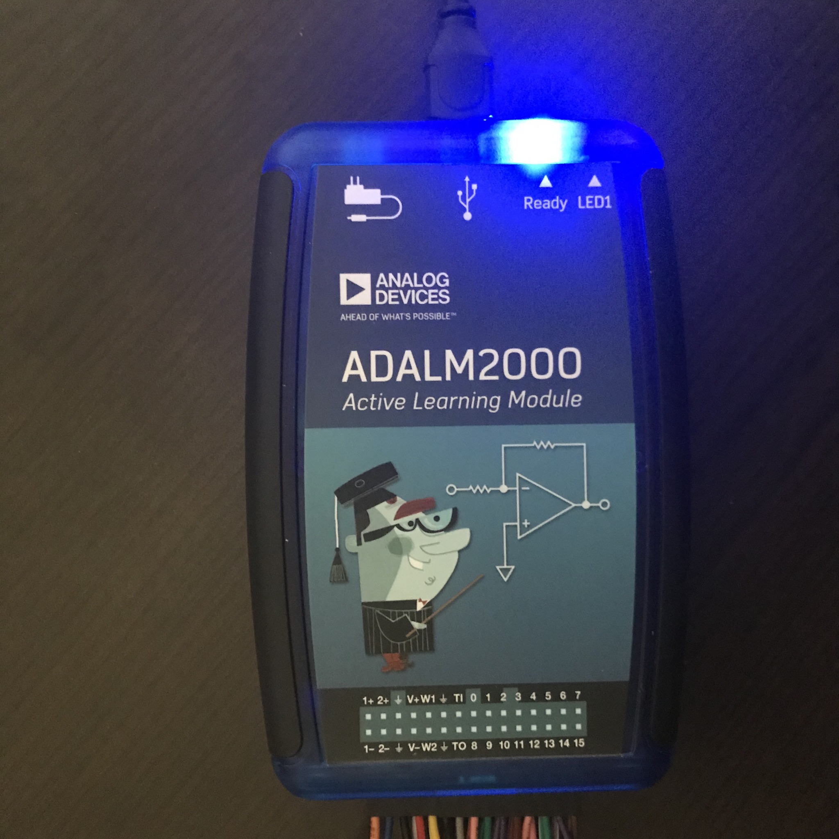
Figure 1: M2k with Ready light.
Now, open Scopy. If your M2k is not properly attached (or you forgot to install the drivers), the graphical interface will not show the M2k. If properly installed and attached, the M2k will appear as on the image on the right of Figure 2.
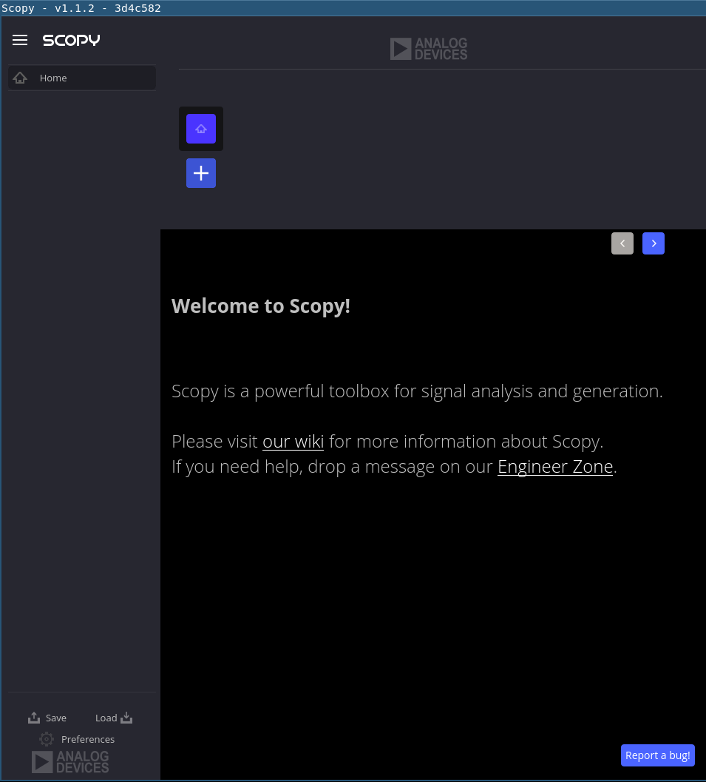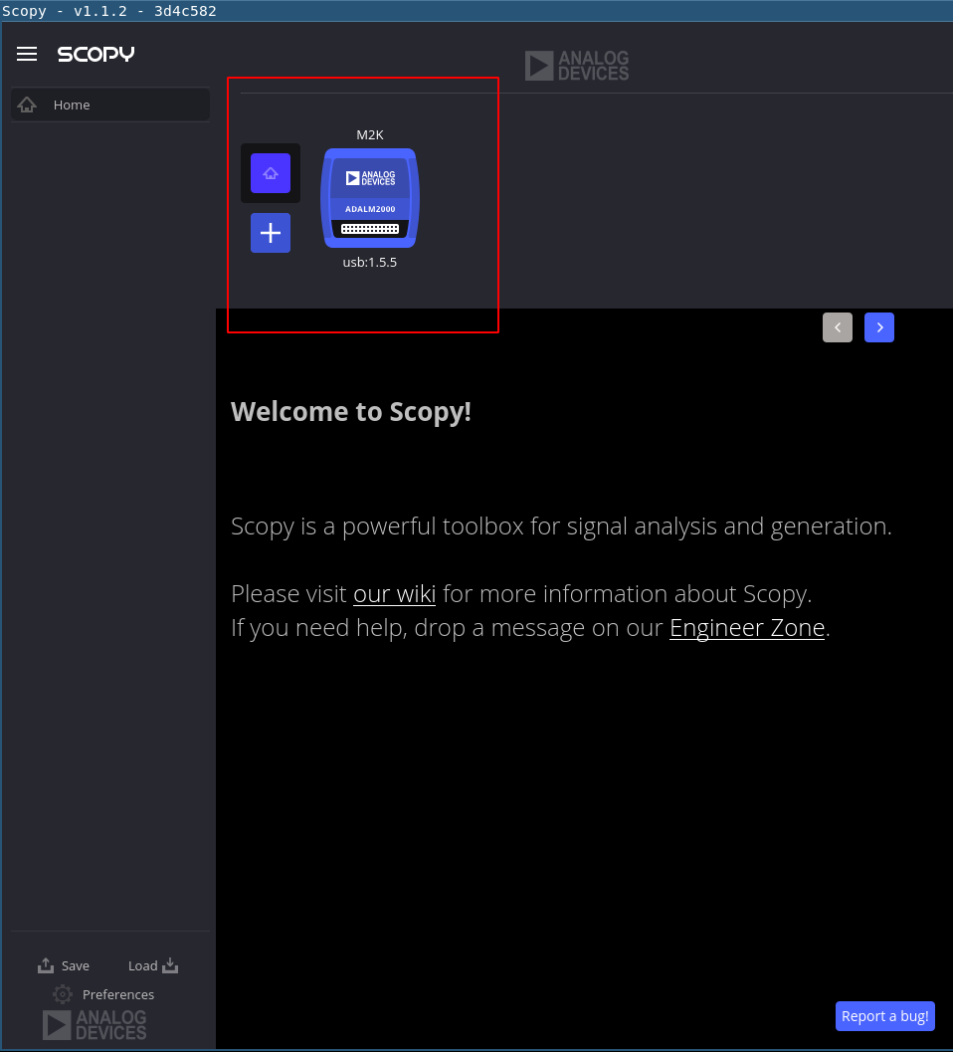
Figure 2: Scopy without (left) and with (right) recognition of the M2k.
Once a device is identified we can select it and press “Connect” and then see the tools available to us in the left pane as shown in Figure 3.
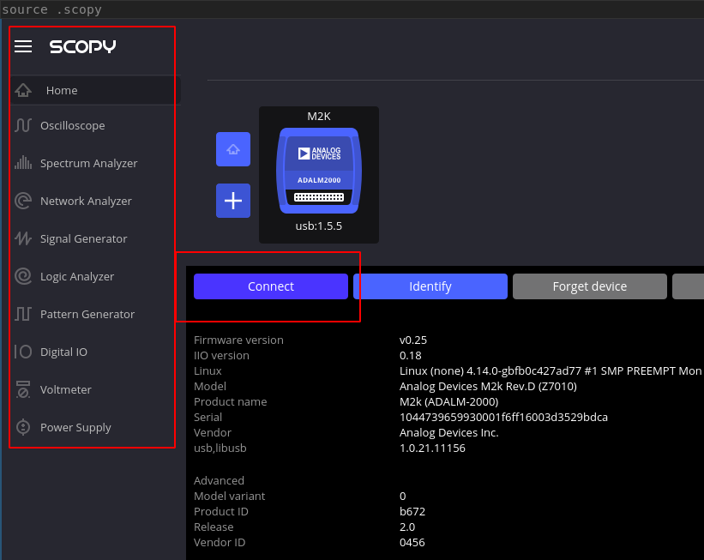
Figure 3: Scopy tools for the M2k.
There two wire harnesses in your M2k kit. Attach the smaller of the two on the left side of the M2k as shown by the highlighted pins in Figure 4.
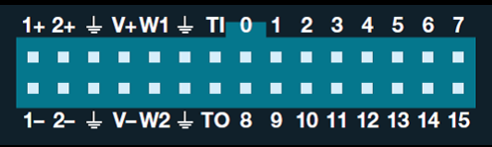
Figure 4: Pins and labels of the M2k.
The details of the pin-out are shown below in Figure 5. This particular harness gives you access to left-most 10 pins on the M2k.
- A positive and negative probe for an Analog Input (voltage) for Channel 1: 1+ and 1-.
- A positive and negative probe for an Analog Input (voltage) for Channel 2: 2+ and 2-.
- A pair of computer-ground connections: all connected to the internal instrument ground node.
- A voltage source capable of up to 5 volts above the computer’s ground reference: V+.
- A voltage source capable of up to 5 volts below the computer’s ground reference: V-.
- And two analog output signals, each relative to the computer’s ground: W1 and W2.
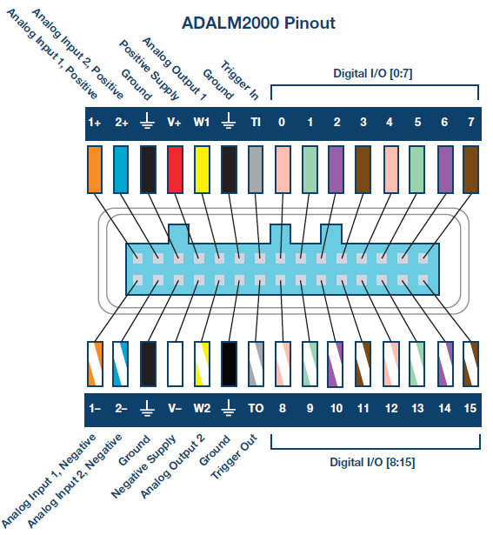
Figure 5: Pins, labels, wire colors, and descriptions of the M2k.
Source: https://wiki.analog.com/university/tools/m2k/devs/intro

The Scopy Voltmeter 
The Scopy voltmeter will allow us to use 1+ and 1- to measure one voltage differential on our circuit and to use 2+ and 2- to measure a second voltage differential. Start by reading the page https://wiki.analog.com/university/tools/m2k/scopy/voltmeter.
Now, let’s take our own voltage measurement. Connect the 1- probe to the negative side of the battery and the 1+ probe to the positive side. To achieve this, use one of the header pins to connect to 6 separate rows of your breadboard (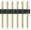for example, breadboard locations e1 through e6). See Figure 6. Connect the orange 1+ wire to e1 and the orange/white 1- wire to e2. Use a small red wire from your electronics kit to jump from d1 to the red power rail and a small black wire to jump from d2 to the black power rail. Do not attach your battery to the power rails yet.
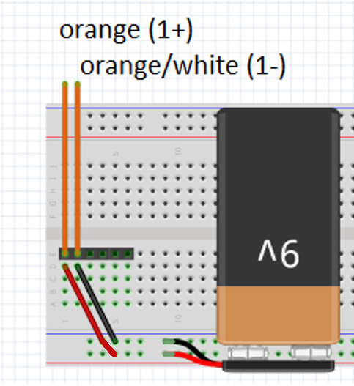
Figure 6: Using header pins to connect Channel 1 to the battery.
In Scopy, choose the voltmeter function on the left-side toolbar. Select Run to enable the voltmeter. Carefully check your connections and then attach the battery to the power rail. If the voltmeter does not immediately report a value in the range from 8-10 volts, you should disconnect power and search for an error in your construction.
Troubleshooting: A voltage less than 1 volt is likely a short circuit - a direct connection between the two terminals of your battery - and will drain your battery rather quickly. A voltage between 7 and 8.5 volts is likely an indication that your battery has already expended much of its energy, likely due to being left plugged in for a long period of time or having been shorted during previous experiments. Other values may require more investigation. Detect any problems and correct them.
Pay attention to the reading of your voltmeter. Make notes on the value displayed and pay attention to the precision of the instrument as well as the proper significant digits of the displayed value.
- Submit a 30 second video as proof of completion. In that video, give your name and section. Discuss any challenges you had installing Scopy. Show your voltmeter’s measurement and explain how many significant digits should be recorded.
Comment: It is critical that you start this assignment early so that you can receive TA help on the installation if needed. If the install doesn’t go well and you have already worked with a TA for assistance, you can record the video demonstrating the issues and naming which TA you worked with. This will buy you a little more time (in lab) to rectify the installation issue without a loss of credit for the prelab.

Appendix: Troubleshooting Install Issues
These are notes from Fall 2020. If you run into issues and/or resolve them, please share on the Lab Discussion Board at Compass2g so that we can better help other students!

MacOS
Question: I'm in the process of trying to download the software necessary for labs, however, Scopy doesn't seem to be compatible with the older OS I have (I have 10.13.6, and it seems that 10.14 is the lowest the software works with). I'm not sure what to do?
Proposed solution: Your best bet might be to install an older version of Scopy. I see one on this discussion,
https://ez.analog.com/adieducation/university-program/f/q-a/104914/adalm2000-scopy-crashes-on-mac---missing-libserialport

Question: The installation appears to have gone fine, but Scopy does not appear when opened.
Proposed Solution: Go to Systems Preferences, select “Security & Privacy”, and click on the “General” tab. On the bottom half of the page it should say that an outside application, Scopy, was blocked from opening. Click open anyway to allow Scopy through your firewall. Mac users have this security issue that they have to change some setting in Security & Privacy in order to open the app. (Please, someone try to get more detail on this!)

Question: Scopy does not appear in my list of apps. How do I open it?
Proposed Solution: The Scopy download from their github is a .dmg file containing the application. Open that .dmg, right click on the scopy icon, and select copy. Then navigate to your applications folder and paste the scopy application.

Question: The driver, HoRNDIS, is not compatible with the latest MacOS version, and the installation always fails.
Proposed Solution: Download the modified version of the driver from https://github.com/jwise/HoRNDIS/issues/102#issuecomment-541237232. The file name is HoRNDIS-9.2-catalina_install.pkg.zip.

Windows
Question: I’ve installed, but Scopy does not display the M2k as an instrument option.
Proposed Solutions:
- Most-common issue is that the student did not install the drivers. Many students do not realize drivers were needed. A TA may need to lead them back to the installation site and point it out.
- There are also reports of students plugging the USB cord into the power port and not the instrument port on the M2k. The power port cannot communicate with the computer.

Question: I’ve installed Scopy and see the “Connect” button. When I press “Connect”, Scopy exits without any message.
Proposed Solutions: No known solution. Might try to do a re-install. Try restarting computer at least a few times.

