EXTECH MN35 Multimeter
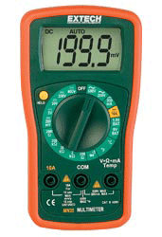 | MN35: Digital Mini MultiMeter  Compact Manual ranging multimeters with 8 functions including Temperature  The MN35 is a convenient mini size multimeter with protective rubber holster and tilt stand. Manual ranging, measures AC and DC Voltage to 600V, Resistance with Continuity and Diode functions, DC Current to 10A, Temperature, and 9V/1.5V Battery test. Includes protective rubber holster, 9V battery, test leads and Type K thermocouple probe.  [source: http://www.extech.com/products/MN35]
Our handheld multimeter is a low-cost convenient means to measure voltage (voltmeter), current (ammeter), and resistance (ohmmeter). This model, MN35, is a manual-ranging meter, meaning that you need to adjust the dial to optimize the number of significant digits. Turning the dial changes the physical circuit within the meter to make this happen. In an auto-ranging device, the switching of the circuit would be done electronically, but the device would be more expensive. The document your are reading is also highlighted in a training video available on our ECE 110 MediaSpace channel.
Let’s start by looking at the user’s manual’s safety precautions.

Safety Precautions
1. Improper use of this meter can cause damage, shock, injury or death. Read and understand this user manual before operating the meter.
2. Make sure any covers or battery doors are properly closed and [secured]. [I am guessing this is the word they wanted here.]
3. Always remove the test leads before replacing the battery or fuses.
4. Inspect the condition of the test leads and the meter itself for any damage before operating the meter. Repair any damage before use.
5. Do not exceed the maximum rated input limits.
6. Use great care when making measurements if the voltages are greater than 25VAC rms or 35VDC. These voltages are considered a shock hazard.
7. Always discharge capacitors and remove power from the device under test before performing Diode, Resistance or Continuity tests.
8. Remove the battery from the meter if the meter is to be stored for long periods.
9. To avoid electric shock, do not measure AC current of any kind.
This all sounds a bit scary, but you should understand that the MN35 does not present much danger to you, it is all the stuff you might be tempted to try to measure with it! Don’t measure current from powerful sources like wall (MAINS) voltages, large or high-voltage capacitors, or automotive batteries and you will have removed most of the potential hazards. The device can be used to measure these voltages with the correct settings, but the user must be careful that their body never completes a circuit with these kinds of powerful sources. It is better to leave it to the experts when in doubt of your knowledge and skills.
The other safety precautions deal with not damaging the MN35 itself. You will likely blow a fuse (once, maybe twice) before you get the hang of using the ammeter, but I don’t anticipate damage to the meter if used under our usual procedures.

Preparation
To measure voltage, resistance, or current (up to $200 mA$), you first insert the probes (measurement wires) into the digital multimeter (we’ll refer to the MN35 as the digital multimeter or DMM from now on). After removing the protective plugs, the black probe should be inserted into the common (COM) jack and the red probe inserted into the $V/Ω/mA$ jack.
The probes are pointed and can be used to touch test points in your circuit but are not convenient for the breadboard training of this course. We can attach wires to the probe in a way that is electrically and mechanically solid so that we can then make connections of the probes directly into locations on our breadboard. In this way, we will not have to hold two probes in place with our hands while trying to make measurements, make changes to our circuit, record data in our notes, or type on our computer.
Find two different-colored wires from your kit. You will want two of the longest wires available. In the figure below, we are using one green and one yellow wire. Choose the “darker-colored” wire to make our connection to the black probe. Start by holding the wire bent with a short end parallel with the probe tip. Holding the wire snug with your left thumb, use your right hand to tightly wind the long-end of the wire about the short-end of the wire and the probe. This will tighten the bare end of the wire against the probe tip. Make about 5 windings, then remove your thumb and feed the long end through the exposed loop and press it down tight against the probe as you slightly undo your last winding.
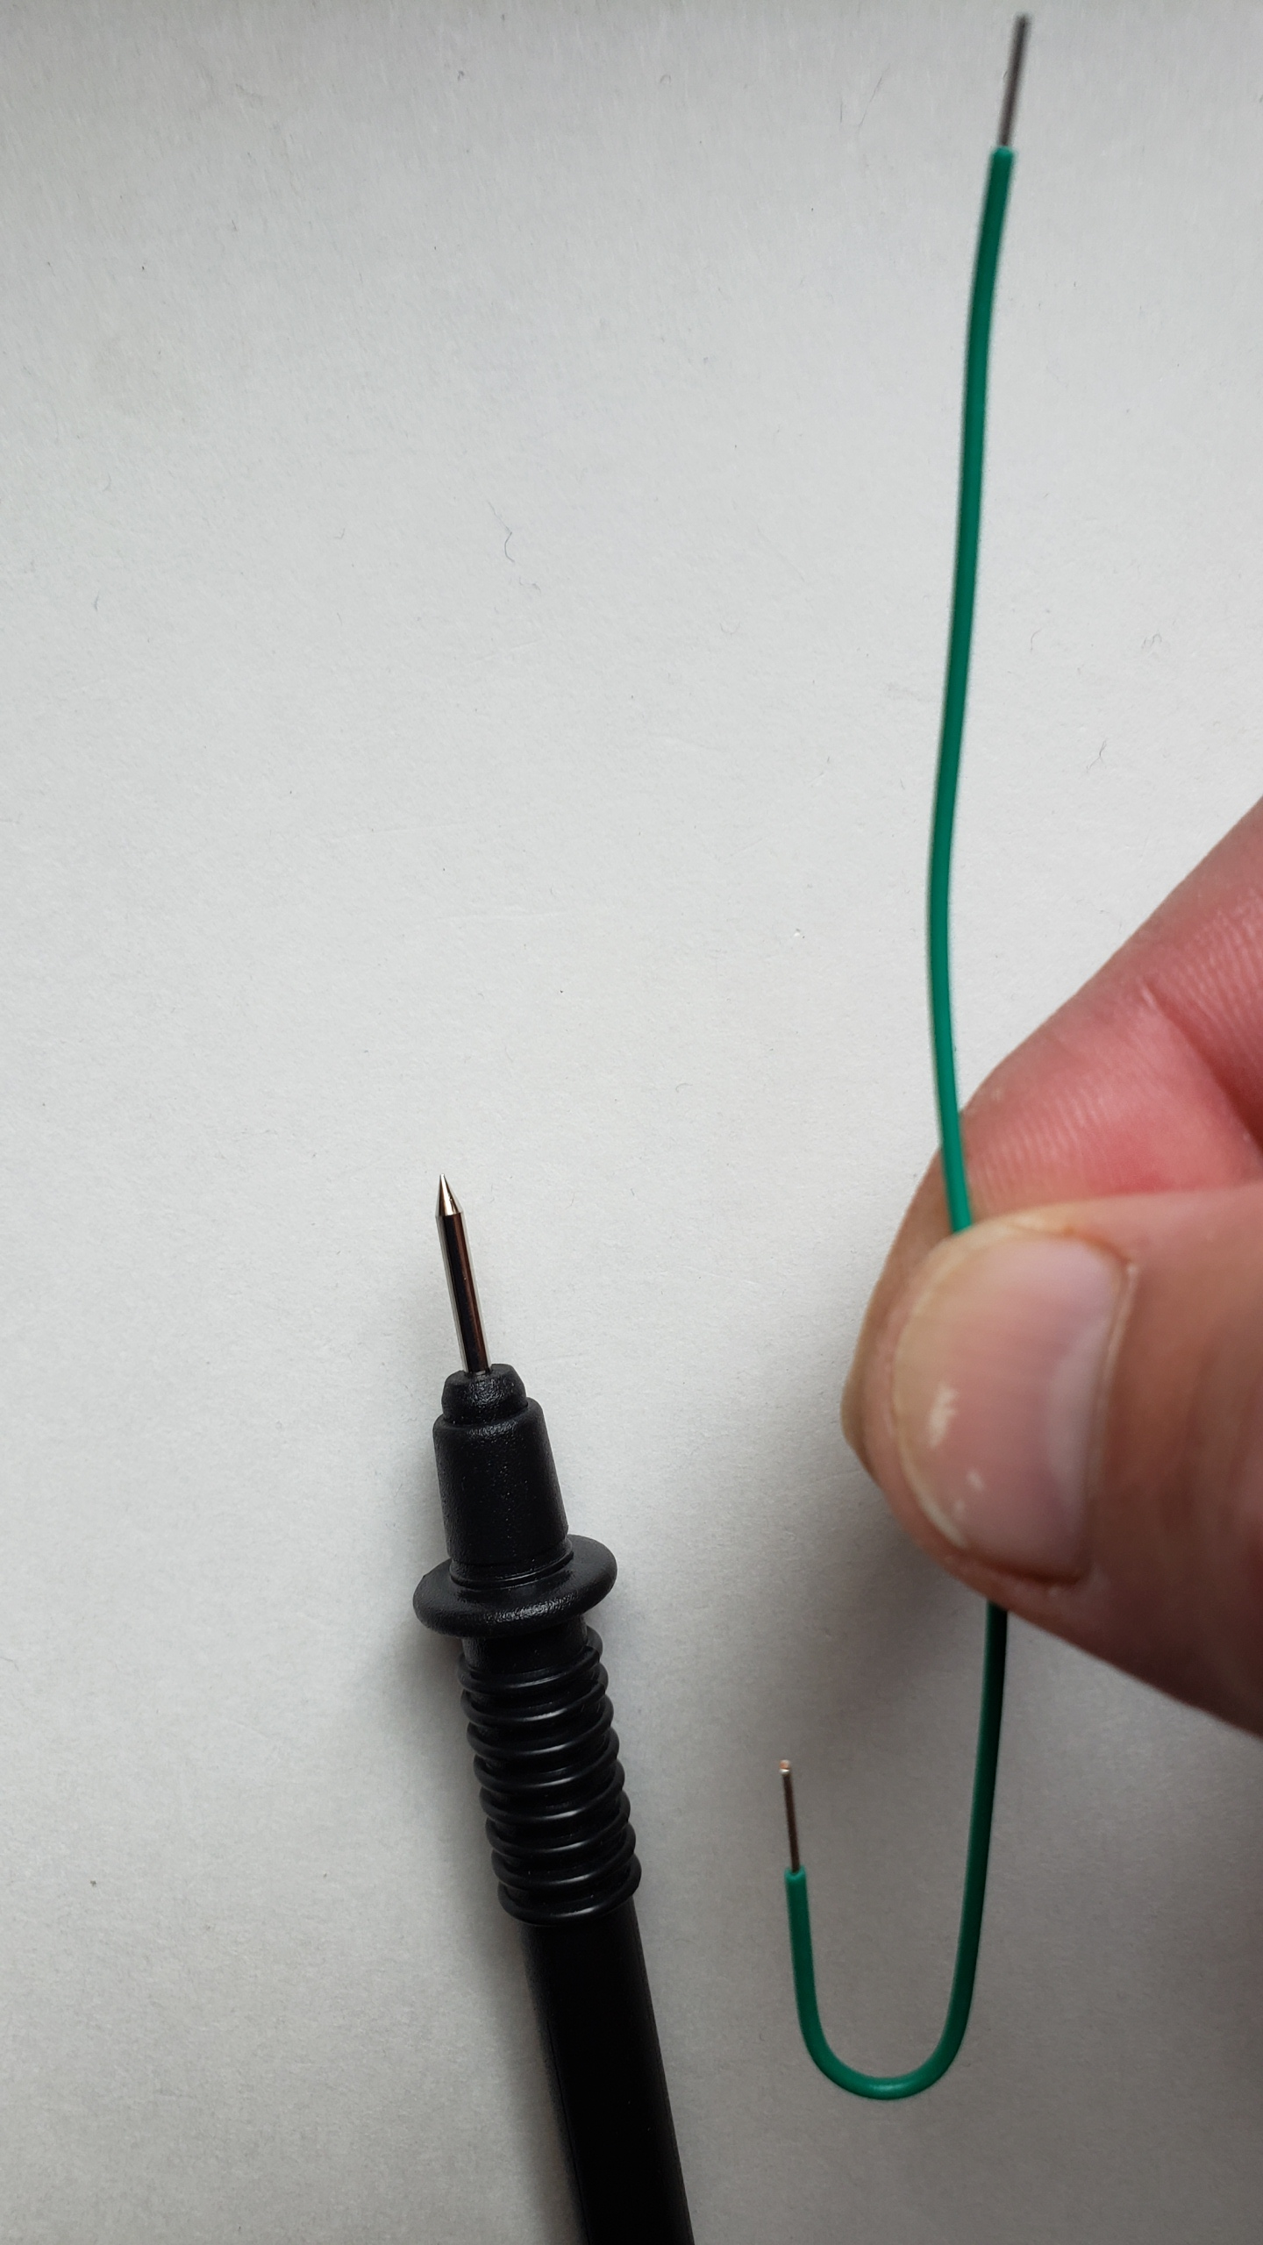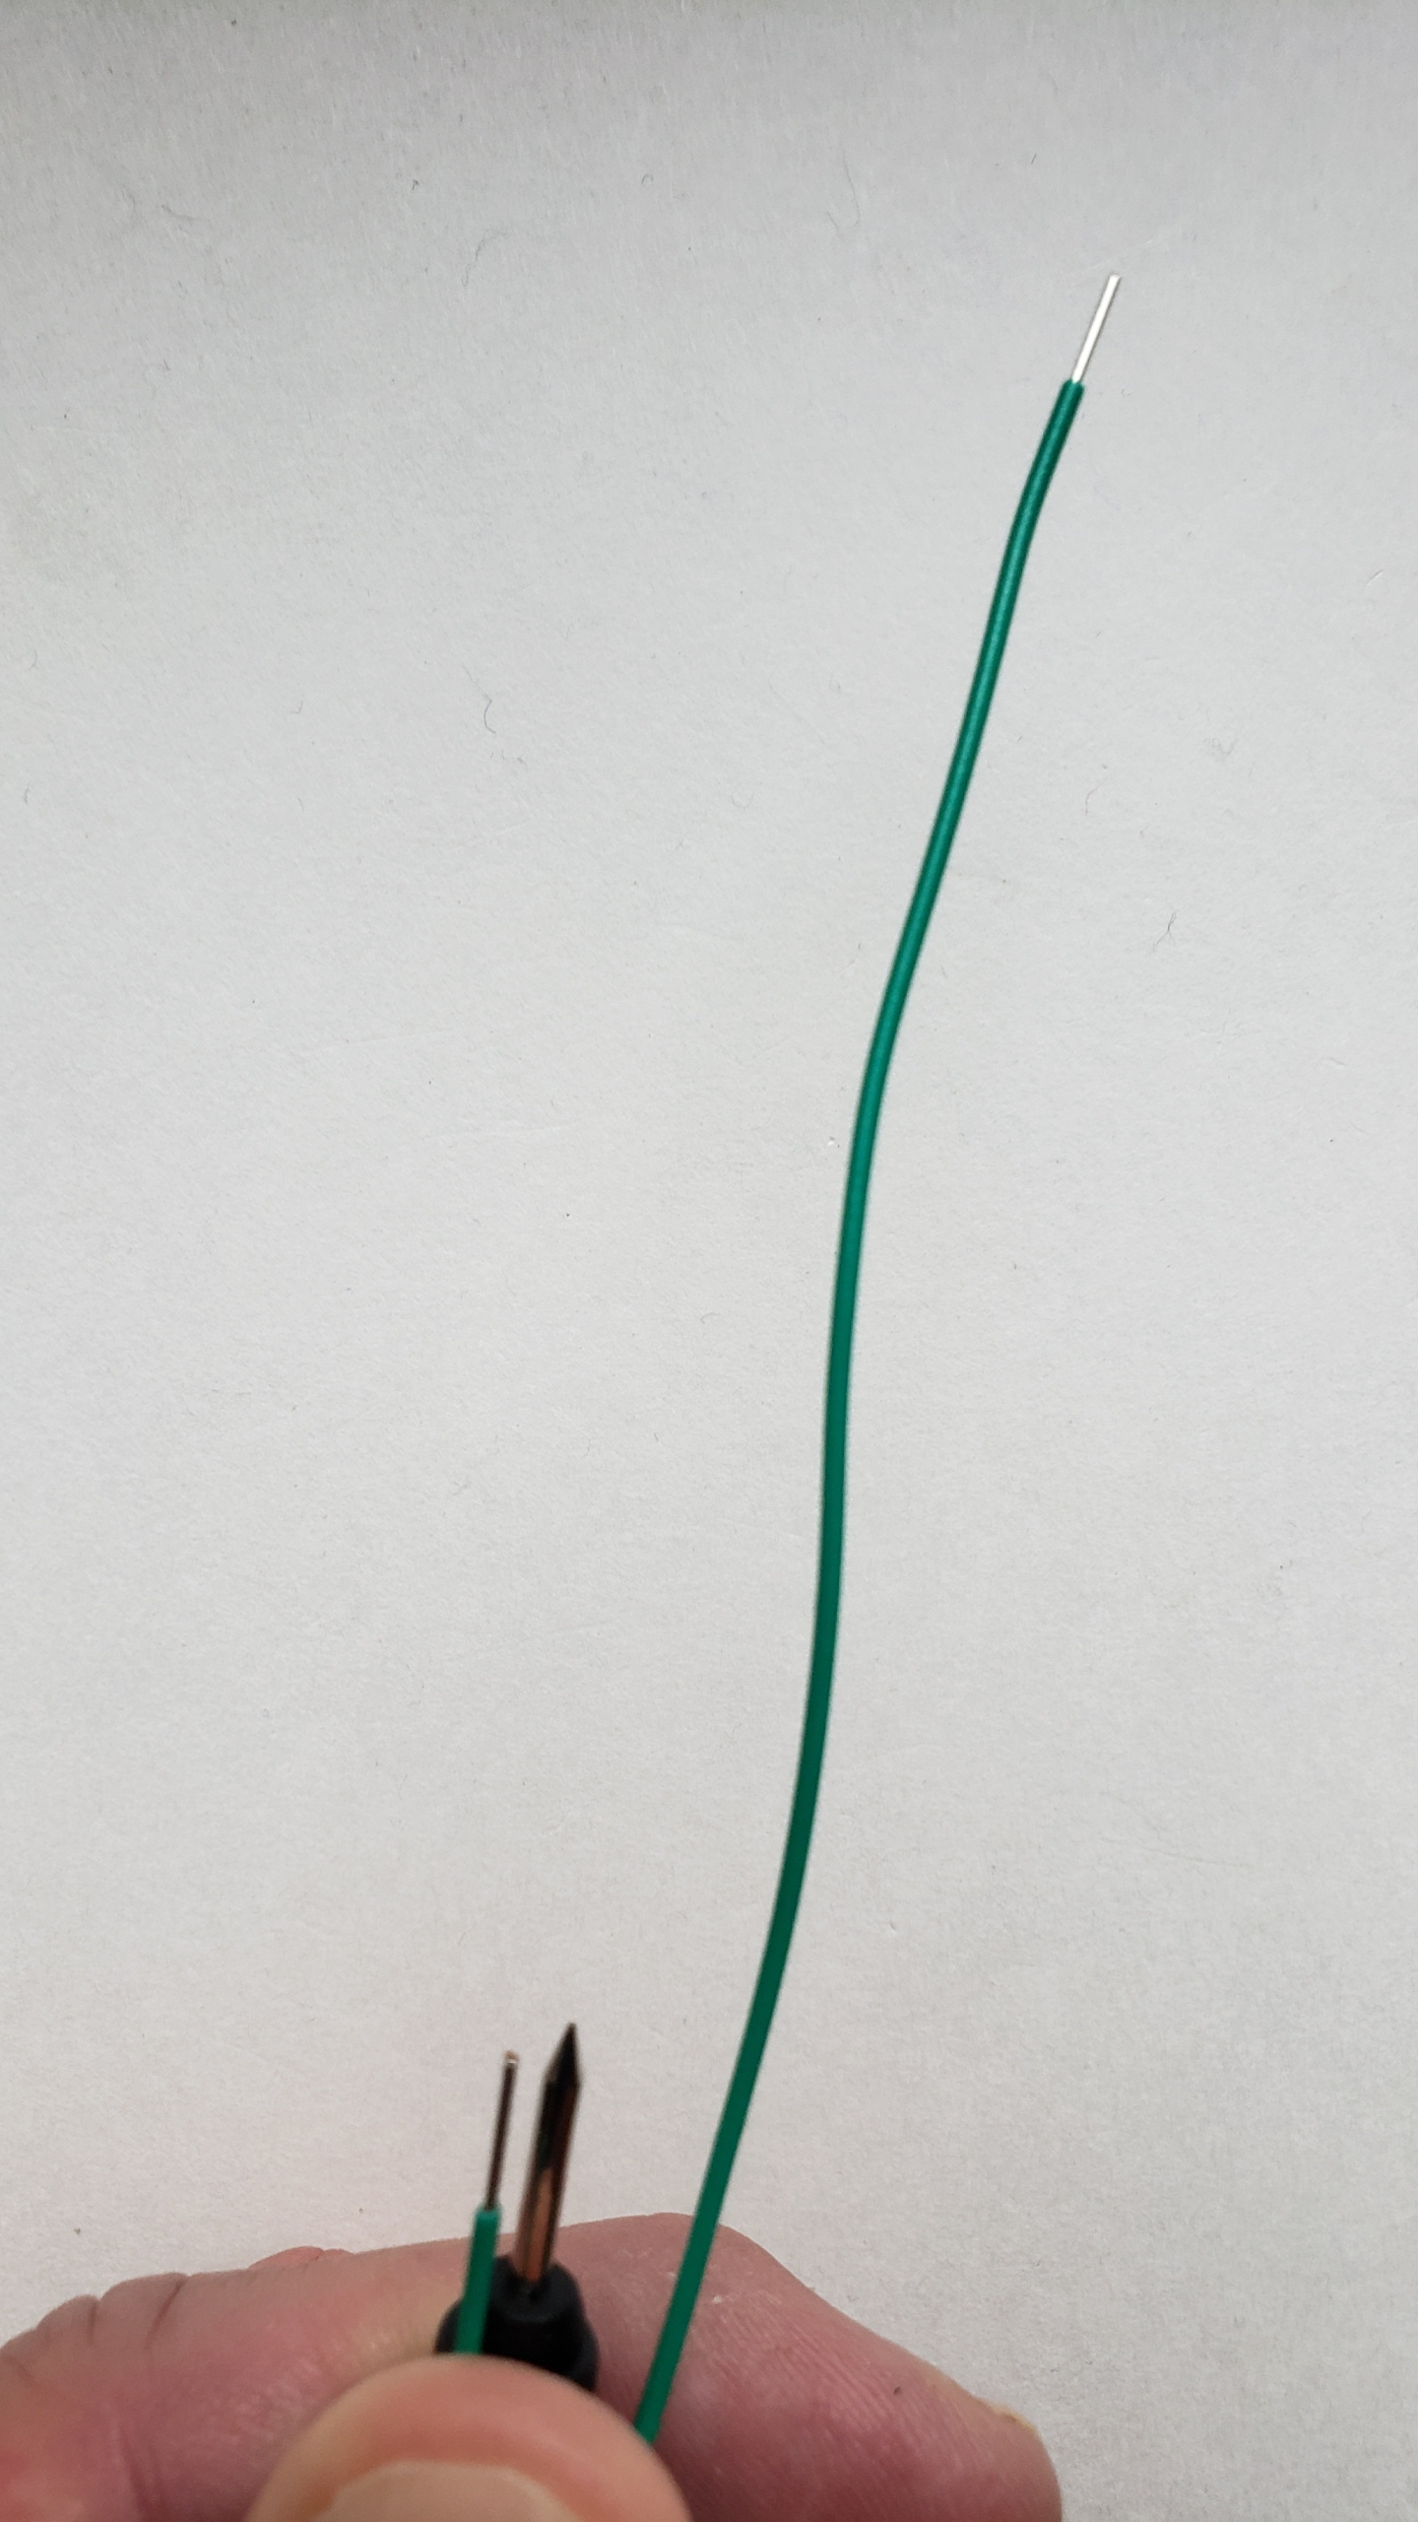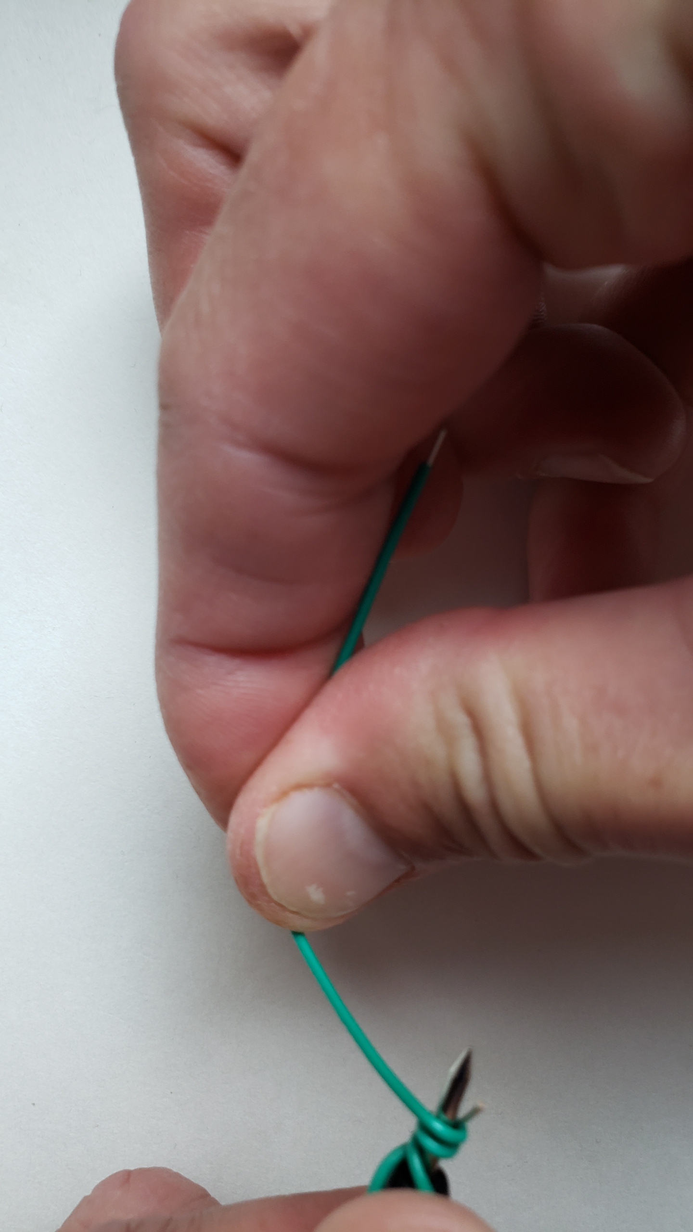
Bare wire
Figure 1: Adapting your MN35 probe—getting an electrical contact between probe and wire.

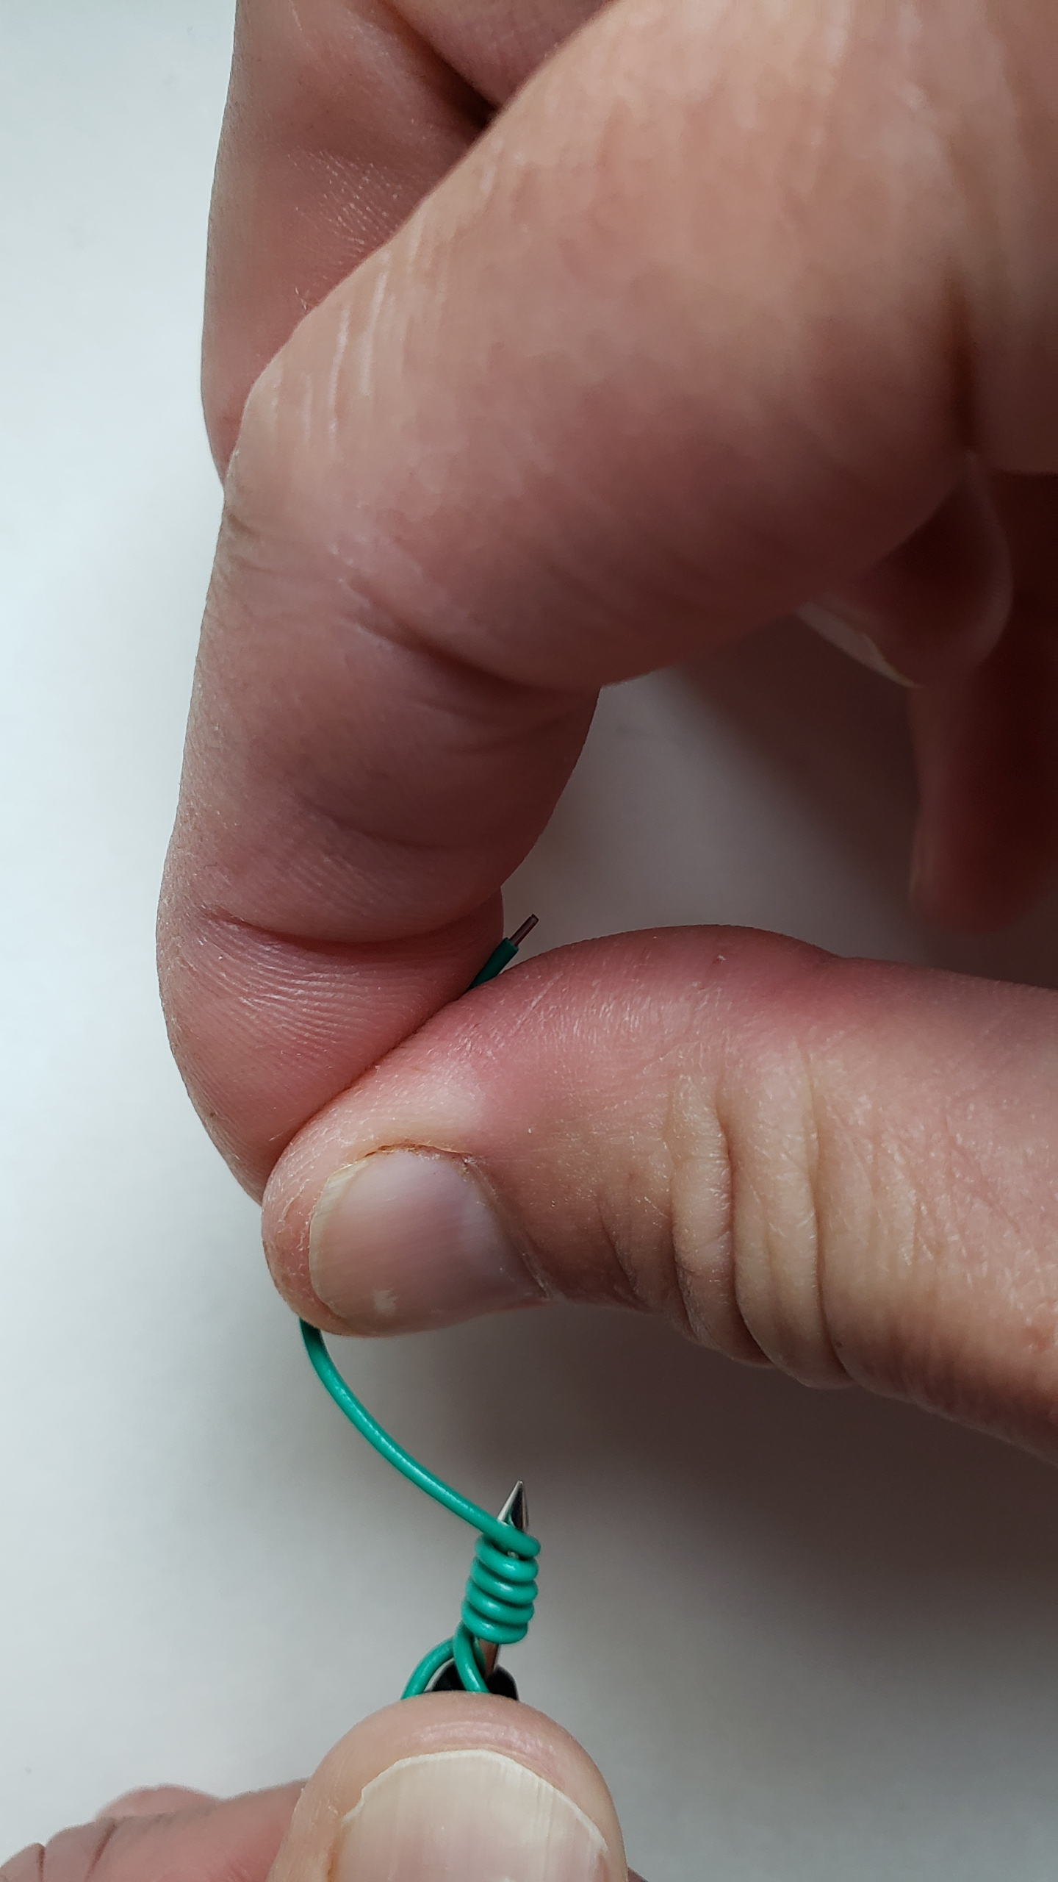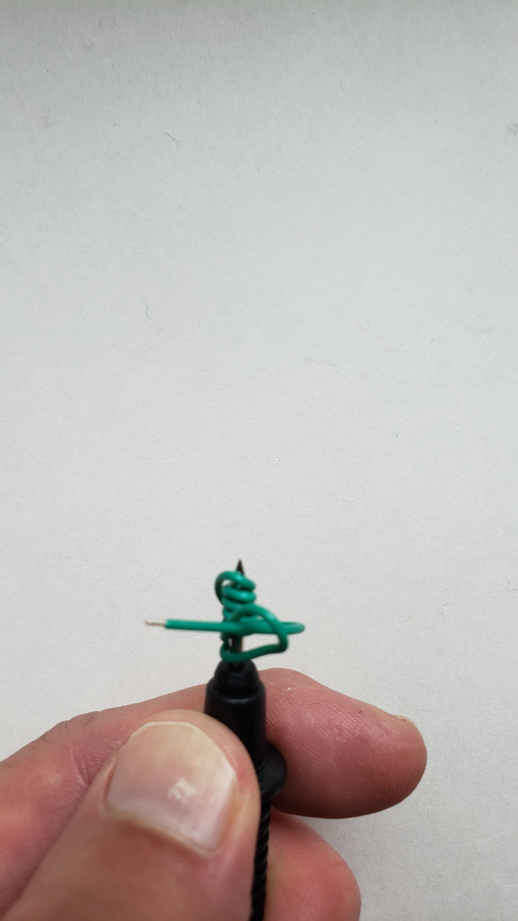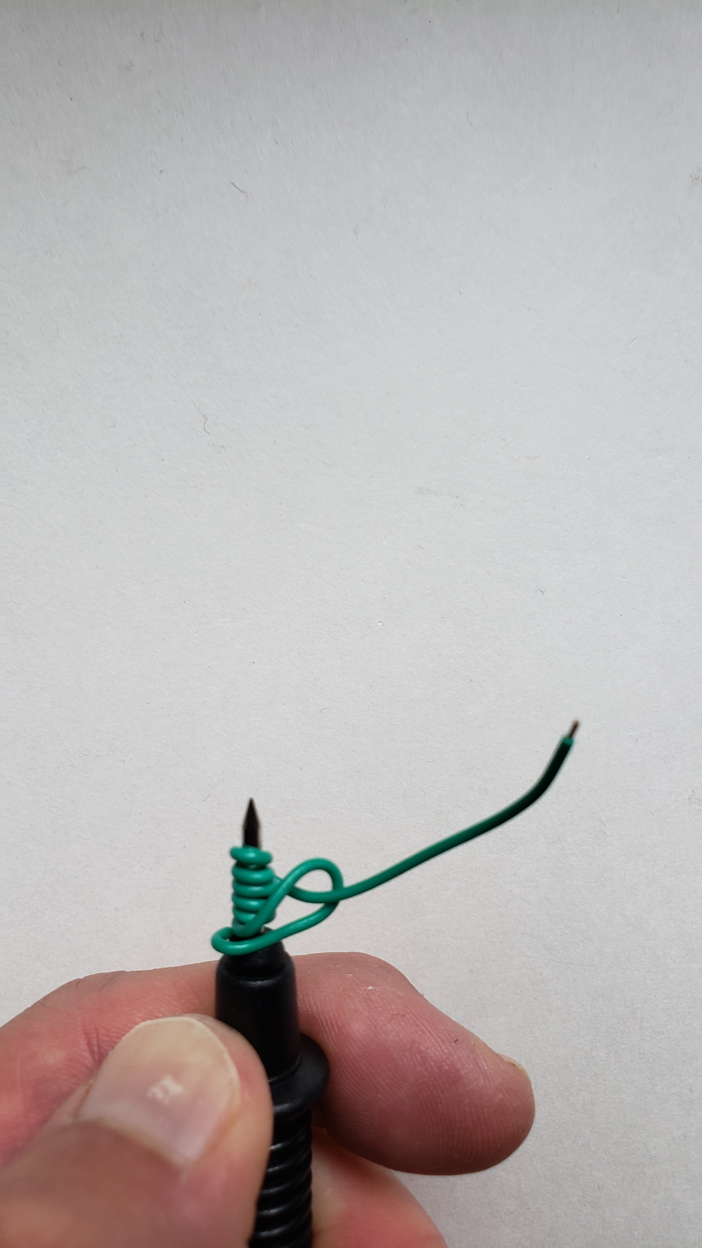
Figure 2: Adapting your MN35 probes—securing the end.

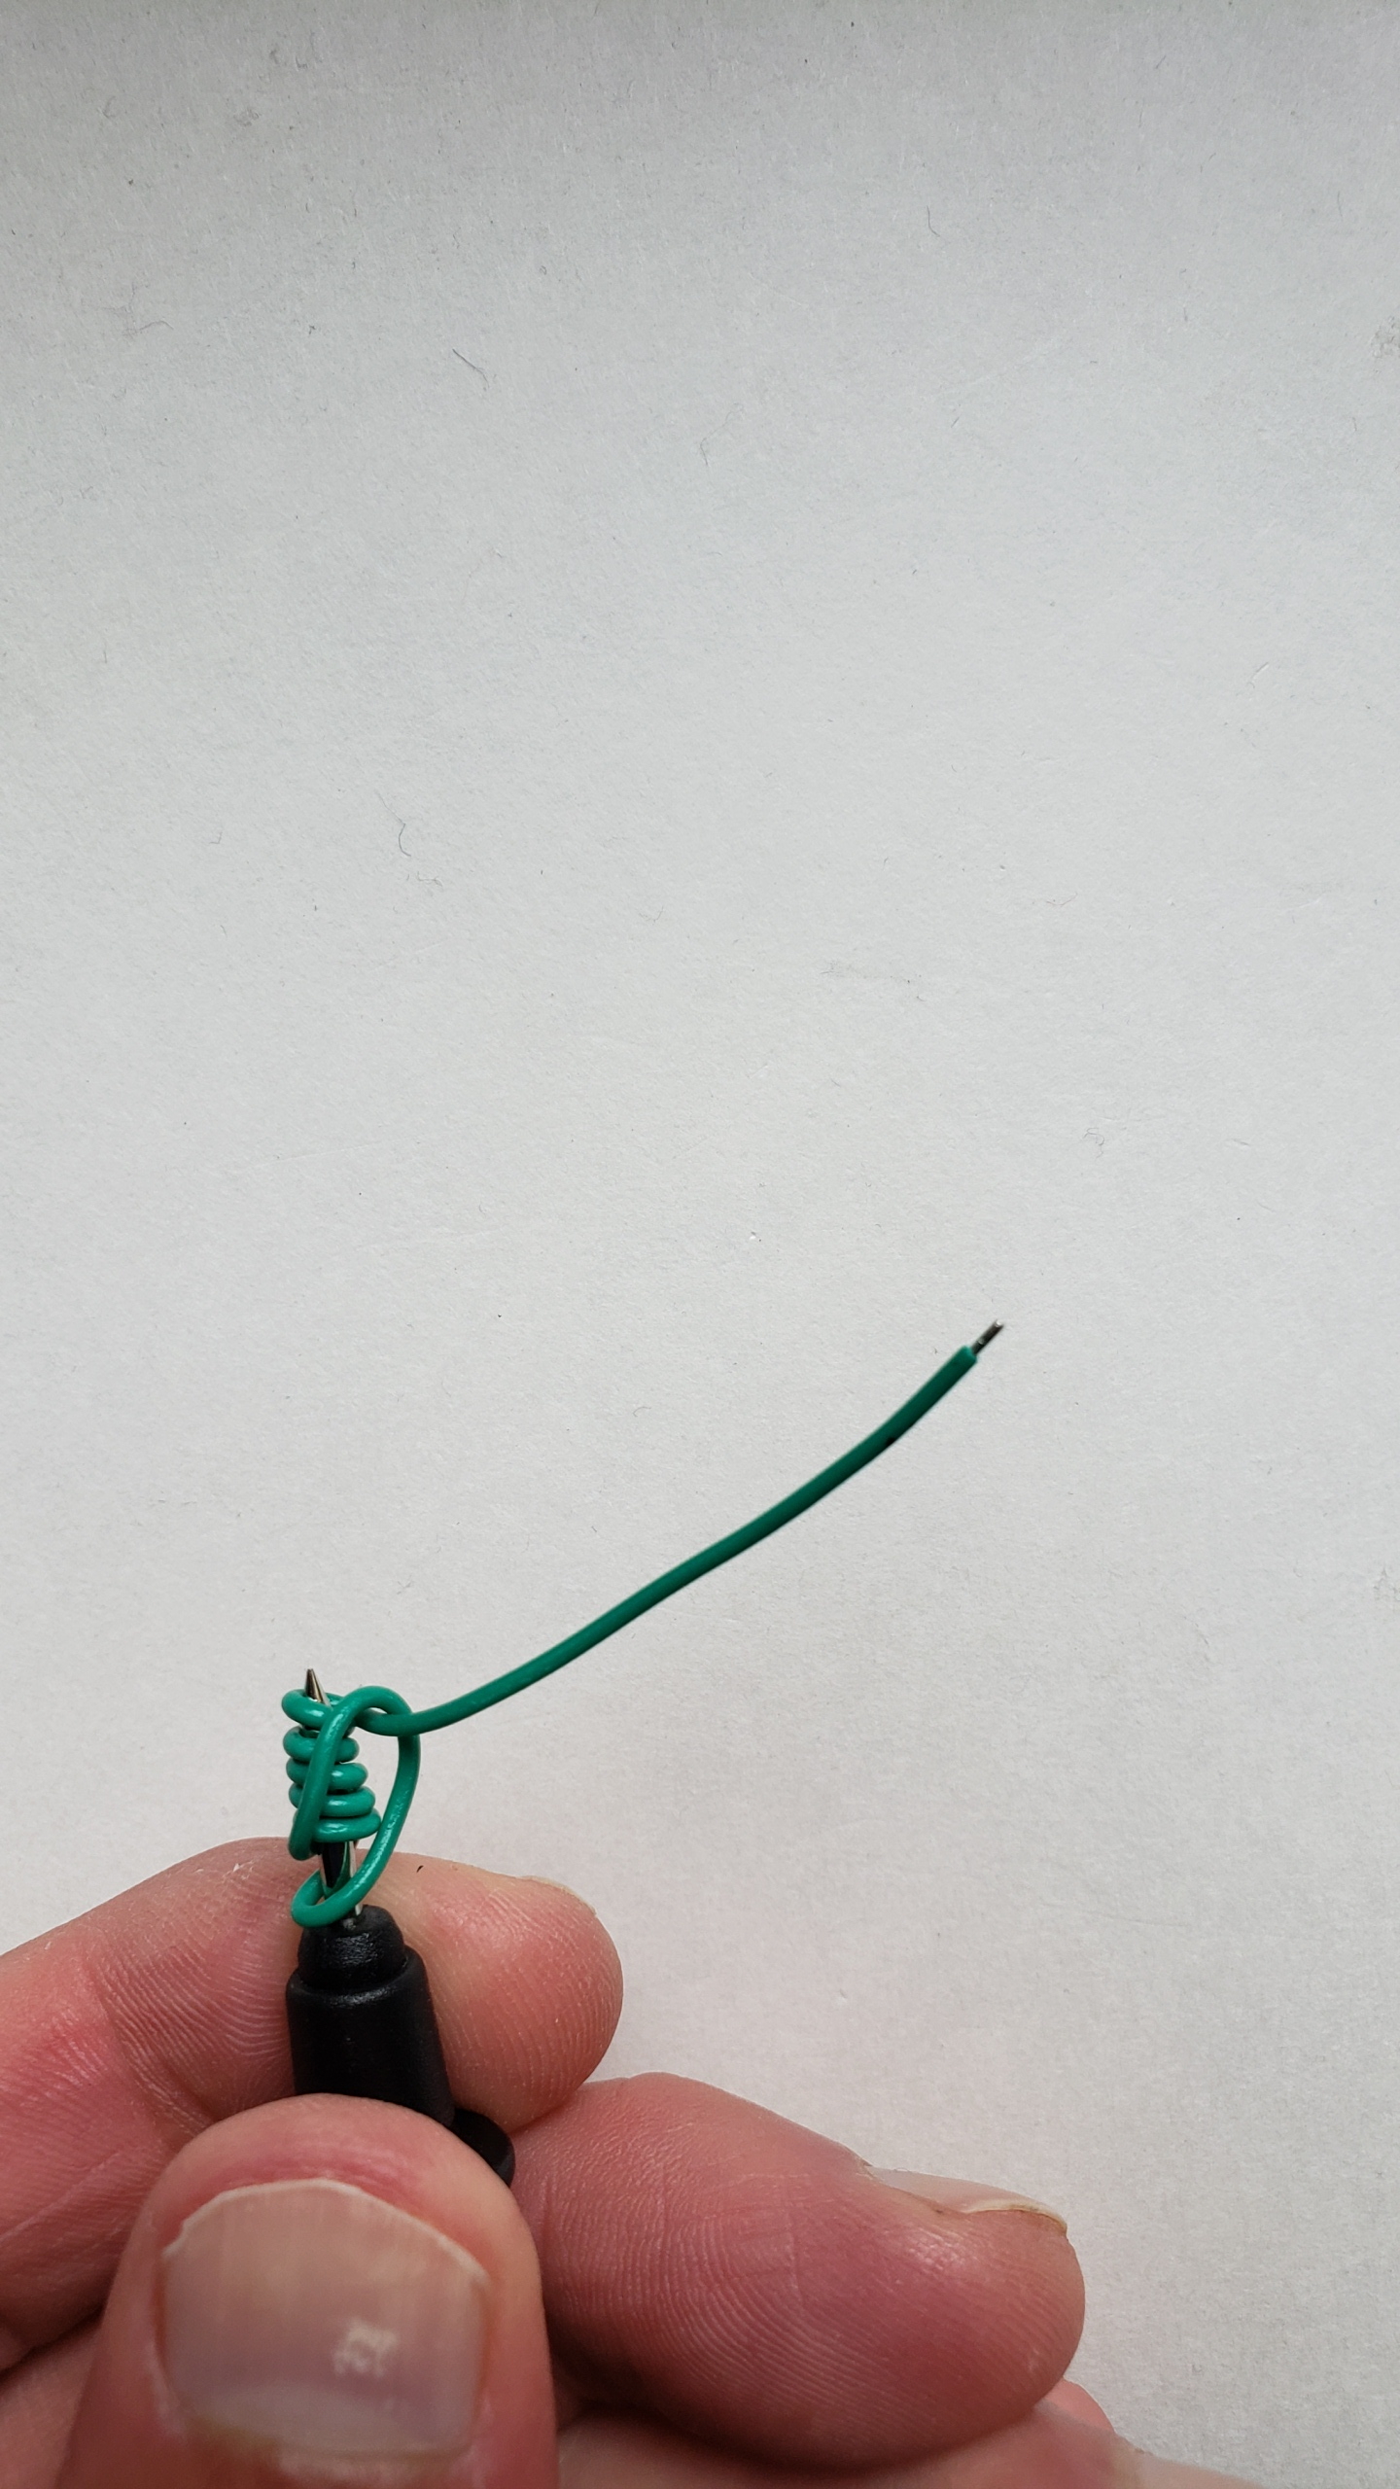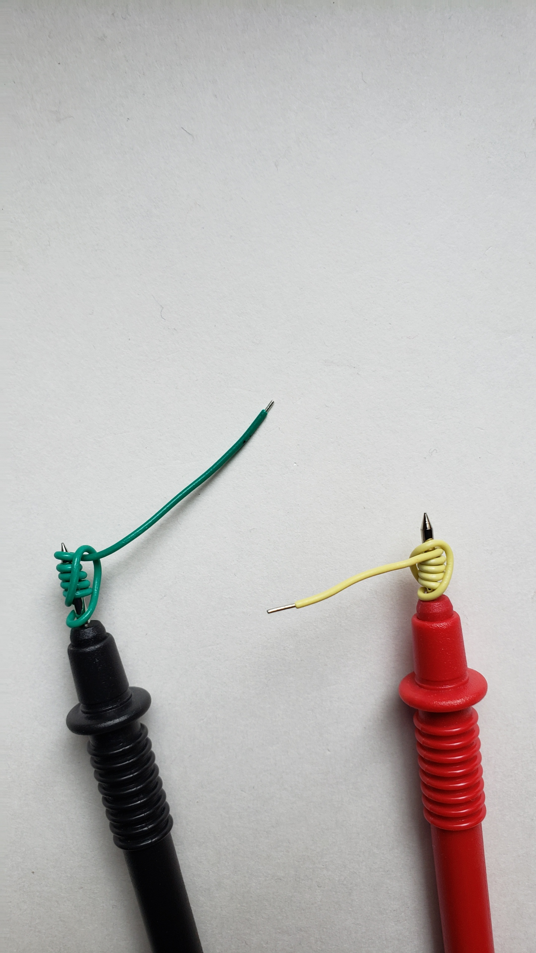
Figure 3: Adapting your MN35 probes for breadboard connection—finished product.
Repeat this process with the “lighter-colored” wire and the red probe. The wires on both probes should be suitably snug and making good electrical contact with the DMM.

Resistance Measurements
The following are the instructions from your MN35 user’s manual.
- Insert the black test lead banana plug into the negative COM jack and the red test lead banana plug into the positive V/Ω/mA jack.
- Set the function switch to the highest Ω position.
- Touch the test probe tips across the circuit or part under test. It is best to disconnect one side of the part under test so the rest of the circuit will not interfere with the resistance reading.
- Read the resistance in the display and then set the function switch to the lowest Ω position that is greater than the actual or any anticipated resistance.
Step 1 is probably obvious. Step 2 is a bit of a precaution that prevents you from mistaking the DMM’s maximum reading at that setting for the actual resistance. Basically, if measuring an unknown resistance, it is better to start at a range where the measurement will not be out of range and then to reduce the range (step 4) to gain higher measurement resolution. Step 3 may seem a little cryptic right now, but it is a VERY COMMON MISTAKE to try to measure a resistance while it is still situated in a circuit. If you don’t remove the resistor (or, at least, separate one end so that it isn’t carrying current from the circuit), you would be measuring the parallel combination of the resistor with the rest of the circuit in which it resides. We might just re-word step 3 to say, “Remove any resistor from a circuit before attempting to discern its value!”
You can test the electrical contact by taking a resistance measurement using a common node on the breadboard to connect the two probe ends. Wiggle the probes slightly to make sure the measurement remains very near $0 Ω$. If you have trouble with this, take measurements using the un-modified probes for now and consult your TA at the next meeting.

Data Hold
Press the Hold button to freeze the reading in the display. “H” will appear in the LCD. Press the key again to release the display.
The user’s manual also mentions the data hold button which is a way to freeze a measurement until you can get that value recorded in your notes. You may not use the data hold button much, but it is important that you are aware of it BECAUSE YOU WILL ACCIDENTALLY PRESS IT and get confused! If you ever notice your DMM’s display not changing, look for the hold indicator on the screen (the boxed “H”) and press the yellow HOLD button to release the hold.

AC or DC Voltage Measurements
- Insert the black test lead banana plug into the negative COM jack and the red test lead banana plug into the positive V jack.
- Turn the rotary switch to the highest VAC or VDC position.
- Touch the test probes to the circuit under test and read the voltage on the display.
- Reset the function switch to successively lower positions to obtain a higher resolution reading. If the polarity is reversed (DC voltage only), the display will show (-) minus before the value.
These steps are many ways similar to those used in measuring resistance. The significant difference is that voltage is meant to be measured across devices in a completed, functional circuit. Unlike when you removed the resistor from the circuit to use the ohmmeter, you do not want to remove a component from the circuit when using the voltmeter. Just place the voltmeter in parallel with the device for which you want the voltage drop measured. We often refer to this as “probing” the voltage.

DC Current Measurements
CAUTION: Do not make current measurements on the 10A scale for longer than 15 seconds followed by a 15 minute cool down period. Exceeding 15 seconds may cause damage to the meter and/or the test leads.
1. Insert the black test lead banana plug into the negative COM jack.
2. For current measurements up to 200mA DC, set the function switch to the 200mA DC position and insert the red test lead banana plug into the V/Ω/mA jack.
3. For current measurements up to 10A DC, set the function switch to the 10A DC range and insert the red test lead banana plug into the 10A jack.
4. Remove power from the circuit under test, then open up the circuit at the point where you wish to measure current.
5. Touch the black test probe tip to the negative side of the circuit. Touch the red test probe tip to the positive side of the circuit.
6. Apply power to the circuit.
7. Read the current in the display.
In ECE 110, we might never need to use the $10 A$ jack. That jack is unfused and currents greater than 10 A are likely to damage the DMM beyond repair. Most of our measurements will be designed so that the current is kept below 200 mA and below the fuse rating of the mA jack.
When preparing to take a current measurement, there are two things you should be very careful about: Removing the power and “breaking the circuit” (step 4) and inserting the ammeter (step 5) to reconnect the circuit. At that point, you should check that current through the ammeter will be properly limited by the rest of the circuit before reapplying the power. You will be less likely to burn your fuse if you take a little time to double-check your connections.
If you burn a fuse, your ammeter will cease to function. You will need to replace the fuse at your next lab meeting or purchase a new fuse yourself.

Fuse Replacement
WARNING: To avoid electric shock, disconnect the test leads from any source of voltage before removing battery/fuse cover.
1. Disconnect the test leads from any circuit being measured.
2. Remove the rubber holster (if in place).
3. Remove the two screws securing the rear cover using a Phillips head screwdriver. Remove the rear cover.
4. Remove the old fuse by gently pulling up on it.
5. Install the new fuse by gently pushing it into the holder.
6. Always use a fuse of the proper size and value; 250mA/250V fast blow.
7. Replace the rear cover and secure with the screws.

Limitations on Voltmeter
In the specifications, there is a voltage limit of 600 volts provided. Voltages above that could result in damage to the DMM.
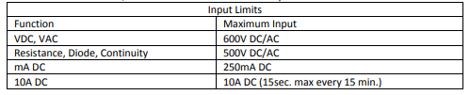
In addition, there is another specification that requires attention.
This means that the voltmeter does not have infinite resistance, but instead looks like a (very large) $10 MΩ$ resistor for DC voltage measurements. This is sufficient when measuring across devices with an effective resistance much smaller (say at least 100 times smaller) than $10 MΩ$, but starts to effect significant figures as the effective resistance of the device-under-test starts to approach this value.

Battery vs Voltmeter Setting
If you can measure the voltage of a battery using the voltmeter, why does the MN35 also provide a separate function for measuring 1.5-volt and 9-volt batteries? First of all, know that 1.5 volts is the nominal voltage of an alkaline battery cell (like AA, C, and D batteries) and that a 9-volt battery is a series combination of 6 such cells. The voltmeter would measure the voltage of the battery while driving current through the effective resistance of the voltmeter ($10 MΩ$ as mentioned in the previous section). Even a weakened battery might provide an open-circuit voltage near its nominal expected value. The MN35 could be assumed to be testing the battery under a small, but significant current draw. The details are not provided in the MN35 documentation but could be derived through a short experiment. That may be an activity for another day!

