Adjustable Smart Cup Base
Project Proposal

Lawrence Cheng
Shengyuan Wang

ECE 445, Senior Design Laboratory
Fall 2026
TA: Zhang Zhuoer
Team 41
Project No.: 41

Abstract
This proposal presents an adjustable smart cup base that attaches to a suitable existing cup or bottle and estimates water consumption from changes in measured mass. The design uses four low-capacity half-bridge load sensors beneath a floating platform, an HX711-type load-cell interface, an ESP32 microcontroller, and an IMU for tilt detection. A small OLED display and simple physical buttons allow the user to set a daily hydration goal and reminder interval. The optional activity feature may provide a coarse Low / Medium / High activity-intensity estimate if time permits; a user-selected reminder interval remains in control until Auto/Reset is selected. The design focuses on practical measurement, rejection of false events caused by lifting or moving the cup, and safe portable operation with a preferred rechargeable power source.

Contents
1. Introduction
1.1 Problem
1.2 Solution
1.3 Visual Aid
1.4 High-Level Requirements
2. Design
2.1 Block Diagram
2.2 Subsystem Overview
2.2.1 Weight Measurement and Mechanical Subsystem
2.2.2 Processing and Intake Detection Subsystem
2.2.3 User Interface and Reminder Subsystem
2.2.4 Motion/IMU Subsystem
2.2.5 Power Subsystem
2.3 Representative Component Options
2.4.1 Weight Measurement and Mechanical Subsystem Requirements
2.4.2 Processing and Intake Detection Subsystem Requirements
2.4.3 User Interface and Reminder Subsystem Requirements
2.4.4 Motion/IMU Subsystem Requirements
2.4.5 Power Subsystem Requirements
2.5 Tolerance Analysis
3. Ethics, Safety and Societal Impact
3.1 Ethics
3.2 Safety
3.3 Standards and Regulatory Considerations
3.4 Societal, Economic, Environmental and Global Impact
References
Appendix A. Requirement and Verification Table

1. Introduction

1.1 Problem
Many people do not drink enough water throughout the day because they forget to drink regularly or have difficulty tracking how much they have consumed. Drinking enough water supports normal body function, and dehydration can negatively affect health and physical functioning [16]. Existing smart bottles require the user to replace an existing cup or bottle, while phone-only reminder systems generally do not know whether water was actually removed from the cup. A portable add-on that works with an existing drinking container could address these limitations while remaining simple to use. The problem is relevant for people who spend long periods studying, working, or exercising and may not notice gradual changes in hydration.
The project is motivated by public-health, human-factors, and practical-use considerations, but the device is intended as a convenience and tracking aid rather than a medical instrument. It should provide feedback without requiring constant manual logging and should continue to function when the cup is lifted, carried, and returned to a surface. A successful design therefore balances measurement sensitivity with mechanical stability, simple user interaction, and portable packaging. The system is intended to estimate water removed from the container and provide reminders, not to diagnose dehydration or prescribe individualized medical intake.

1.2 Solution
We propose an adjustable smart cup base that remains attached to a suitable drinking cup or bottle. The bottle rests on a floating upper platform supported by four low-capacity, three-wire half-bridge load sensors arranged as one weighing bridge and read by an HX711-type load-cell interface. The ESP32 compares accepted stable weights over time: stable decreases are treated as estimated water consumption, stable increases as refills, and negligible or unstable changes are ignored. The target detectable water-change range is approximately 50-300 mL. The mechanical design uses a thin retaining ring to constrain lateral movement and outer support pillars that connect the ring to the lower base outside the load-cell-supported weighing area, so the guide structure is not intended to carry the bottle's vertical load around the sensors.
An IMU provides orientation information for tilt detection and may optionally provide a coarse Low / Medium / High activity-intensity estimate. When the bottle is sufficiently tilted, the display can show "TILTED - RETURN TO NORMAL" and pause acceptance of a new weight until the bottle returns to a normal, stable state. Three simple buttons provide local configuration of the daily goal and reminder interval; Auto/Reset is a menu action rather than a required fourth button. The user can set a daily goal from approximately 1000 to 4000 mL in 200 mL increments and a reminder interval from approximately 10 to 120 minutes. If the optional activity feature is implemented, automatic reminder behavior may use the activity estimate, but a user-selected reminder interval takes priority until Auto/Reset is selected. A compact OLED provides intake, goal, reminder, and status information. An optional buzzer may provide an audible reminder and can be disabled by the user. The overall mechanical arrangement is intended to support a portable, carry-around form factor; additional development effort could reduce size and weight and improve ergonomics while preserving the same basic load path.

1.3 Visual Aid
The visual aid below shows the intended use of the device as a compact attachment for a drinking cup or bottle. It illustrates the retaining ring used for lateral constraint, outer support pillars located outside the weighing area, and a thicker side support that can serve as a convenient carrying grip without contacting the bottle. The refined product appearance used in the concept graphics is a reference for the desired overall form, not a representation of the exact laboratory prototype. The laboratory CAD and fabrication will prioritize demonstrating the weighing and sensing functions; with additional mechanical development and packaging effort, the same overall arrangement could be developed into a more compact, ergonomic portable form.
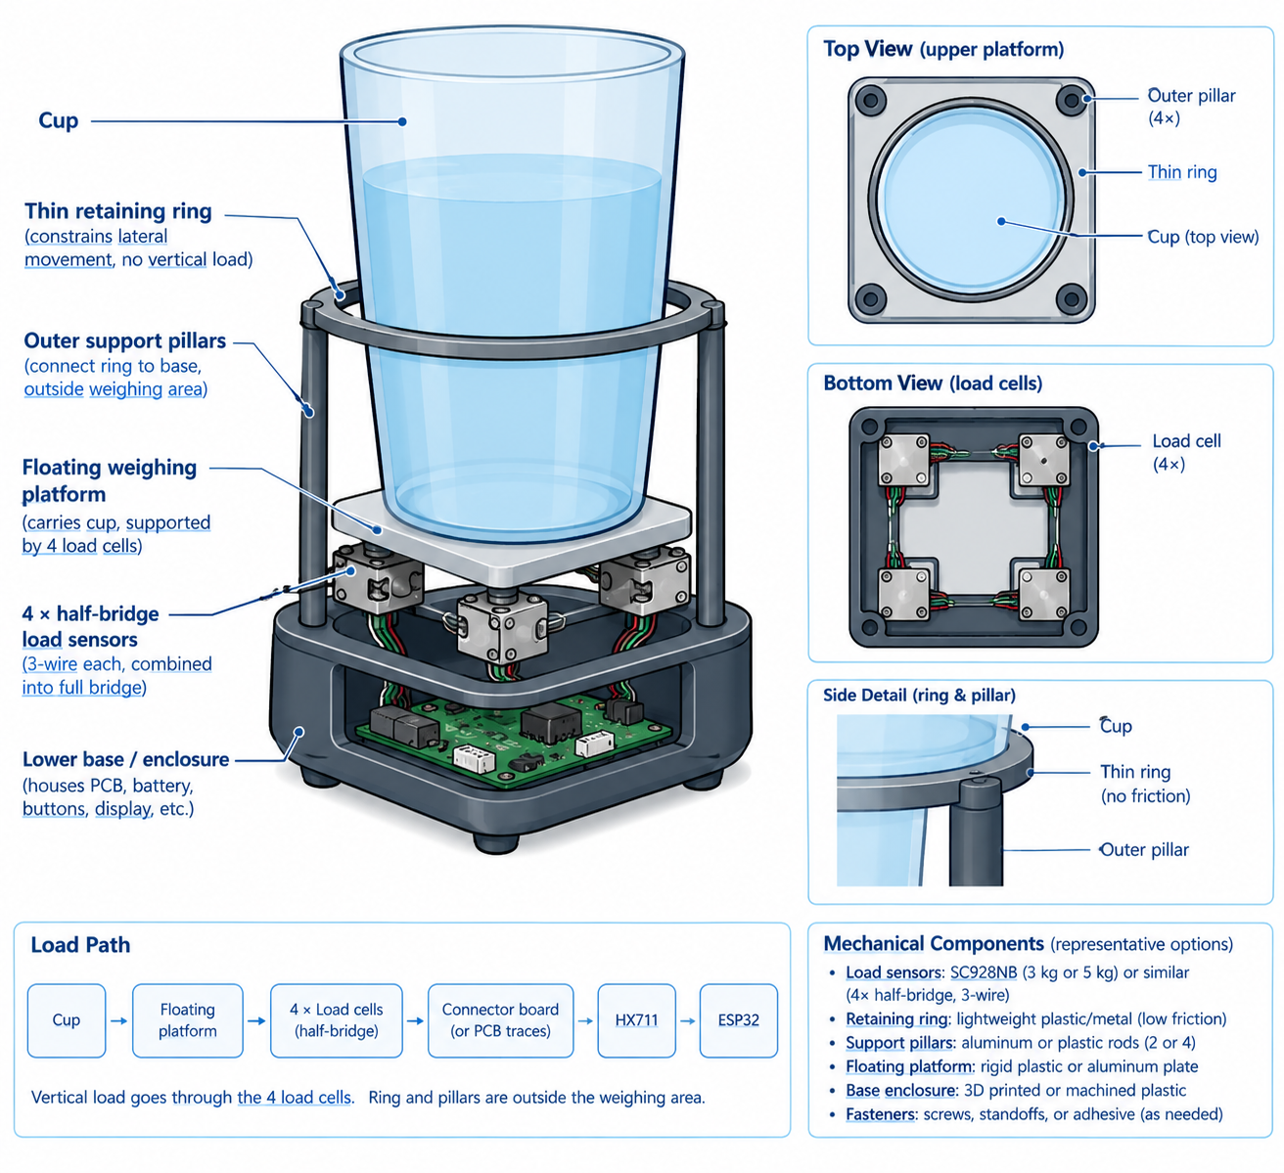
Figure 1. Intended use and high-level mechanical load path for the adjustable smart cup base.

1.4 High-Level Requirements
• The system shall detect stable water-content reductions of approximately 50-300 mL during normal operation and distinguish stable increases as refills; negligible or unstable changes shall not be recorded as consumption.
• The system shall correctly reject at least 80% of lift-and-return or motion-only trials in which no water is intentionally removed, while avoiding acceptance of substantially tilted or unstable measurements as intake.
• The system shall provide local hydration tracking and reminders for at least 3 hours of continuous operation, with a user-selectable daily goal of 1000-4000 mL in 200 mL increments and a reminder interval of approximately 10-120 minutes.

2. Design

2.1 Block Diagram
The design is divided into weight measurement/mechanical, processing/intake detection, user interface/reminder, motion/IMU, and power subsystems. Red connections represent electrical power (3.3 V or 5 V as applicable), green connections represent data or control signals, and blue connections represent mechanical load/support. The HX711 communicates with the ESP32 through its digital serial interface; the IMU and OLED may use I2C; buttons and the optional buzzer use GPIO. The diagram identifies representative interfaces and signal flow while leaving exact component selections and implementation details open to prototype testing.
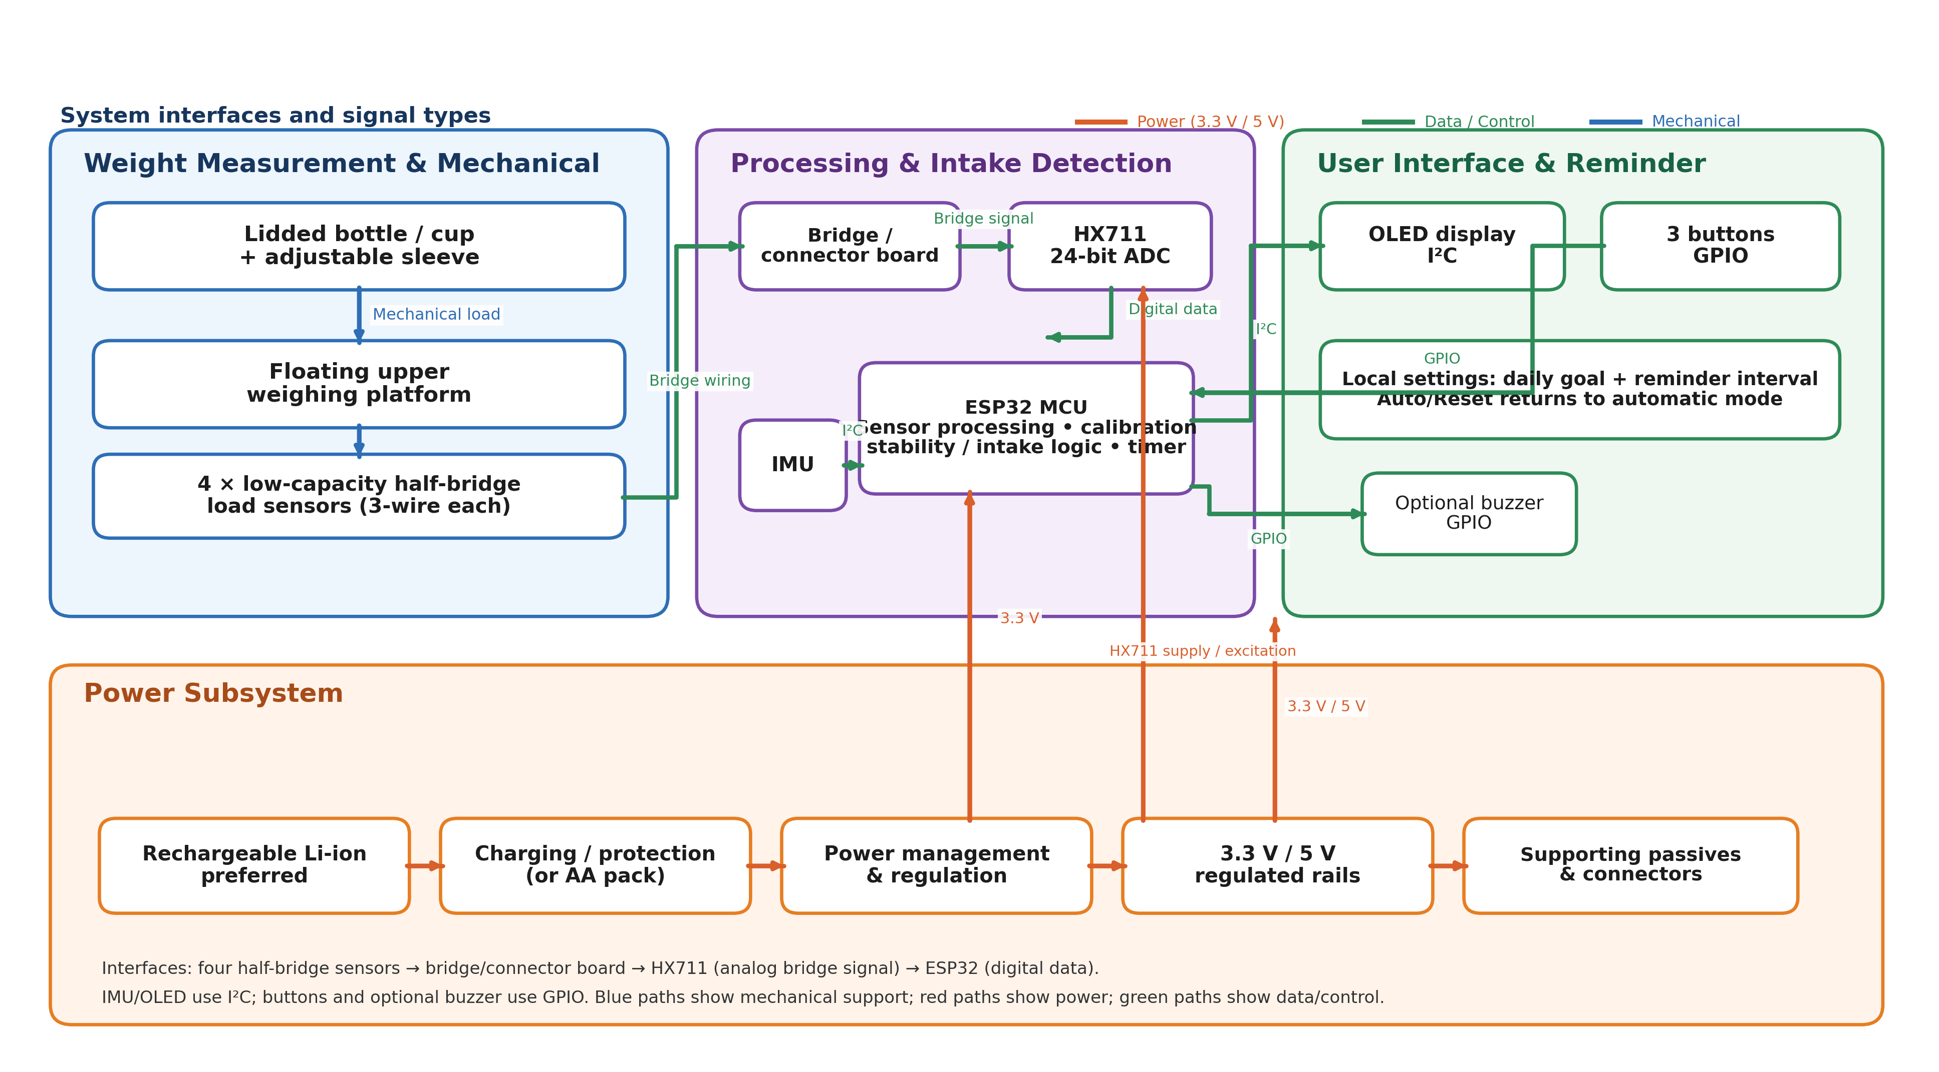
Figure 2. High-level system block diagram of the adjustable smart cup base.

2.2 Subsystem Overview

2.2.1 Weight Measurement and Mechanical Subsystem
The weight subsystem supports the bottle on a floating upper platform. Four low-capacity half-bridge load sensors are positioned beneath the platform so that the intended vertical bottle load is transferred through the sensors. The thin retaining ring constrains lateral cup movement, while outer support pillars connect the ring to the lower base outside the primary load-cell-supported weighing area. These guides are intended to constrain lateral motion without intentionally carrying the bottle's vertical weight around the sensing elements. Candidate sensors include the Sensorcon SC928NB or SC913A in a 3 kg or 5 kg half-bridge version, or similar low-capacity platform sensors. The four sensors are intended to be combined into a single full bridge feeding one HX711-type interface. This subsystem supports the water-change and motion-rejection requirements by providing a stable and repeatable mechanical load path. [1], [2]
The four sensors will be connected through a bridge-combination arrangement appropriate to the selected half-bridge devices so that a single HX711-type interface can be used in the baseline design. The final platform geometry, shallow sensor recesses, mounting details, and guide clearances will be selected after evaluating actual sensor dimensions and prototype behavior. The outer ring and pillars remain outside the principal weighing path so that the bottle load is carried through the four sensing elements.
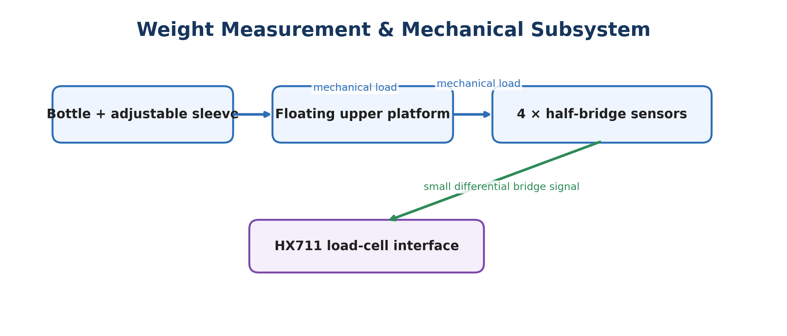
Figure 3. High-level weight-sensing path and mechanical design considerations.

2.2.2 Processing and Intake Detection Subsystem
The HX711 converts the low-level differential bridge signal from the four half-bridge sensors into digital measurements for the ESP32. The ESP32 will apply calibration and basic digital processing to reduce measurement noise and determine when the weight reading is sufficiently stable. Candidate approaches include lightweight methods such as a short moving-average or exponential-smoothing filter or simple outlier rejection, but the exact filter, or whether additional filtering is necessary beyond stability processing, will be determined after reviewing experimental data. The processing is based on changes between accepted stable states rather than instantaneous values. A representative ESP32 module is the ESP32-WROOM-32E family, or similar ESP32 module. The ESP32 may be programmed through the selected development board's USB connection or, where exposed by the hardware, through JTAG. This subsystem supports the measurement and false-event requirements by converting sensor data and determining when a weight state is valid. [3], [4]
Lift-and-return and moving events are handled by state changes. When the bottle is lifted or moved, the load measurement becomes unloaded or unstable and the IMU may indicate motion, so those readings are temporarily ignored. After the bottle is returned to a sufficiently upright and stationary condition, the firmware waits through a configurable stability window and then accepts the new weight. The selected stability window will remain below 10 seconds and will be chosen from measured settling behavior rather than fixed at this proposal stage.
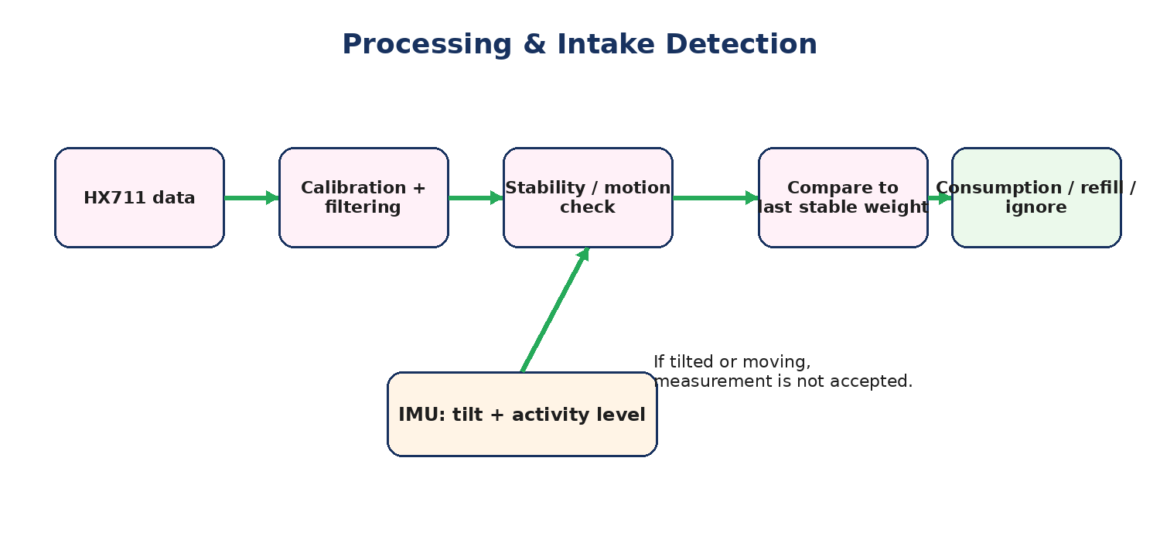
Figure 4. High-level processing and intake-event detection flow.

2.2.3 User Interface and Reminder Subsystem
A small OLED display provides the primary user feedback. A display using the SSD1306 controller, or similar OLED interface, is one representative option. Three simple physical buttons provide a low-complexity menu interface: Menu/Select, Up, and Down. Reset/Auto is a menu action rather than a required fourth button. The user can set a daily goal from approximately 1000 to 4000 mL in 200 mL increments and a reminder interval from approximately 10 to 120 minutes. If the optional activity feature is implemented, a user-selected reminder interval overrides any automatic activity-based adjustment until Reset/Auto is selected. The main screen can show intake, goal progress, next reminder, and status messages such as "TILTED - RETURN TO NORMAL." An optional active buzzer or similar reminder output can provide a short audible alert and can be disabled by the user. This subsystem supports the configuration, status, and reminder portions of the overall design. [5], [6]

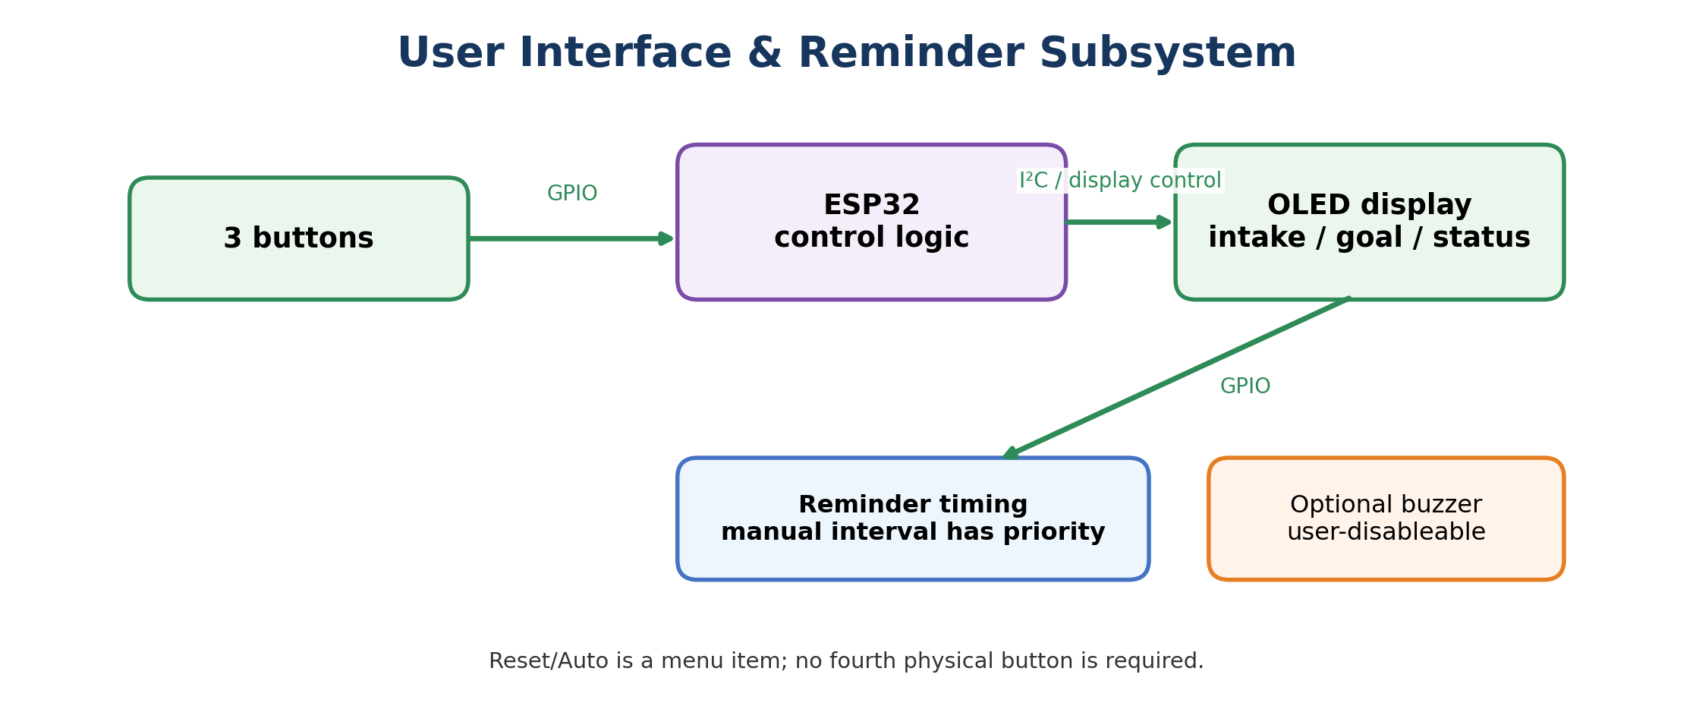
Figure 5. High-level user-interface and reminder flow.

2.2.4 Motion/IMU Subsystem
The IMU provides orientation information for the required tilt-detection function. If implemented as an additional feature, the same sensor can also provide a coarse three-level Low / Medium / High activity-intensity estimate. The design does not require recognition of a specific named activity, and activity estimation is not required for the core weight-tracking or manually selected reminder interval. Representative motion sensors include the Bosch BMA400 accelerometer, Bosch BMI270, TDK ICM-42688-P, or similar devices. [7], [8], [9]
If the optional activity feature is used, the firmware may use recent motion intensity to influence automatic reminder behavior. A manually selected reminder interval remains in force until Reset/Auto is selected. The activity feature is intentionally optional and is an unlikely extension because the core project already combines multi-sensor weighing, motion/tilt detection, local user controls, reminder timing, and power management. Adding activity level estimation would require additional motion-data collection and threshold tuning that could increase development and integration risk without being necessary for the core hydration-tracking function.
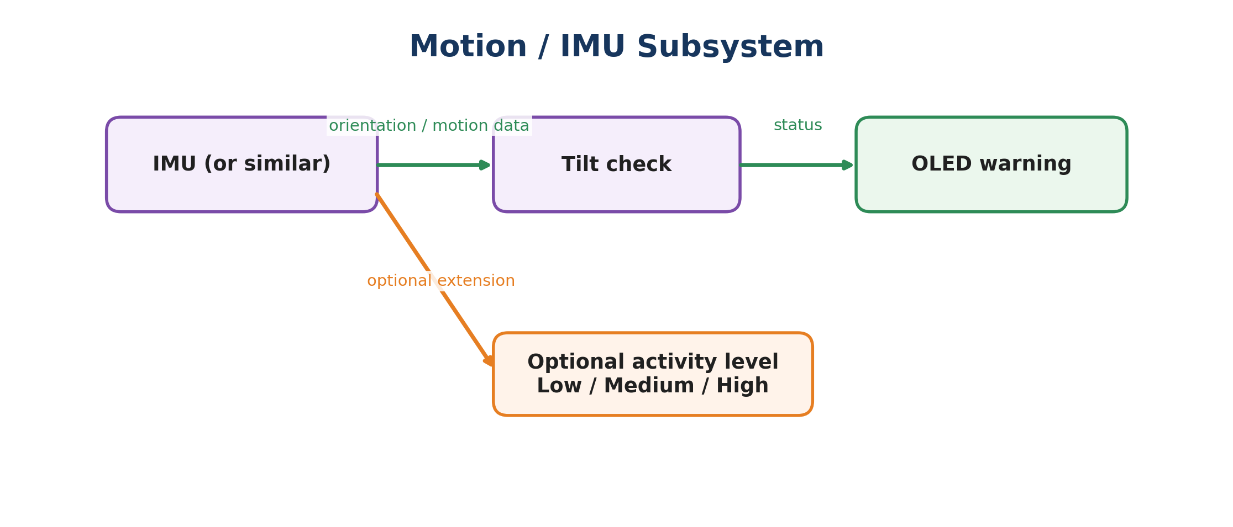
Figure 6. High-level IMU tilt-detection and optional activity-intensity logic.

2.2.5 Power Subsystem
The power subsystem will preferably use a rechargeable battery with USB-C charging and appropriate protection, power management, and regulated supply rails for the electronics. If a rechargeable implementation is not practical for the final packaging or power budget, a suitable removable battery pack, such as an AA-cell pack or similar source, may be used instead, provided the resulting supply is compatible with the electronics. Candidate charger/power-management ICs include the Microchip MCP73831 family or TI BQ24074, or similar, while a low-power regulator such as TI TLV75533PDBVR or similar is one possible regulator choice. Supporting components include resistors for charger configuration, pull-up or bias functions, and indicators; capacitors for IC decoupling, regulator stability, and bulk power filtering; connectors; a power switch; and protection components as required by the selected power source. This subsystem supports the continuous-operation requirement by providing a stable supply and practical portable power. [10], [11], [12]

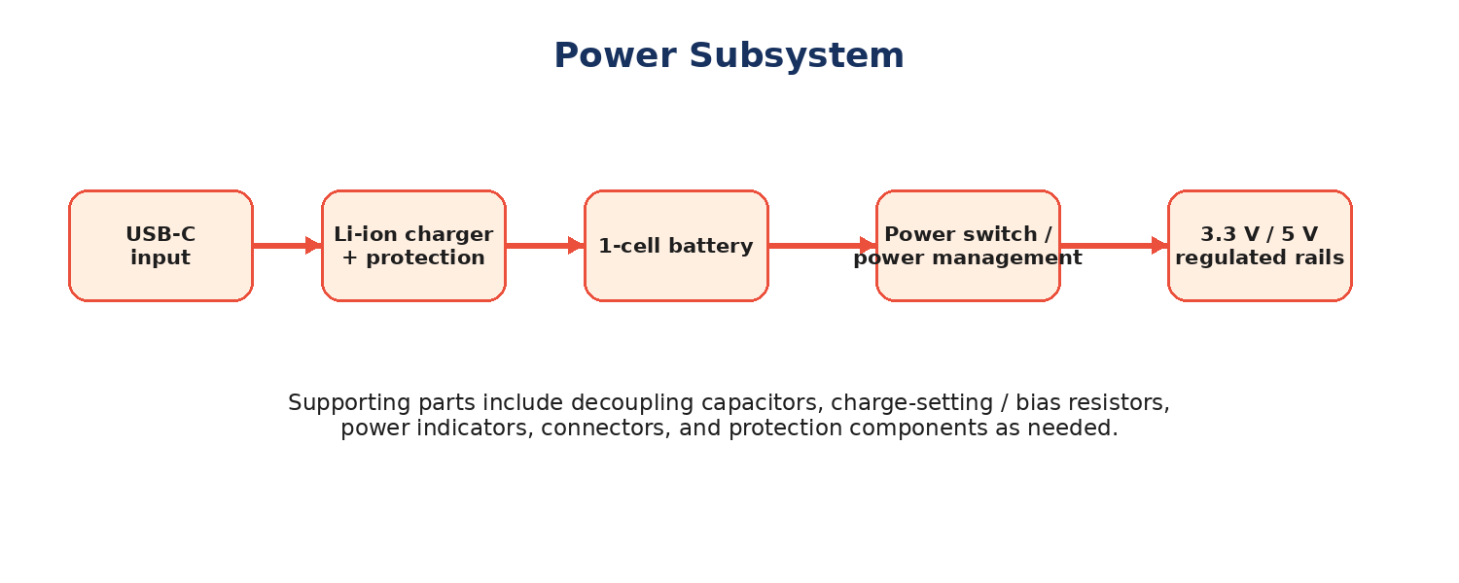
Figure 7. High-level portable power architecture with rechargeable power preferred and alternate battery sources permitted.

2.3 Representative Component Options
The following examples identify practical component families without locking the design to a single vendor or exact part. The final selection will consider availability, package, mechanical fit, electrical compatibility, safety, and prototype results. Representative choices include the listed devices or similar parts with comparable function and interface.
Table 1. Representative Component Options.
Subsystem | Representative options | Role
MCU | ESP32-WROOM-32E or similar ESP32 module | Main MCU, GPIO, I2C/SPI, timing, and firmware
Weight sensing | Sensorcon SC928NB / SC913A, approximately 3 kg or 5 kg, 3-wire half-bridge sets, or similar | Four-sensor platform weighing
Load-cell interface | HX711 or similar load-cell ADC/interface | Bridge signal amplification and analog-to-digital conversion
Motion sensing | Bosch BMA400 accelerometer, Bosch BMI270, TDK ICM-42688-P, or similar | Required tilt sensing; optional activity-intensity sensing
Display | OLED module using SSD1306 controller, or similar | Local intake, settings, reminders, and warnings
Buttons | Omron B3F tactile switches, or similar | Menu, increment, and decrement controls
Reminder | Small active buzzer or piezo element, or similar; optional | Audible reminder output when installed; user-disableable
Power / charging | Microchip MCP73831 family, TI BQ24074, or similar, if rechargeable source is used | Battery charging and power management
Voltage regulation | TI TLV75533PDBVR, or similar 3.3 V regulator | Regulated logic and sensor supply
Battery source | Single-cell Li-ion rechargeable pack, or suitable AA battery pack or similar | Portable energy source
Passives / connectors | Resistors, capacitors, JST-style connectors, or similar | Decoupling, biasing, configuration, external connections, and protection

2.4 Subsystem Requirements

2.4.1 Weight Measurement and Mechanical Subsystem Requirements
• The weighing structure shall support the intended cup and liquid load without an unintended mechanical bypass around the sensing elements.
• The upper platform shall transfer the intended vertical load through the sensing elements while the sleeve or guides primarily constrain lateral motion.
• The assembled platform shall support reference-mass calibration and repeatability testing at more than one cup position.

2.4.2 Processing and Intake Detection Subsystem Requirements
• The processing subsystem shall receive weight and motion/orientation information and maintain the hydration total in firmware.
• The firmware shall apply a repeatable stability criterion before accepting a new weight and shall ignore readings while the cup is substantially tilted or moving; the configurable stability window shall remain below 10 seconds.
• The event detector shall distinguish stable decrease, stable increase, negligible change, and unstable or unloaded conditions.

2.4.3 User Interface and Reminder Subsystem Requirements
• The user interface shall provide a readable local display and a simple set of physical controls for configuring the daily goal and reminder interval.
• The user shall be able to set a daily goal over approximately 1000-4000 mL in 200 mL increments and a reminder interval over approximately 10-120 minutes.
• A user-selected reminder interval shall override any automatic activity-based reminder adjustment until the Reset/Auto menu action is selected.
• A reminder output may be included and, if installed, shall be user-disableable.

2.4.4 Motion/IMU Subsystem Requirements
• The IMU subsystem shall provide orientation information sufficient to detect a substantial tilt condition; a coarse Low / Medium / High activity-intensity estimate may be implemented as an optional extension.
• Tilt status shall be communicated to the user on the display and shall pause acceptance of a new weight until the cup returns to a sufficiently normal orientation.
• The optional activity-intensity feature shall not be necessary for the core weight-tracking function or a manually selected reminder interval.

2.4.5 Power Subsystem Requirements
• The power system shall provide the regulated electrical power needed by the active electronics during normal operation.
• The selected power source shall support at least 3 hours of continuous operation in a representative prototype configuration.
• The selected battery solution shall include appropriate charging and protection when a rechargeable source is used, or suitable input protection for an alternative battery pack, together with a power switch or equivalent user control.

2.5 Tolerance Analysis
A primary feasibility risk is detecting relatively small changes in cup mass while rejecting changes produced by movement. As a first-order example, the Sensorcon SC928NB is available in a 3 kg half-bridge version with a rated output of 0.75 mV/V [1]. At 5 V excitation, this corresponds to about 3.75 mV at the rated load. A 50 g total change distributed approximately evenly across four 3 kg sensors is about 0.42% of each sensor's full-scale load, corresponding to an order-of-magnitude bridge signal of roughly 16 µV per sensor if the response is treated as approximately linear. The HX711 datasheet specifies a typical input noise of about 50 nV RMS at gain 128 and 10 samples/s [4]. This gives substantial nominal signal-to-noise margin at the converter input, indicating that the HX711 is suitable in principle for this measurement range. Actual system accuracy and repeatability will depend more strongly on sensor matching, mechanical load distribution, bridge wiring, calibration, environmental drift, and measured prototype noise.
A second feasibility risk is false event detection after lifting or moving the cup. The proposed state-based detector uses weight stability together with IMU tilt/motion information. A lifted or moving cup produces an unloaded or unstable weight condition, so those readings can be ignored. After the cup returns to a normal orientation and becomes sufficiently stable, the firmware accepts a new measurement and compares it with the previous accepted value. This avoids trying to model the detailed trajectory of the cup during movement.
For power feasibility, the project targets at least three hours of continuous use. The final current draw will be measured after the electronics are selected, and battery capacity will be chosen with reasonable margin. A rechargeable Li-ion source is preferred, while a suitable AA battery pack or similar source remains an alternate implementation. This provides a clear verification test without fixing the project to a particular battery size at the proposal stage.

3. Ethics, Safety and Societal Impact

3.1 Ethics
The main ethical issue is accurately communicating what the device measures. The system estimates water removed from the cup; mass loss cannot distinguish drinking from pouring, spilling, or another intentional removal of liquid. The interface and documentation will describe this limitation rather than presenting the estimate as a medical measurement. This is consistent with the IEEE Code of Ethics emphasis on public safety, realistic technical claims, and disclosure of limitations. [13]
The baseline design operates locally and does not require a user account or cloud service. The project will avoid collecting personal information that is not necessary for the prototype. Technical results will be reported using measured data and clearly identified uncertainties.

3.2 Safety
The principal hardware risks are rechargeable-battery hazards, short circuits, heat, and mechanical failure. The lithium-ion battery will be used with an appropriate charger/protection circuit, insulated wiring, strain relief, and an enclosure that reduces accidental contact with exposed conductors. University of Illinois battery-safety guidance will be followed during laboratory construction, charging, storage, and disposal. [14]
The mechanical assembly will be checked for sharp edges, loose fasteners, unstable cup support, accidental bypass of the load sensors, and exposed conductors. Electronics will be placed to reduce exposure to spilled liquid. The optional buzzer will be kept at a comfortable audible level and will not be required for core operation.

3.3 Standards and Regulatory Considerations
IEC 62133-2:2017+A1:2021 is a relevant safety standard for portable sealed rechargeable lithium systems and will be used as a reference for battery-related design and handling considerations. [15] Because this is an academic prototype rather than a commercial product, additional production, transportation, electromagnetic compatibility, and certification requirements would depend on any future commercialization. At the prototype stage, the team will follow University of Illinois laboratory policies and manufacturer handling instructions for batteries, electronics, and soldering.

3.4 Societal, Economic, Environmental and Global Impact
The project is intended to improve convenience by adapting to an existing cup rather than requiring a dedicated smart bottle. Reusing an existing container may reduce the need to purchase another drinking vessel, while the local embedded design can provide useful feedback without requiring a cloud-connected system. The concept may also be useful in settings where continuous phone connectivity is undesirable or unavailable.
Environmental considerations include the use of a rechargeable battery and a 3D-printed mechanical enclosure. Reusable hardware can avoid some disposable accessories, while battery replacement and end-of-life recycling remain considerations. Illinois provides a process for battery disposal and recycling on campus. [14]
The concept is intended to be broadly applicable across different users and cup types, but activity-based reminders and water-consumption estimates should not be interpreted as universal medical recommendations. Differences in climate, exercise, diet, age, and individual needs mean that user-selected settings remain important.

References
[1] Sensor and Control Co., “SC928NB Half-Bridge Micro Load Cell,” product page and datasheet. SC928NB product page; SC928NB datasheet
[2] Sensor and Control Co., “SC913A Half-Bridge Micro Load Cell,” product page. SC913A product page
[3] Espressif Systems, “ESP32-WROOM-32E & ESP32-WROOM-32UE Datasheet,” v2.1. ESP32-WROOM-32E datasheet
[4] Avia Semiconductor, “HX711 24-Bit Analog-to-Digital Converter for Weigh Scales,” datasheet. HX711 datasheet
[5] Solomon Systech, “SSD1306 128 x 64 Dot Matrix OLED/PLED Controller,” product documentation. SSD1306 documentation
[6] OMRON, “B3F Tactile Switch,” product documentation. B3F datasheet
[7] Bosch Sensortec, “BMA400 Ultra-Low Power Accelerometer,” product page. BMA400 product page
[8] Bosch Sensortec, “BMI270 Inertial Measurement Unit,” datasheet. BMI270 datasheet
[9] TDK InvenSense, “ICM-42688-P High Precision 6-Axis MEMS MotionTracking Device,” product page. ICM-42688-P product page
[10] Microchip Technology, “MCP73831 Single-Cell Li-Ion/Li-Polymer Charge Management Controller.” MCP73831 product page
[11] Texas Instruments, “BQ24074 Standalone 1-Cell 1.5-A Linear Battery Charger with PowerPath.” BQ24074 product page
[12] Texas Instruments, “TLV755P 500-mA Low-IQ Low-Dropout Regulator,” part details for TLV75533PDBVR. TLV75533PDBVR product page
[13] IEEE, “IEEE Code of Ethics.” IEEE Code of Ethics
[14] University of Illinois Division of Research Safety, “Battery Safety,” updated June 29, 2026. Illinois Battery Safety
[15] International Electrotechnical Commission, “IEC 62133-2:2017+A1:2021, Secondary cells and batteries containing alkaline or other non-acid electrolytes - Safety requirements for portable sealed secondary cells and batteries for use in portable applications - Part 2: Lithium systems,” 2021. IEC 62133-2:2017+A1:2021
[16] Centers for Disease Control and Prevention, “About Water and Healthier Drinks,” Mar. 5, 2026. CDC Water and Healthier Drinks

Appendix A. Requirement and Verification Table
Table 2. Requirement and Verification Table.
Requirement | Target | Verification Method | Status
1. Water-change detection | Detect stable water reductions of approximately 50-300 mL. | Use reference masses representing changes across the range; compare accepted readings with the known change. | Planned
2. False-event rejection | Reject at least 80% of lift-and-return and motion-only trials with no water removed. | Repeat lift, carry, and motion tests; calculate the fraction correctly ignored. | Planned
3. Operation and configuration | Operate for at least 3 h while supporting a 1000-4000 mL daily goal in 200 mL increments and a 10-120 min reminder interval. | Battery discharge test plus interface tests at minimum, middle, and maximum settings. | Planned
Weight subsystem | Four half-bridge sensors; calibrated platform; lateral guides without intended vertical bypass. | Mechanical inspection, reference masses at multiple positions, and repeatability measurements. | Planned
Processing subsystem | Configurable stability window below 10 s; tilt/motion gating; stable decrease/increase logic. | Firmware tests with controlled lifting, movement, refill, and consumption events. | Planned
UI subsystem | OLED plus simple three-button interface; manual interval overrides automatic behavior until Reset/Auto. | Human-operated menu test across settings and override/reset scenarios. | Planned
Motion/IMU subsystem (activity feature optional) | Tilt detection required; optional Low / Medium / High activity-intensity estimate. | Controlled tilt and repeatable motion conditions if the extension is implemented. | Planned
Power subsystem | At least 3 h continuous operation with normal functions active. | Full-charge runtime measurement and load-current logging. | Planned

Appendix B. Detailed Mechanical Visual Aid
The following concept illustration provides additional detail on the portable bottle enclosure, retaining ring, outer support pillars, floating weighing platform, and four-sensor arrangement. It is included as a supplementary mechanical visual aid. The refined appearance is a reference for the desired overall form and carrying concept, not a representation of the exact laboratory prototype; final geometry, packaging, and ergonomics will be refined through prototyping.
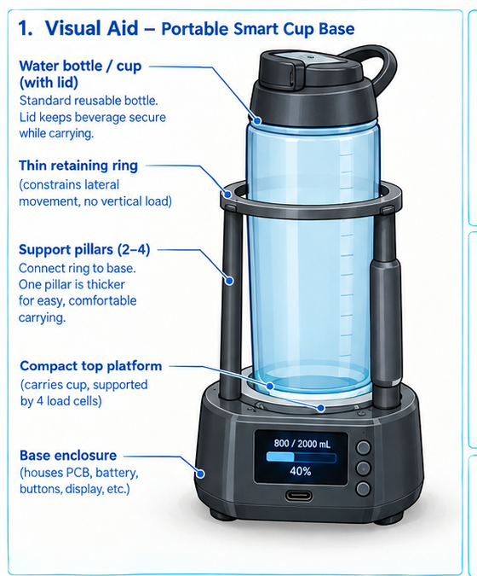
Figure B1. Supplementary mechanical concept showing the lidded portable bottle, thin retaining ring, outer support pillars, floating platform, and four half-bridge load sensors.

Appendix C. Full Project Poster-Style Design Graphic
Figure C1. Full poster-style overview of the proposed smart cup base, including the mechanical concept, user interface, system architecture, subsystem relationships, requirements, and optional extensions.
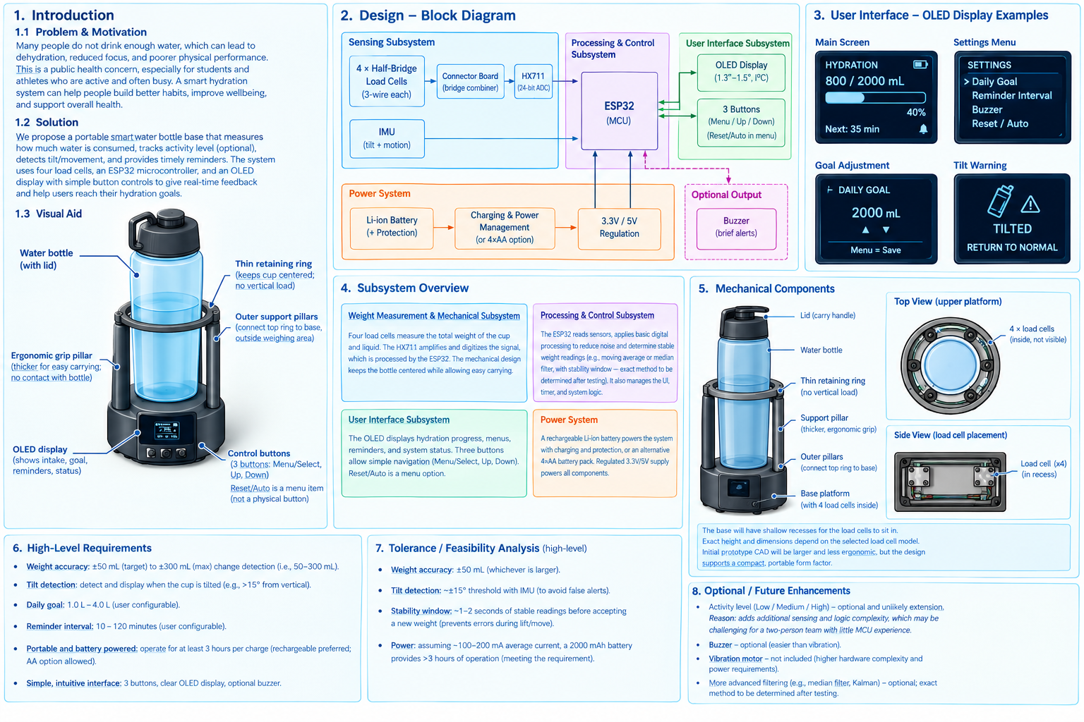
This poster is a supplementary design visualization; the proposal text and requirements remain authoritative.

