Adjustable Smart Cup Base
  - Design Review Document
Lawrence Cheng lrcheng2
Shengyuan Wang sw110
Team 41
ECE 445 Senior Design Laboratory
Fall 2026
TA Zhang Zhuoer
2 October 2026
We will build a desk base that estimates water removed from an existing bottle using four SC928NB half-bridge load cells, a custom HX711 interface, an ESP32-S3 controller, a local OLED and three buttons, and rechargeable power. The bottle lifts out of the base. The display and buttons sit outside the base on separate boards. Core verification uses calibrated blocks for mass changes and bottles for mechanical fit and lifting. Tilt sensing is optional.
The controller, POWER and HX711 boards were submitted on September 30 for the first PCB round. The HX711 will receive the 3.3 V assembly changes in Section 2.4. Requirements describe the completed prototype; bench results will follow assembly.

1 Introduction

1.1 Problem and solution
People can overlook drinking water while working or studying. Water supports normal body function [1], but a reminder timer does not establish whether water has left a bottle. Our reusable desk base accepts bottles of different diameters and estimates removed water from settled mass changes. A local display shows the removed-volume estimate, goal and reminder interval without a phone or cloud service.
The design combines a floating weighing platform, a adjustable guide ring, four small half bridges, team-assembled analog and controller boards, and a rechargeable power PCB. The ring constrains lateral motion while the load cells carry the vertical load. Stable decreases accumulate; increases are classified as refills. A pour or spill also reduces mass, so the display says “REMOVED EST” rather than claiming confirmed consumption. The device is a convenience aid, not a medical instrument.
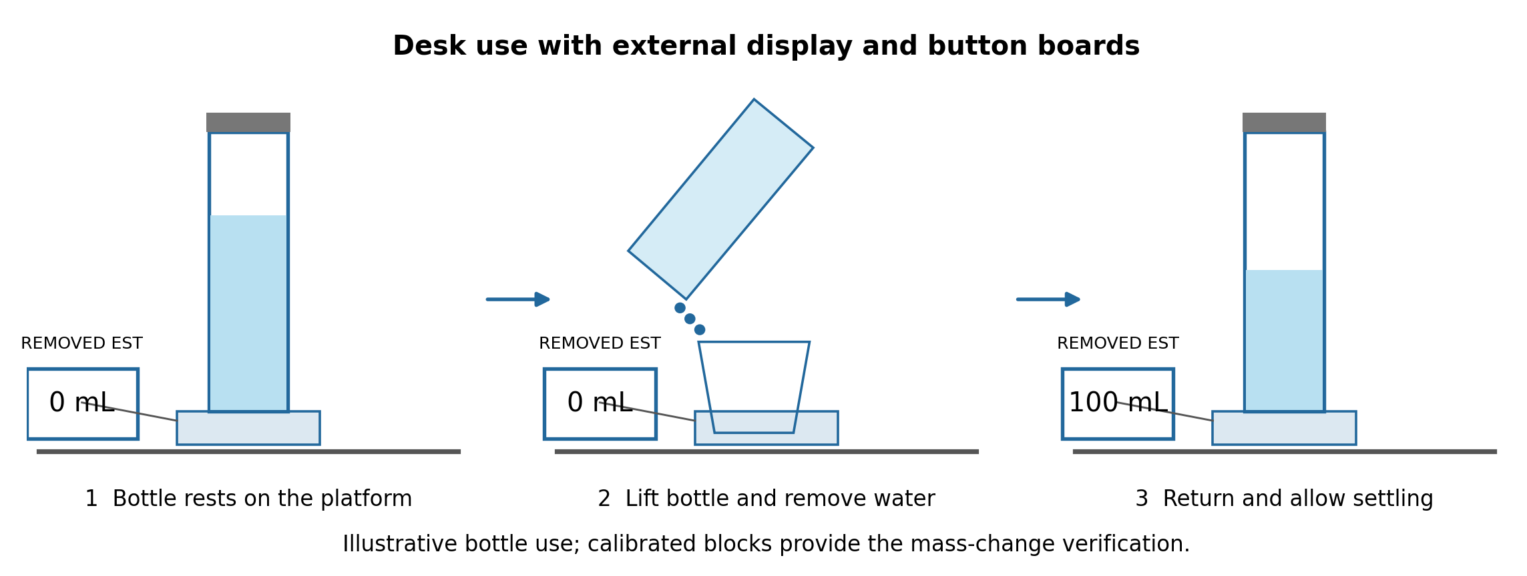
Figure 1. Intended desk use with external display and button boards. The bottle is lifted and returned; the base stays on the desk. Display values are illustrative. Verification uses calibrated blocks.

1.2 High level requirements
- HL1. At a gross supported load of 1.00–3.00 kg before and after removal, the system shall estimate 50–300 g mass removals within ±50 g in at least 18 of 24 trials, including at least four successes among six trials at each nominal 50, 100, 200 and 300 g size. A passing trial commits an estimate ≥30 g. The display reports water-equivalent volume using 1 g ≈1 mL.
- HL2. The system shall produce no false removal event in at least 16 of 20 unchanged-mass fixture trials: ten lifts ≥50 mm for 2–5 s and ten lateral movements of 10–20 mm. Five settled 100 g additions shall all be classified as refills without increasing the removed-volume total.
- HL3. The battery-powered system shall operate for at least 120 minutes without resetting or losing its running total, and display an accepted event within 2 s of STABLE in at least five of six timing trials. Goal and reminder settings shall be adjustable through the three-button interface as verified in UI1.

2 Design

2.1 Architecture and interfaces
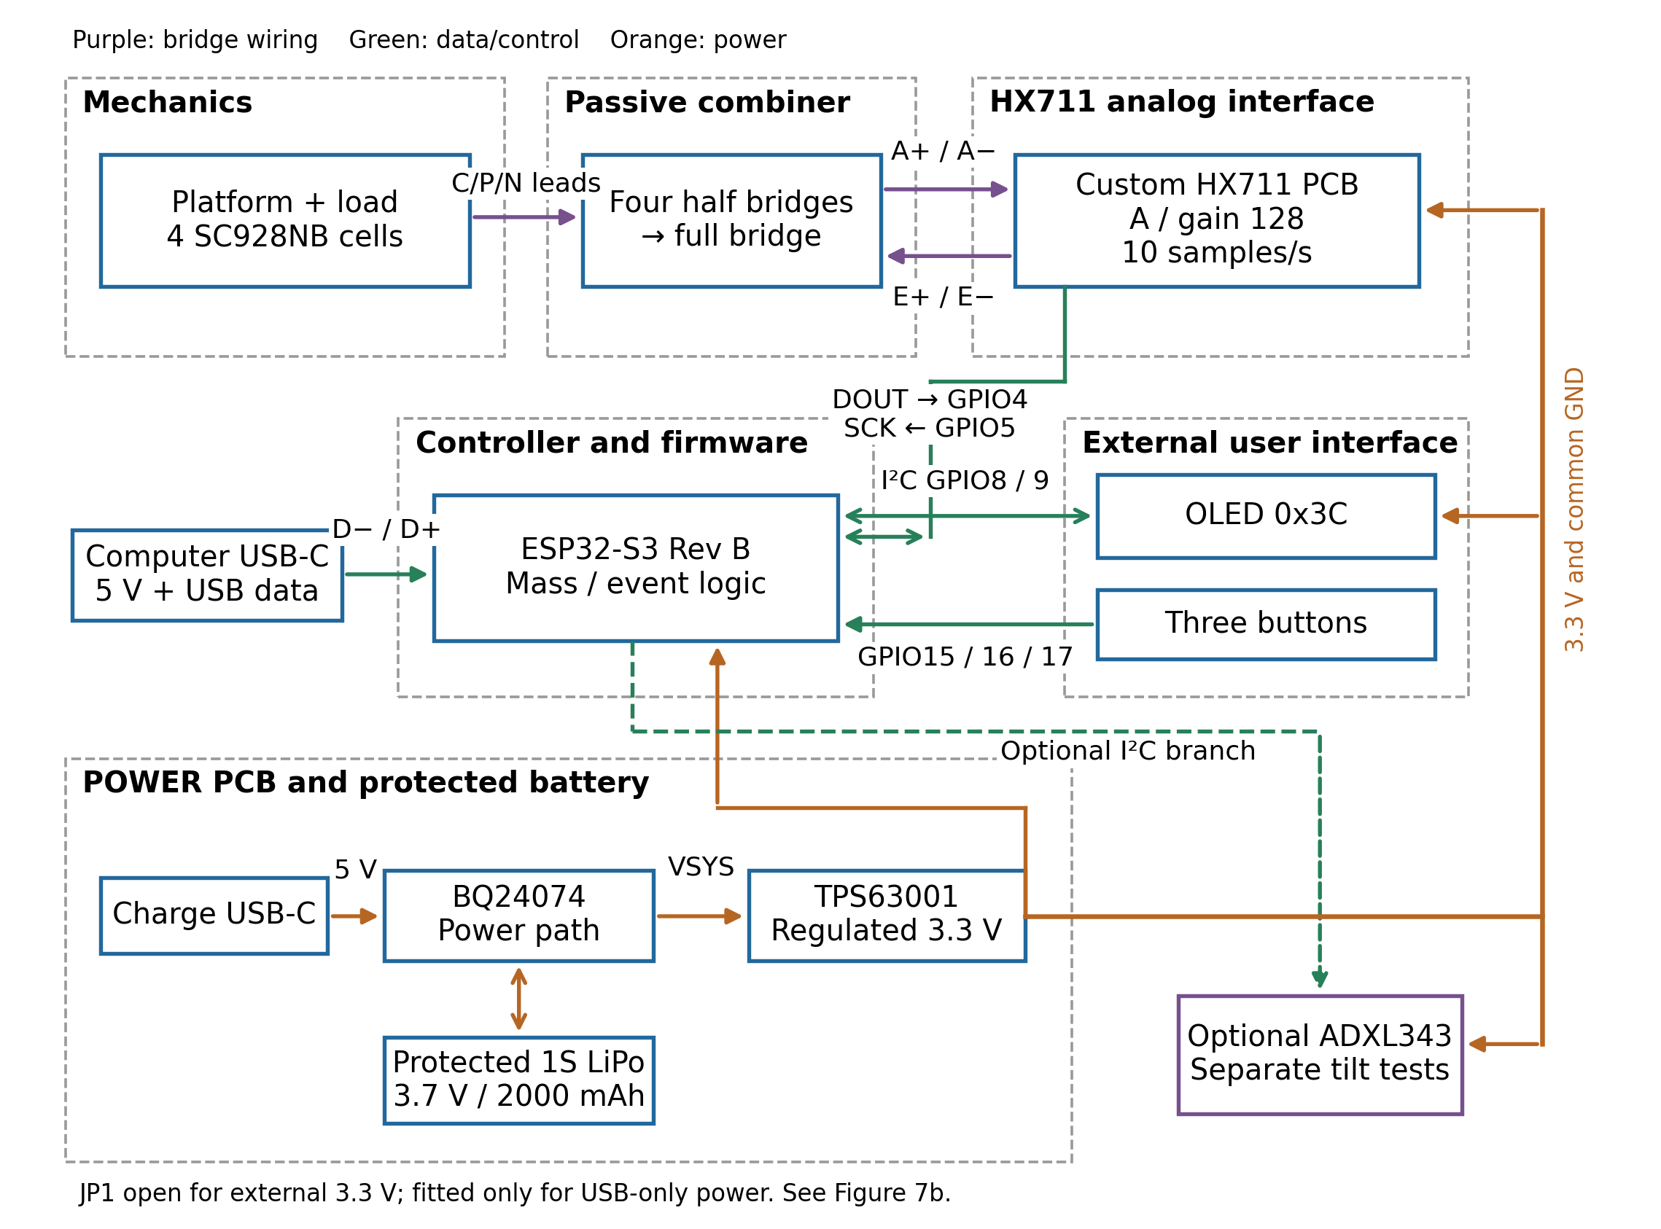
Figure 2. Modular architecture with separate mechanics, combiner, HX711, controller, power and external user interface. Purple paths are bridge wiring, green data/control and orange power. Tilt remains optional and does not gate core mass events.
The four half bridges form one differential bridge through a passive combiner. The HX711 reads channel A at gain 128 and nominal 10 samples/s. The ESP32 stores successive settled masses, classifies their differences, updates the OLED and handles buttons. The BQ24074 charges a protected cell and supplies the TPS63001, which powers the electronics at 3.3 V [2]–[7].
Table 1. Defined board interfaces. ESP, POWER and HX prefixes distinguish references on separate boards.
Interface | Signal | Connection
POWER → ESP | 3.3 V/GND | ESP J2 pin 2 = +3V3; pin 1 = GND. Strain-relieved output cable; JP1 open.
Bridge ↔ HX | E+/E− and A+/A− | HX K1: 1 shield/GND, 2 A+, 3 A−, 4 E−/GND, 5 E+. E+ is analog 3.3 V; differential return is INA+/INA−. Confirm continuity before attaching the harness.
HX ↔ ESP | 3.3 V logic | HX K3: 1 SCK, 2 DOUT, 3 VCC, 4 GND. ESP GPIO5 drives SCK; GPIO4 reads DOUT.
OLED ↔ ESP | 100 kHz I²C | GPIO8 SDA; GPIO9 SCL; address 0x3C; 3.3 V supply. One effective pull-up pair to 3.3 V.
Buttons → ESP | Active-low GPIO | GPIO15/16/17; buttons close to GND; internal pull-ups; 30 ms debounce.
Computer ↔ ESP | USB 5 V and data | Native D−/D+ on GPIO19/20. Fit JP1 only for USB-only power with external 3.3 V disconnected.
ADXL ↔ ESP | Optional 100 kHz I²C | GPIO8/9, address 0x53, 3.3 V/GND; separate carrier and tests.

2.2 Test conditions and measurement definitions
Core weighing tests use calibrated blocks on a load fixture, a bench within ±2° of level, 20–25 °C room temperature, and the load center within 25 mm of platform center. A reference balance with ≤1 g resolution verifies each nominal 50/100/200/300 g test mass within ±2 g; record the actual mass and stated uncertainty ≤2 g. Bottles are tested separately for fit and lifting. No bench results have been collected.
At 10 samples/s, apply a five-sample median filter. STABLE requires at least 40 valid filtered samples in a continuous 5 s window with maximum minus minimum ≤20 g; use the median of that window as its plateau mass. Invalid or saturated conversions restart the window. Differences below 30 g are ignored. A decrease of 30–350 g is removal; an increase of 30–350 g is refill. A magnitude above 350 g is flagged OUT OF RANGE and updates the baseline without accumulating removal. Each accepted plateau commits at most once. Firmware reports water-equivalent mL using 1 g ≈1 mL; room-temperature water density is about 0.998 g/mL [8]. Core tests establish mass accuracy.

2.3 Mechanical subsystem and bridge combiner
Inputs are bottle load and bridge excitation; outputs are force at the four cells and A+/A− to the HX711. This subsystem supports HL1 and HL2 by preventing a parallel load path through the fixed frame. A 140 ×140 mm floating platform rests on four retained SC928NB seats at the corners of a 100 ×100 mm square inside a 180 ×180 mm base. Platform/base widths and seat spacing have ±1 mm fabrication tolerance. The guide lower edge is 120 ±10 mm above the platform.
Two C-shaped guides slide along the inner ring on close-fit tabs and retain their setting lightly. They fit the two demonstration bottle sizes in MECH1 with a minimum 0.2 mm gap at the checked locations. The bottle lifts vertically without clamping or vertical support from the guides; the platform carries its weight. A print-fit coupon selects the slide tolerance. If tabs cannot retain the setting, lightly retained rods through the upper ring replace the adjustment mechanism. Sensor cradles retain cell bodies without drilling or clamping their flexures [2].
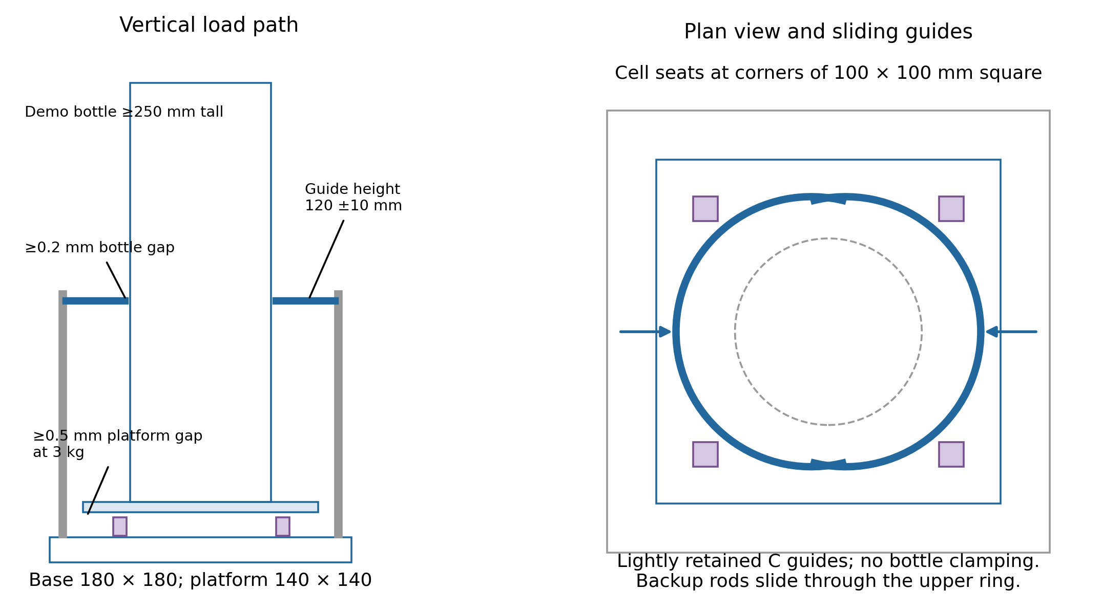
Figure 3. Mechanical concept with dimensions in millimetres. At least one demonstration bottle is ≥250 mm tall. The platform carries the vertical load; sliding guides retain clearance. Final seat profiles follow the delivered SC928NB drawing.
Table 2. Mechanical requirements and verification.
ID | Requirement | Verification and pass criterion
MECH1 | Two bottles with measured diameters 60–65 and 95–100 mm shall fit; at least one shall be ≥250 mm tall. A 0.2 mm strip shall pass at four guide locations on each bottle; adjustment shall shift ≤2 mm after ten lifts per bottle. | Measure each bottle diameter/height. At each adjusted setting, pass the strip vertically at four directions; require all eight checks and ten unobstructed lift/return cycles per bottle. Mark and remeasure guides; require ≤2 mm shift.
MECH2 | At a 3 kg centered load, platform clearance from the fixed frame and stops shall be ≥0.5 mm at four sides. Each cell shall produce a positive calibrated response ≥20 g in at least two of three placements of 100 ±2 g above its seat; ≥10/12 placements shall pass overall. | Hold 3 kg for 60 s and check four gaps with a 0.5 mm gauge. Apply/remove the reference mass three times above each cell after settling; pass ≥10/12 correctly signed responses ≥20 g, with at least two passes per cell.
MECH3 | The combiner shall match Figure 4 with no short between E+ and E−, and shall produce a positive ≥30 g estimate for a central 50 ±2 g step in ≥4/6 trials without ADC saturation. | Unpowered DMM: record each resistance half and confirm the four joined pairs. Sum the two elements in each Figure 4 leg; expected E+–E− resistance is (upper-left + lower-left) in parallel with (upper-right + lower-right). Require measured input resistance within ±10% of this calculation. Apply/remove 50 ±2 g six times; pass ≥4/6 positive estimates ≥30 g with no saturated ADC code.
MECH4 | Base and platform widths and seat spacing shall match their stated dimensions within ±1 mm; ring height shall be 120 ±10 mm. | Measure both base/platform axes and adjacent cell-seat spacings with calipers; measure ring height from the platform with a ruler. Record each value; all must satisfy its tolerance.
Number cells 1–4 around the platform. C is each midpoint lead; P is the outer lead whose resistance to C increases under the intended load, and N is the decreasing-resistance lead. Identify these by measurement rather than wire color. Connect C1=E+, C3=E−, C4=A+, C2=A−; join P1–P2, N2–N3, P3–P4 and N4–N1. Each bridge leg contains two gauge elements. The combiner uses four three-wire solder-pad inputs and one four-wire solder-pad output with strain relief, so no detachable input connectors are required.
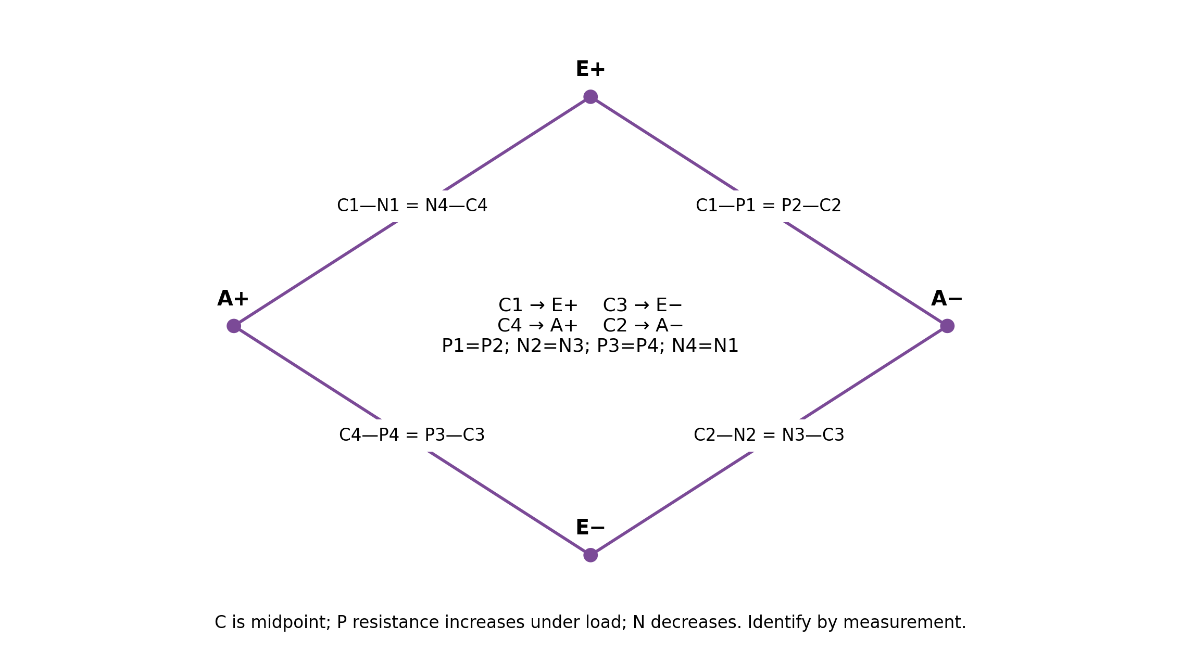
Figure 4. Exact combiner wiring. Each labelled branch contains two resistive elements; joined outer leads are shown by “=”.

2.4 HX711 analog subsystem
Inputs are regulated 3.3 V and bridge A+/A−; outputs are signed 24-bit DOUT samples clocked by PD_SCK. The bare SOP-16 HX711 and team-assembled board support HL1. RATE is grounded for nominal 10 samples/s. Firmware uses 25 clocks per conversion to select channel A at gain 128, keeps clock-high pulses within 1–10 µs, and rejects codes 0x800000 and 0x7FFFFF as saturated [3].
The submitted HX711 layout is not yet the finished 3.3 V assembly. Its 20 kΩ/8.2 kΩ feedback divider requests approximately 4.30 V. We will use the external-supply configuration instead: omit Q1 and R3; jumper Q1 pads 2–3 while leaving pad 1 open; populate R4 and R5 with 0 Ω. This supplies VSUP, DVDD, AVDD and E+ from 3.3 V, grounds VFB, and leaves BASE open. Retain supply bypass capacitors. Figure 10 shows the first-round circuit and the explicit rework locations; the main system has one selected 3.3 V configuration [3], [9].
Table 3. Analog requirements and verification.
ID | Requirement | Verification and pass criterion
ADC1 | The controller shall receive ≥480 valid samples in 60 s at nominal 10 samples/s. Valid means DOUT-ready, a complete 24-bit read with 25 clocks, and a nonsaturated code. | Use a logic analyzer on DOUT/SCK and a timestamped serial log during a stationary load. Count samples, inspect pulse timing, and confirm no DOUT stall >2 s. Pass ≥480 valid samples.
ADC2 | At 1, 2 and 3 kg stationary loads, the filtered stream shall reach STABLE within 30 s in at least two of three placements at each load. | For each load, place the dry fixture centrally three times. Log filtered samples and first STABLE time. Pass ≥2/3 per load using the defined 20 g/5 s criterion. Also report 30 s peak-to-peak noise as a diagnostic, without a separate accuracy claim.
ADC3 | AVDD, DVDD and E+ shall be 3.1–3.5 V; both INA inputs shall lie between AGND+1.2 V and AVDD−1.3 V at gross loads of 1, 2 and 3 kg. | After unpowered rework continuity checks, measure supplies and INA+/INA− with a DMM at all three loads. Check DOUT/SCK with a scope; pass stated limits and no saturated plateau.

2.5 Controller subsystem
The ESP32-S3-WROOM-1-N16 module receives HX711 samples and button inputs, drives the OLED, and implements the event state machine for all three high-level requirements. The Rev B board provides native USB and exposed GPIO headers. Its USB-only supply uses LD1117, a 22 µF ceramic output capacitor and C6 10 µF tantalum. JP1 is a 0603 zero-ohm link, not a switch: fitted for USB-only operation; open when the external power PCB supplies 3.3 V. The two regulator outputs must never be paralleled. Figure 7b shows the two power modes; Figures 8–9 show the supplied schematic and layout [4], [10], [11].
Table 4. Controller requirements and verification.
ID | Requirement | Verification and pass criterion
CTRL1 | With JP1 fitted and external power absent, USB shall enumerate, flash/verify firmware and boot in three consecutive cold starts. | Use a data-capable C-to-C cable and laptop. Disconnect/reconnect three times; save enumeration, flash verification and boot messages. Pass all three.
CTRL2 | With JP1 open and USB power absent, external 3.3 V shall boot the controller three times without reset loops; after the initial power-on ramp, J2 pins 2/1 shall remain at 3.1–3.5 V. | Check the open link and polarity with an unpowered DMM. Use a current-limited source and scope the final harness during three boots; pass all three and the rail limits.
CTRL3 | GPIO4/5, GPIO8/9 and GPIO15/16/17 shall operate with all peripheral headers loaded; USB enumeration and flash from CTRL1 shall still succeed. | Connect final HX711, OLED and buttons. Log ADC reads, an I²C screen update, and one recognized press per button. In USB-only power mode, repeat one enumerate/flash/boot cycle with peripherals connected; pass every listed operation.

2.6 Power subsystem
Inputs are USB 5 V and a protected Adafruit 2011 1S 2000 mAh LiPo; output is regulated 3.3 V to all loads. BQ24074 provides charging and power-path management; TPS63001 supplies 3.3 V through a 2.2 µH SRN4018 inductor. R_ISET=2.21 kΩ sets nominal fast charge near 0.403 A, with the configuration checked against a 0.450 A limit. EN1=GND and EN2=VSYS select the resistor-programmed input limit: R4=3.16 kΩ gives about 0.51 A. R5=3.16 kΩ gives about 43 mA termination; R7=49.9 kΩ sets nominal 6.65 h fast-charge and 40 min precharge timers. The power switch controls converter EN. A thermistor is electrically insulated and coupled to the battery pouch; the board-mounted thermistor position alone does not monitor pack temperature [5]–[7]. Figures 6–7 identify the charger, converter, battery socket and output connection.
The first-round POWER board has no dedicated output connector. We will attach a strain-relieved two-wire cable at the converter 3.3 V output node and ground return. Bring-up uses a bench source and electronic load before connecting the battery. USB charging and controller programming use separate ports; JP1 isolates the controller USB regulator in battery mode.
Battery operation avoids a desk charging cable during use. A planning estimate is 2.5 h from 3.7 V × 2.0 Ah × 70% usable capacity × 80% conversion efficiency ÷ (3.3 V × 0.50 A average load). These are design assumptions; PWR2 verifies the required 120 min with the assembled system [6], [7].
Table 5. Power requirements and verification.
ID | Requirement | Verification and pass criterion
PWR1 | The converter shall maintain 3.1–3.5 V with ≤150 mV peak-to-peak ripple at 100 and 500 mA for simulated cell inputs of 3.3, 3.7 and 4.1 V. | Cell disconnected: apply all six input/load combinations for 60 s using a current-limited source and electronic load. Measure DMM voltage and scope ripple with a ground spring and 20 MHz bandwidth limit; pass all six.
PWR2 | The battery-powered assembly shall run ≥120 min without reset or loss of the total, with the system rail at 3.1–3.5 V. | Start with a 2.00 ±0.03 kg dry fixture after approved charging and one accepted removal; record the initial total and disconnect USB. Run OLED/HX711 continuously for 120 min. At 30/60/90/120 min remove one verified 100 ±2 g block; log pack/rail voltage, accepted commits and total. Pass with no reset, rail limits met, and displayed total equal to the initial total plus the sum of logged accepted commits at 120 min.
PWR3 | The assembled ISET/thermistor network shall limit fast charge to ≤450 mA, inhibit charging at −5/55 °C thermistor equivalents, and enable charging at 25 °C. Battery polarity shall match BAT/GND. | Before using a cell, connect a battery simulator and resistance decade box using the selected NTC curve. Test each temperature equivalent for 30 s; cold/hot current <5 mA, 25 °C charging ≤450 mA. Check connector polarity with a DMM and record TA safety review.

2.7 Firmware and user interface
Firmware receives HX711 samples, button presses and timer ticks; it outputs event classifications, the running total and OLED states. Calibration uses an empty-platform tare and a 2000 ±2 g reference load, recording a 5 s stable median at each point. Grams equal (raw counts − tare counts) × 2000/(loaded counts − tare counts). Store tare and scale in ESP32 nonvolatile storage; check separate 1 and 3 kg loads through ADC2/FW4. Readings <200 g or unsettled readings freeze total and baseline. Settled decreases add to the total and restart the reminder; refills update baseline only. Subthreshold changes preserve baseline until their cumulative magnitude reaches 30 g. Figure 5 defines the flow.
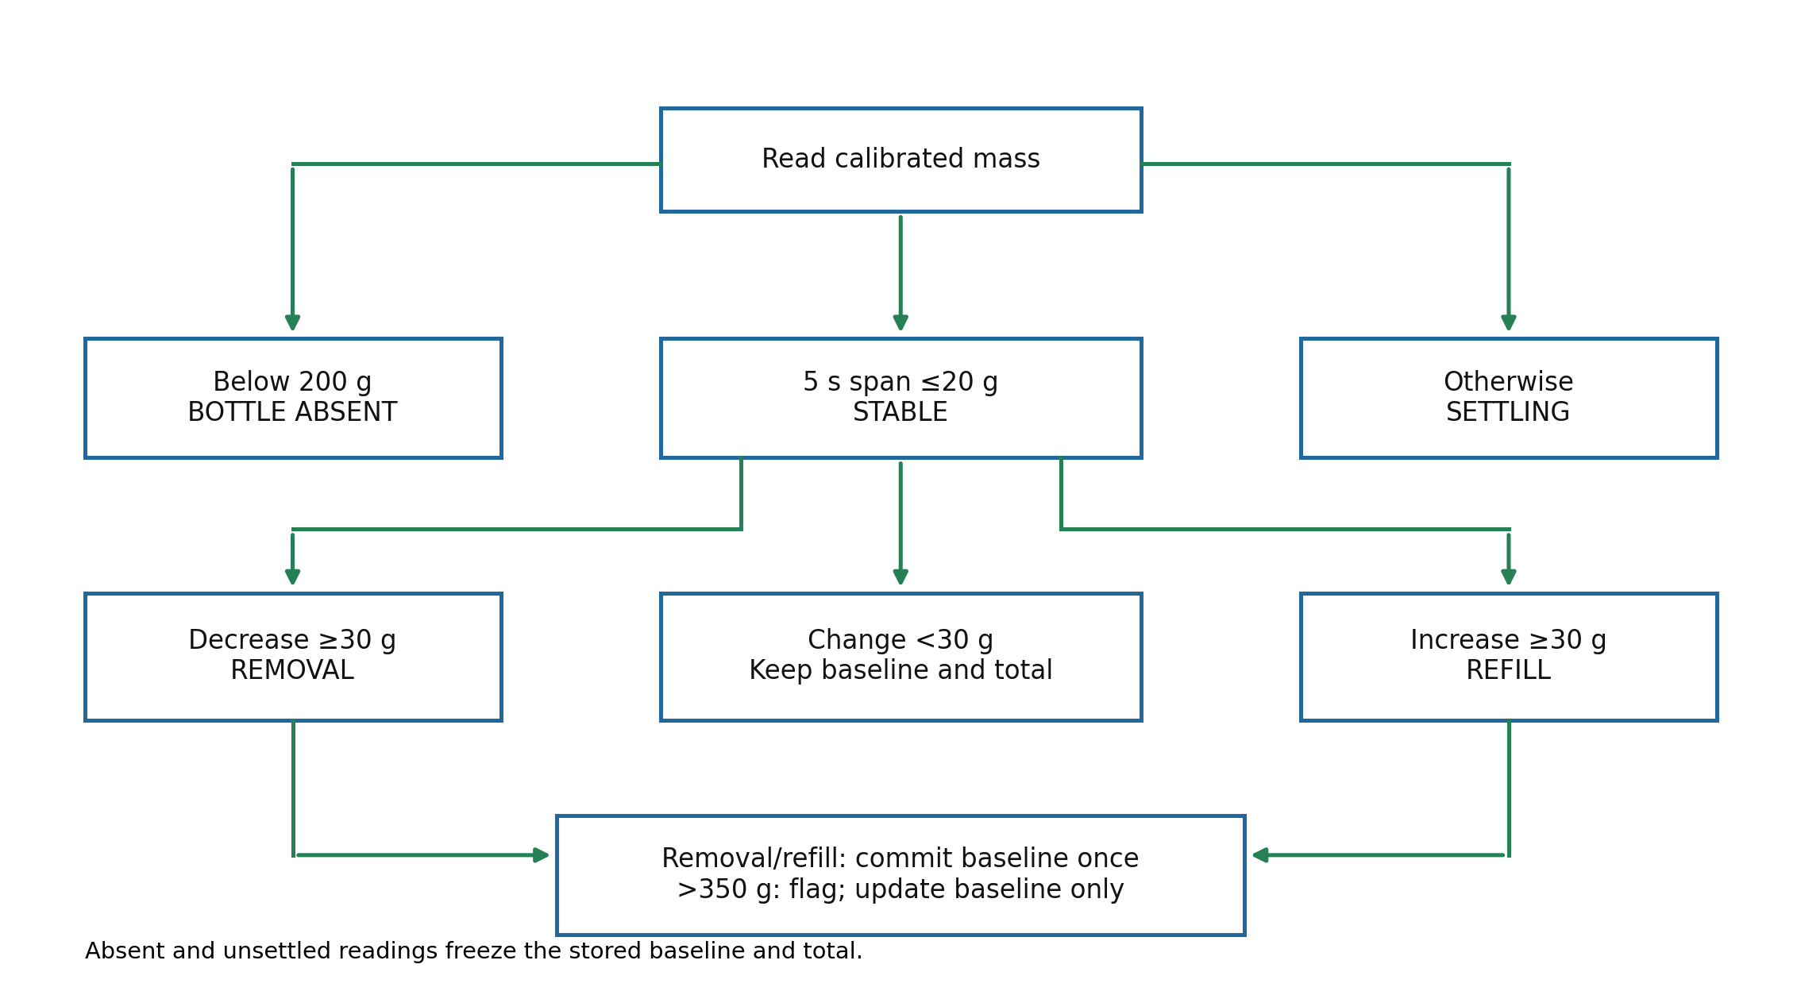
Figure 5. Core mass-based state flow. The first settled bottle establishes a baseline. Optional accelerometer readings do not participate in core acceptance.
Table 6. Integrated mass-event requirements and verification.
ID | Requirement | Verification and pass criterion
FW1 | Meet HL1: ≥18/24 mass-removal trials within ±50 g; ≥4/6 at each size; each passing trial commits ≥30 g, displayed as water-equivalent mL. | Use nominal 50, 100, 200 and 300 g blocks, each verified within ±2 g; record actual reference mass. For each size run two removals at gross starts of 1.35 ±0.03, 2.00 ±0.03 and 2.97 ±0.03 kg, never exceeding 3.00 kg. Lift the fixture ≥50 mm, remove the block, then return centrally within 25 mm. Final gross load must stay ≥1.00 kg. Record reference, estimate, sign, error and settling time. Missing events or settling >30 s fail. Retain all 24 outcomes; apply the stated pass counts.
FW2 | Meet HL2: ≥16/20 unchanged-mass motion trials with no removal event; all five 100 ±2 g additions classified REFILL without total increase. | At 2.00 ±0.03 kg run ten unchanged-mass fixture lifts ≥50 mm for 2–5 s and ten lateral shifts of 10–20 mm. Return centrally and allow 30 s; any removal commit fails that trial. Then rebaseline at 2.00 ±0.03 kg and place five verified 100 ±2 g blocks, one at a time after STABLE, ending near 2.50 kg. All five additions must classify REFILL without increasing the total.
FW3 | At least five of six 100 ±2 g removals shall update the OLED within 2 s of STABLE and commit only once. | Use serial timestamps and synchronized phone video. Measure first updated frame minus STABLE time; hold each final load stationary for 10 s. Pass ≥5/6 within 2 s, with no repeated increment in each passing trial.
FW4 | The 1.00 and 3.00 kg operating boundaries shall accept at least two of three removal estimates ≥30 g each for 50 ±2 g steps. | Run three 1.05→1.00 kg and three 3.00→2.95 kg dry-mass steps, using a reference balance. Require settling ≤30 s and |estimate−reference| ≤50 g for ≥2/3 at each boundary. These are additional boundary checks, outside FW1’s 24 block trials.
FW5 | Absent readings shall freeze the total and baseline; 29 g shall not commit, 31 g shall classify by sign, and 351 g shall flag without accumulating. Reset requires a 2 s button hold then confirmation; reminder persists until acknowledged. | Replay independent episodes initialized at a 2 kg baseline for 150 g absent, stable 29/31/−31/−349/−351 g changes, and duplicate plateaus. Require expected state/total for every case. Test reset hold 1 s (no reset), hold 2.1 s + button 3 (total/baseline cleared; next stable load rebaselines), and a reminder held 60 s before acknowledgment with button 1. Also inject a 10 ms button pulse (ignored) and a 50 ms pulse (one action) to verify 30 ms debounce. These logic tests supplement physical trials.
Three buttons select a 1000–4000 mL goal in 200 mL steps and a 10–120 min reminder interval in 10 min steps. Button 1 enters/selects the menu; buttons 2 and 3 increase/decrease. A 2 s button-1 hold requests total reset, confirmed by button 3. All buttons use 30 ms debounce. The home screen shows REMOVED EST, goal and reminder interval; the menu edits goal or interval. A due reminder shows DRINK REMINDER until button 1 acknowledges it; the next press opens the menu. Confirmed reset clears total and baseline, so the next stable fixture or new bottle establishes its baseline. Calibration is retained. The OLED supplies the visual reminder [12].
Table 7. UI1 is core; OPT1 and OPT2 are optional and excluded from HL1–HL3.
ID | Requirement | Verification and pass criterion
UI1 | Both users shall correctly read at least 16 of 18 combined total, goal and interval fields at 0.5 m under 300–700 lux. Each button shall recognize ≥9/10 deliberate presses; settings shall reach the stated endpoints. A 10 min reminder shall appear within ±2 min. | Measure distance/lux; each teammate reads the three fields in three screen states, requiring ≥16/18 correct field readings. Exercise each button ten times with presses 0.2–1 s apart by ≥0.5 s. Set goals 1000/2000/4000 and intervals 10/30/120; all settings must display correctly. Time and acknowledge one reminder.
OPT1 | A separate ADXL343 carrier shall return device ID 0xE5 at address 0x53 while the OLED remains accessible at 0x3C. | Use an I²C scanner and device-ID read on GPIO8/9 at 100 kHz; require both addresses, expected ID and a screen update. Failure does not fail HL1–HL3.
OPT2 | Tilt ≥20° for 2 s shall raise a tilt indication; after return within 5° of level, indication shall clear within 10 s in ≥5/6 cycles. | Use a 0°/10°/25° jig and six 0→25→0° cycles held ≥5 s at each position. Require indication within 3 s at 25° and clearing within 10 s of level for ≥5/6. A 10° hold must not trigger. Test tilt separately from mass changes.
The optional bare Analog Devices ADXL343BCCZ-RL uses a team-made carrier with CS=3.3 V, ALT ADDRESS=GND, local 1 µF/0.1 µF bypassing and the shared I²C bus. Static tilt is θ=atan2(√(ax²+ay²),az), with z normal to the base. This is a later orientation enhancement, excluded from the core success criteria [13].

2.8 Tolerance analysis
The critical function is detecting a 50 g removal on a 1–3 kg gross load. We use the lower published SC928NB sensitivity of 0.60 mV/V and a conservative 20 kg aggregate reference for four 5 kg cells. Calibration establishes the assembled sensitivity; a half-sensitivity case is retained [2].
ΔV = S Vexc (Δm / MFS) = 0.00060 × 3.0 × (0.050 / 20) = 4.50 µV. (1)
S is differential sensitivity in V/V, Vexc excitation, Δm removed mass in kg and MFS aggregate reference mass. The 3.0 V calculation is conservative relative to ≥3.1 V excitation. At half sensitivity the 50 g signal is 2.25 µV. A 3 kg signal of 0.27 mV plus the published zero-output allowance of 1.5 mV stays below the ±11.72 mV input limit [2], [3].
VFS = ±0.5 AVDD / G = ±0.5 × 3.0 / 128 = ±11.72 mV. (2)
Here G=128 is the selected gain. A balanced bridge at 3.3 V has about 1.65 V common mode, inside the HX711 1.2–2.0 V window; ADC3 checks the assembled inputs. With an assumed assembled rms noise of 0.50 µV, the 50 g signal-to-noise ratio is 9, or 4.5 at half sensitivity. This is a feasibility assumption rather than measured performance [3].
Table 8. Provisional error allocation. Values are allowances, not measurements or additional acceptance requirements.
Source | Model allowance | At 50 g | At 300 g
Gain/calibration | 2% of step | 1.0 | 6.0
Reference mass | 2 g | 2.0 | 2.0
Placement/load-path change | 15 g | 15.0 | 15.0
Plateau noise/repeatability | 12 g | 12.0 | 12.0
Short-term drift/creep | 8 g | 8.0 | 8.0
1 g/mL approximation | 0.2% of step | 0.1 | 0.6
Worst-case linear sum | Design allocation | 38.1 | 43.6
The provisional error sums fit the ±50 g target. For a numerical feasibility check, 100,000 synthetic trials per size use independent uniform errors within the Table 8 allowances. Success requires error ≤50 g and a committed estimate from 30 to 350 g. Table 9 reports the resulting fractions; the assumed distributions are not bench results.
Table 9. Synthetic pass probability under the stated allocation model.
True step g | Predicted successful event
50 | 95.0%
100 | 100.0%
200 | 100.0%
300 | 100.0%
The 350 g classifier limit leaves a 50 g guard band above the largest required step. Physical tests FW1 and FW2 establish compliance; calibration, placement and stationary logs assess the assumed allocations.

2.9 Risk analysis and procurement contingencies
The hardest requirement is HL2: returning a bottle at a different position can change the measured load path. We address this with ring clearance, repeatable seating, filtered plateau comparison and the 30 g deadband; MECH1/MECH2 and FW2 isolate mechanical and event-classification behavior. Noise or drift that prevents stable plateaus is investigated with raw-count logs before changing calibration. A rail or communication failure is isolated through PWR1, CTRL1 and ADC1 before integration.
Table 10. Main choices and conditional replacements. Only one configuration is operated at a time.
Main choice | Trigger and date | Replacement and reason
Four SC928NB 5 kg half bridges | Submit supplier order by Oct 5; obtain committed arrival by Oct 12; delivery go/no-go Oct 16. | First use the same SC928NB 3 kg version if it can arrive by Oct 23. Capacity is per cell; system range stays 1–3 kg. Recalibrate.
SC928NB shipment from China | At the Oct 16 go/no-go, neither SC928NB capacity has a committed arrival by Oct 23. | Activate the Amazon two-bar full-bridge set [14] on Oct 16 after checking seller rating, drawing, excitation and ETA. Shipping delay is the trigger. Replace the entire mount/combiner with two bars and two custom HX711 channels; sum calibrated masses and repeat core tests. No supplied HX711 breakout is used.
UCTRONICS U602602 OLED | No confirmed delivery by Oct 16. | Use Adafruit 326 SSD1306 OLED after checking 3.3 V pinout/address. Same user interface and tests.
Two sliding C guides | Print coupon cannot hold setting or pass MECH1. | Friction-fit rods through the upper ring; preserve clearance and repeat MECH1.

3 Cost and schedule

3.1 Parts and fabrication
Table 11 is one completed main prototype, including the corrected HX711 population and combiner. Dollar amounts are planning estimates from the reconciled purchasing list [15], not checkout quotations. Course-stock parts have $0 team expenditure; listed MPNs specify compatible equivalents to confirm against supplied stock. Optional ADXL343 and contingent replacements are excluded. No machine-shop work is planned (0 quoted hours); printed seats and guides use course printing [16], [17]. Lab instruments are borrowed at $0 incremental cost. Reference prefixes identify the board.
Table 11. Main prototype bill of materials. Linked source names open the purchasing or stock route.
Reference | Manufacturer and part specification | Qty | Line cost | Source
ESP U2 | Espressif ESP32-S3-WROOM-1-N16 | 1 | $0.00 | ECE Shop
ESP U3 | ST LD1117S33CTR / E-Shop LD1117-3.3, SOT-223 | 1 | $0.00 | ECE Shop
ESP J1 | HRO TYPE-C-31-M-12, 12-pin USB-C | 1 | $0.90 | Keebio
ESP SW1,SW2 | XUNPU TS-1088-AR02016, 4 × 3 mm tactile | 2 | $0.16 | LCSC
ESP R1,2,4–6 | Yageo RC0603FR-075K1P, 5.1 kΩ 0603 | 5 | $0.20 | DigiKey
ESP R3; JP1 | Yageo RC0603FR-0710KL 10 kΩ; RC0603JR-070RL 0 Ω, 0603 | 2 | $0.00 | ECE Shop
ESP C1,C4 | Samsung CL10A106MQ8NNNC 10 µF 6.3 V X5R 0603 | 2 | $0.00 | ECE Shop
ESP C2 | Samsung CL10A226MQ8NRNC 22 µF 0603 | 1 | $0.40 | DigiKey
ESP C3,C5 | KEMET C0603C104K4RACTU 0.1 µF; Samsung CL10B105KA8NNNC 1 µF, 0603 | 2 | $0.00 | ECE Shop
ESP C6 | KYOCERA AVX TACR106K010RTA 10 µF 10 V 0805 tantalum | 1 | $2.30 | DigiKey
ESP D1–D3 | Lite-On LTST-C190EKT/GKT/TBKT red/green/blue 0603 | 3 | $0.00 | Self service
ESP J2,J3 | Samtec TSW-120-07-G-S equivalent 1×20 2.54 mm male | 2 | $0.00 | Self service
POWER U1 | TI BQ24074RGTR, 16-pin charger/power path | 1 | $2.80 | DigiKey
POWER U3 | TI TPS63001DRCR 3.3 V buck-boost | 1 | $2.60 | DigiKey
POWER L1 | Bourns SRN4018-2R2M, 2.2 µH | 1 | $0.85 | DigiKey
POWER F2 | Bourns MF-MSMF050-2, 1812 resettable fuse | 1 | $0.45 | DigiKey
POWER SW2 | C&K JS102011SAQN slide switch | 1 | $0.80 | DigiKey
POWER J1 | GCT USB4105-GF-A-060 USB-C charge receptacle | 1 | $0.00 | ECE Shop
POWER J2 | JST B2B-PH-K-S vertical 2-pin battery connector | 1 | $0.30 | DigiKey
POWER R1,R2,R8,R10 | Yageo RC0805FR-075K1L ×2; RC0805FR-071KL; RC0805FR-07100KL | 4 | $0.00 | ECE Shop
POWER R3 | Yageo RC0805FR-072K21L, 2.21 kΩ | 1 | $0.04 | DigiKey
POWER R4,R5 | Yageo RC0805FR-073K16L, 3.16 kΩ | 2 | $0.08 | DigiKey
POWER R6 | Yageo RC0805FR-07100RL, 100 Ω | 1 | $0.04 | DigiKey
POWER R7 | Yageo RC0805FR-0749K9L, 49.9 kΩ | 1 | $0.04 | DigiKey
POWER C1,C3–5,C10–11 | Samsung CL21A106KPFNNNE 10 µF 10 V X5R 0805 | 6 | $0.00 | ECE Shop
POWER C2,C9; D1 | KEMET C0603C104K4RACTU ×2; Lite-On LTST-C170GKT LED | 3 | $0.00 | ECE Shop
POWER TH1 | TDK B57861S0103F040 10 kΩ NTC; remote insulated pack attachment | 1 | $0.65 | DigiKey; validate TS curve
POWER BATT | Adafruit Product 2011 protected 1S 2000 mAh LiPo | 1 | $12.50 | Adafruit
HX U1 | Avia HX711 SOP-16 bare IC, LCSC C43656 | 1 | $0.85 | LCSC
HX R1,R2 | Yageo RC0603FR-07100RL, 100 Ω | 2 | $0.08 | DigiKey
HX R4 | Yageo RC0603JR-070RL, 0 Ω 0603 (VFB ground) | 1 | $0.00 | Course stock
HX R5 | Yageo RC0603JR-070RL, 0 Ω 0603 (excitation link) | 1 | $0.00 | Course stock
HX C1,C3–5; C2,C6 | KEMET C0603C104K4RACTU ×4; Samsung CL31A106KAHNNNE 10 µF 1206 ×2 | 6 | $0.00 | ECE Shop
HX K1–K3 | Samtec TSW-105/102/104-07-G-S equivalent 2.54 mm male | 3 | $0.00 | Self service
MECH 4 cells | Sensor and Control SC928NB four-cell 5 kg set | 1 | $18.00 | Supplier
PCB ESP | Team 41 controller board 29 ×51.9 mm | 1 | $8.00 | Course PCB service
PCB POWER | Team 41 power board 80 ×50 mm | 1 | $10.00 | Course PCB service
PCB HX | Team 41 HX711 board approximately 22 ×22 mm | 1 | $6.00 | Course PCB service
PCB BRIDGE | Team 41 passive combiner, 4×3 + 1×4 solder pads | 1 | $6.00 | Course PCB service
MECH print | PLA filament for base, platform, guides and retained seats | 1 lot | $4.00 | Course printing
HARNESS | 22–26 AWG insulated wire, heat-shrink and strain relief | 1 lot | $3.00 | Course stock
MECH fit | Friction-fit tabs/rod material and insulating mounts | 1 lot | $3.00 | Course printing/stock
UI OLED | UCTRONICS U602602, SSD1306 128 × 64 I²C | 1 | $9.00 | Amazon
UI UI×3 | TE Connectivity 1825910-6 normally-open tactile switches for the separate user interface | 3 | $0.00 | Self service
BUS RPU1/RPU2 | Yageo RC0603FR-074K7L 4.7 kΩ pull-ups to 3.3 V; fit only if OLED lacks them | 2 | $0.00 | Course stock
Main parts and fabrication total: $93.04. Shipping allowance: $15.00. Tax allowance: 8% of parts = $7.44. Estimated cash expenditure: $115.48. The Q1 pad jumper uses harness wire. The optional carrier adds approximately $8.50 (ADXL343 $3.50 and PCB $5.00; stock passives/header $0). If activated, the two-bar contingency adds one HX711 channel and revised mount costs, priced before purchase; it is not added to the main configuration.

3.2 Labor
We estimate 160 hours per teammate: design/documentation 40 h, fabrication/assembly 35 h, firmware/integration 45 h, and verification/reporting 40 h. A planning wage of $45/h corresponds to $93,600/year at 2080 h/year; it is an assumed entry-level engineering rate, not student wages. The course requires the 2.5 overhead multiplier [18].
Table 12. Equal estimated labor and total project cost.
Item | Calculation | Total
Lawrence Cheng | 160 h × $45/h × 2.5 | $18,000.00
Shengyuan Wang | 160 h × $45/h × 2.5 | $18,000.00
Combined labor | 320 h × $45/h × 2.5 | $36,000.00
Grand total | Labor + main parts + shipping + tax | $36,115.48

3.3 Schedule
Table 13 assigns one primary deliverable per teammate per week. The September 30 PCB order is expected October 7–14, using the stated 1–2 week lead time. The next round on October 7 includes the passive combiner, with arrival targeted October 14–21. Arrival dates are estimates; the October 16 delivery decision in Table 10 protects integration time [16], [19].
Table 13. Weekly deliverables and division of labor.
Week | Lawrence Cheng | Shengyuan Wang
Sep 28–Oct 4 | Freeze the design document and core tests. | Submit POWER/controller/HX711 round 1 on Sep 30.
Oct 5–11 | Order SC928NB by Oct 5 and release the print-fit coupon. | Design and submit the passive combiner on Oct 7.
Oct 12–18 | Complete ring/platform drawing and Oct 16 delivery decision. | Demonstrate power/controller bring-up and HX711 rework on received boards.
Oct 19–25 | Complete the isolated sensor mount. | Assemble combiner/HX711 and log signed mass readings.
Oct 26–Nov 1 | Complete calibration and the first 12 block-removal trials. | Complete power/harness and charger-network verification.
Nov 2–8 | Demonstrate integrated tracking and complete the other 12 block trials. | Complete the 120 min battery run.
Nov 9–15 | Complete 20 motion and five refill trials. | Complete UI/timing/firmware verification.
Nov 16–22 | Complete mock-demo rehearsal and needed corrections. | Complete spill/tip checks and optional ADXL tests.
Nov 23–29 | Close remaining mass/mechanical test failures. | Close remaining assembly/power test failures.
Nov 30–Dec 6 | Deliver bottle-use demonstration and measured results. | Deliver hardware-mode demonstration and circuit record.
Dec 7–10 | Complete final report figures and measured R&V. | Complete final BOM and notebook evidence.

4 Ethics safety and engineering standards
The device supports voluntary awareness and reminders, but neither mass loss nor a displayed goal establishes medical need or actual drinking. Goals remain user-selected, and the screen labels the total as an estimate. We will report every verification outcome and attribute the Soldered HX711 and atomic14 controller reference designs [9], [10]. Honest limitations, accurate records, public safety and credit to prior work follow the IEEE and ACM codes and course ethical guidance [20]–[22].
Local operation avoids account requirements and collection of drinking histories. Reusing an existing bottle reduces the need to replace a container; course-stock parts and repairable separate boards limit cost and waste. Small display size remains an accessibility limitation, addressed by U1 rather than an unsupported universal-readability claim. Keep battery replacement possible and send depleted or damaged lithium cells to the university-approved battery recycling stream, never ordinary trash. Foreign component supply creates lead-time and transport impacts; Table 10 defines a practical procurement response.
Electrical and battery controls. Use protected 1S cells, verified JST polarity, insulating mounts, strain relief and an accessible power disconnect. Obtain required course/TA battery approval, attach the remote NTC to the pack with electrical insulation, and pass PWR3 before charging a real cell. Charge supervised in the course-prescribed safety bag on a nonflammable surface. Record voltage, current and pack temperature every 5 min; stop for swelling, odor, pack temperature ≥40 °C or a rise ≥10 °C, or cell voltage above the approved 4.20 V limit. End discharge at 3.0 V. Confirm charger/instrument tolerance with the TA. No unattended charging or exposed pouch contact with sharp printed edges [5], [7], [23], [24].
Spills and mechanical stability. The display, buttons, electronics and battery use separate boards beside the base, outside the bottle footprint, with insulating covers and cable drip loops. Before powered use, apply a 20 mL platform spill with power disconnected; witness paper at the electronics/battery must remain dry. Tilt the supporting surface to 10° in four directions with a representative bottle or retained dry fixture at 1 and 3 kg; the base must neither tip nor slide. Use a spotter and repeat after any enclosure/foot correction. Guard platform gaps, round exposed edges and use the bottle on a level desk.
Table 14. Applicable standards and design implications. Referenced safeguards do not claim certification.
Reference | Application
USB Type-C Cable and Connector Specification Release 2.5, 2026 [25] | 5.1 kΩ CC sink pull-downs, verified receptacle pinout, and separate charging/programming ports. USB current depends on the source advertisement; use a qualified 5 V charger for charge tests.
IEC 62133-2:2017 + AMD1:2021 [26] | Portable lithium battery safety informs protected-cell selection, thermal monitoring and handling.
IEC 62368-1:2023 [27] | Electrical/thermal safeguard principles inform insulation, enclosures and access to disconnect.
47 CFR Part 15 and FCC module integration guidance [28] | Preserve module antenna clearance; radios disabled in core testing. No final-product authorization claim.
OSHA 29 CFR 1910 Subpart S and course safety rules [23], [29], [24] | Current-limited bring-up, insulating benches, guarded hot tools and supervised lithium-battery work.
UL 2054 Edition 3, 2021, revised 2022 [30] | Portable-battery safeguards inform protected-pack selection, insulation and safe storage/disposal. No battery or prototype certification is claimed.

References
[1] Centers for Disease Control and Prevention, “About Water and Healthier Drinks,” 2026. [Online]. Available: https://www.cdc.gov/healthy-weight-growth/water-healthy-drinks/index.html. Accessed: Oct. 2, 2026.
[2] Sensor and Control, “SC928NB Half Bridge Load Cell,” product specifications and mechanical drawing. [Online]. Available: https://sensor-con.com/product/sc928nb/. Accessed: Oct. 2, 2026.
[3] Avia Semiconductor, “HX711 24-Bit ADC for Weigh Scales,” datasheet. [Online]. Available: https://cdn.sparkfun.com/datasheets/Sensors/ForceFlex/hx711_english.pdf. Accessed: Oct. 2, 2026.
[4] Espressif, “ESP32-S3 Hardware Design Guidelines,” 2026. [Online]. Available: https://docs.espressif.com/projects/esp-hardware-design-guidelines/en/latest/esp32s3/. Accessed: Oct. 2, 2026.
[5] Texas Instruments, “BQ24072/BQ24073/BQ24074/BQ24075/BQ24079 USB-Friendly Li-Ion Charger and Power-Path Management IC,” datasheet. [Online]. Available: https://www.ti.com/lit/gpn/bq24074. Accessed: Oct. 2, 2026.
[6] Texas Instruments, “TPS6300x High-Efficient Single Inductor Buck-Boost Converter,” datasheet. [Online]. Available: https://www.ti.com/lit/ds/symlink/tps63001.pdf. Accessed: Oct. 2, 2026.
[7] Adafruit, “Lithium Ion Polymer Battery, 3.7 V 2000 mAh,” Product 2011. [Online]. Available: https://www.adafruit.com/product/2011. Accessed: Oct. 2, 2026.
[8] National Institute of Standards and Technology, “Thermophysical Properties of Fluid Systems,” water density at room temperature. [Online]. Available: https://webbook.nist.gov/chemistry/fluid/. Accessed: Oct. 2, 2026.
[9] Soldered Electronics, “Load-cell amplifier HX711 board hardware design,” schematic and PCB reference. [Online]. Available: https://github.com/SolderedElectronics/Load-cell-ampfilier-HX711-board-hardware-design. Accessed: Oct. 2, 2026.
[10] atomic14, “Basic ESP32-S3 Dev Board,” source files. [Online]. Available: https://github.com/atomic14/basic-esp32s3-dev-board. Accessed: Oct. 2, 2026.
[11] STMicroelectronics, “LD1117 Low Drop Fixed and Adjustable Positive Voltage Regulators,” datasheet. [Online]. Available: https://www.st.com/resource/en/datasheet/ld1117.pdf. Accessed: Oct. 2, 2026.
[12] UCTRONICS, “0.96 Inch 128 × 64 OLED Display U602602,” module documentation. [Online]. Available: https://www.uctronics.com/download/Amazon/U602602.pdf. Accessed: Oct. 2, 2026.
[13] Analog Devices, “ADXL343 Three-Axis Digital Accelerometer,” Rev. A datasheet. [Online]. Available: https://www.analog.com/media/en/technical-documentation/data-sheets/adxl343.pdf. Accessed: Oct. 2, 2026.
[14] ShangHJ, “S18X4 digital weighing load-cell set,” seller listing, conditional backup; verify delivered specifications. [Online]. Available: https://www.amazon.com/dp/B09VYSHW16. Accessed: Oct. 2, 2026.
[15] Team 41, “Team41 External Purchase Links Reconciled,” working purchasing workbook, Oct. 1, 2026.
[16] ECE 445, “Order a PCB” and supplied Team 41 PCB ordering guide. [Online]. Available: https://courses.grainger.illinois.edu/ece445/lab/order-a-pcb.asp. Accessed: Oct. 2, 2026.
[17] ECE 445, “Getting Parts for Your Project,” University of Illinois. [Online]. Available: https://courses.grainger.illinois.edu/ece445/lab/getting-parts.asp. Accessed: Oct. 2, 2026.
[18] ECE 445, “Design Document,” guidelines. [Online]. Available: https://courses.grainger.illinois.edu/ece445/guidelines/design-document.asp. Accessed: Oct. 2, 2026.
[19] ECE 445, “Fall 2026 Calendar.” [Online]. Available: https://courses.grainger.illinois.edu/ece445/calendar.asp. Accessed: Oct. 2, 2026.
[20] IEEE, “Code of Ethics.” [Online]. Available: https://www.ieee.org/about/corporate/governance/p7-8.html. Accessed: Oct. 2, 2026.
[21] Association for Computing Machinery, “ACM Code of Ethics and Professional Conduct.” [Online]. Available: https://www.acm.org/code-of-ethics. Accessed: Oct. 2, 2026.
[22] ECE 445, “Ethical Guidelines.” [Online]. Available: https://courses.grainger.illinois.edu/ece445/guidelines/ethical-guidelines.asp. Accessed: Oct. 2, 2026.
[23] ECE 445, “Safety Guidelines,” University of Illinois. [Online]. Available: https://courses.grainger.illinois.edu/ece445/guidelines/safety.asp. Accessed: Oct. 2, 2026.
[24] ECE 445, “Safe Practice for Lead Acid and Lithium Batteries,” course staff, 2016. [Online]. Available: https://courses.grainger.illinois.edu/ece445/documents/GeneralBatterySafety.pdf. Accessed: Oct. 2, 2026.
[25] USB Implementers Forum, “USB Type-C Cable and Connector Specification,” Release 2.5, 2026. [Online]. Available: https://usb.org/document-library/usb-type-cr-cable-and-connector-specification-release-25. Accessed: Oct. 2, 2026.
[26] IEC, “Secondary cells and batteries—Safety requirements for portable sealed secondary lithium systems,” IEC 62133-2:2017 + AMD1:2021. [Online]. Available: https://webstore.iec.ch/en/publication/70017. Accessed: Oct. 2, 2026.
[27] IEC, “Audio/video, information and communication technology equipment—Part 1: Safety requirements,” IEC 62368-1:2023. [Online]. Available: https://webstore.iec.ch/en/publication/69308. Accessed: Oct. 2, 2026.
[28] Federal Communications Commission, “Modular transmitter guidance and Part 15.” [Online]. Available: https://apps.fcc.gov/oetcf/kdb/forms/FTSSearchResultPage.cfm?id=44637&switch=P. Accessed: Oct. 2, 2026.
[29] Occupational Safety and Health Administration, 29 CFR 1910, workplace electrical and personal protection requirements. [Online]. Available: https://www.osha.gov/laws-regs/regulations/standardnumber/1910. Accessed: Oct. 2, 2026.
[30] UL Standards and Engagement, “Household and Commercial Batteries,” UL 2054, Edition 3, Nov. 17, 2021, revised Mar. 10, 2022. [Online]. Available: https://www.shopulstandards.com/ProductDetail.aspx?productId=UL2054. Accessed: Oct. 2, 2026.

Appendix A POWER schematic and layout
Figure 6 is the supplied KiCad schematic. U1 is the BQ24074 charger, U3 the TPS63001 converter, J1 charging USB and J2 the protected pack. TH1 is mounted remotely at the pack. The output harness attaches to the 3.3 V output node and ground; POWER prefixes identify these parts in the BOM.
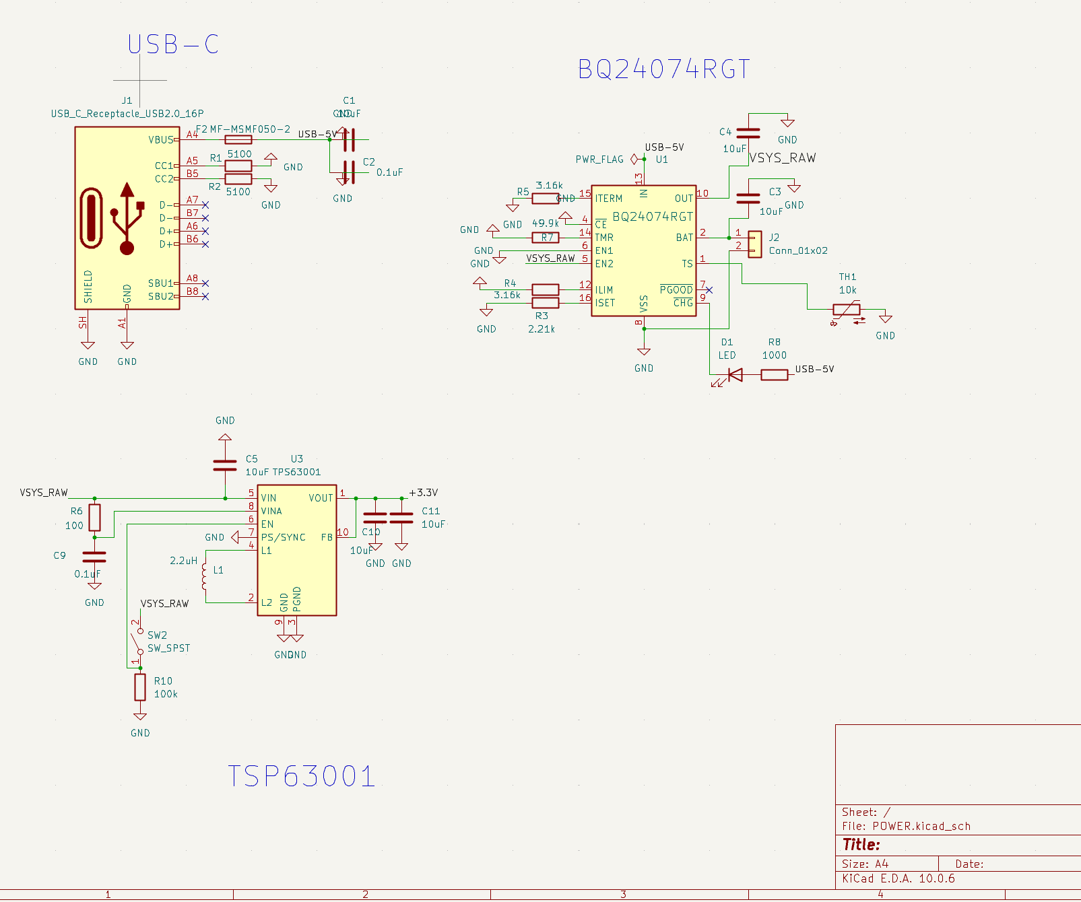
Figure 6. Submitted POWER schematic. Upper left: USB sink. Upper right: charger and battery path. Lower left: TPS63001 3.3 V converter and enable switch.

Appendix A POWER PCB and operating modes
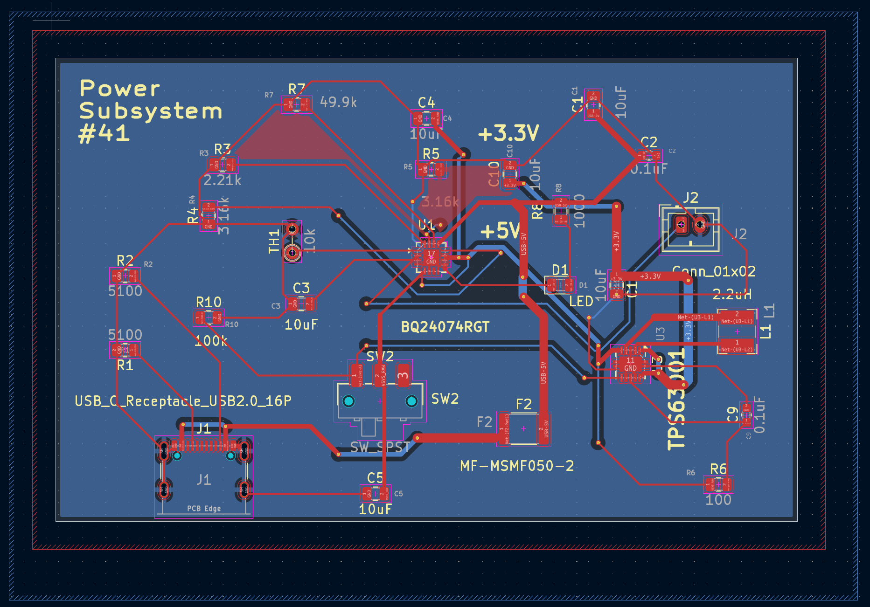
Figure 7a. Supplied KiCad POWER layout, 80 × 50 mm. J1 is charging USB, J2 battery, U1 charger, U3 converter and L1 inductor. Copper fills are shown.
Attach the insulated output harness at the converter output capacitor positive node and ground. Move TH1 to the battery with insulated leads. Verify PWR1/PWR3 before connecting a real pack.
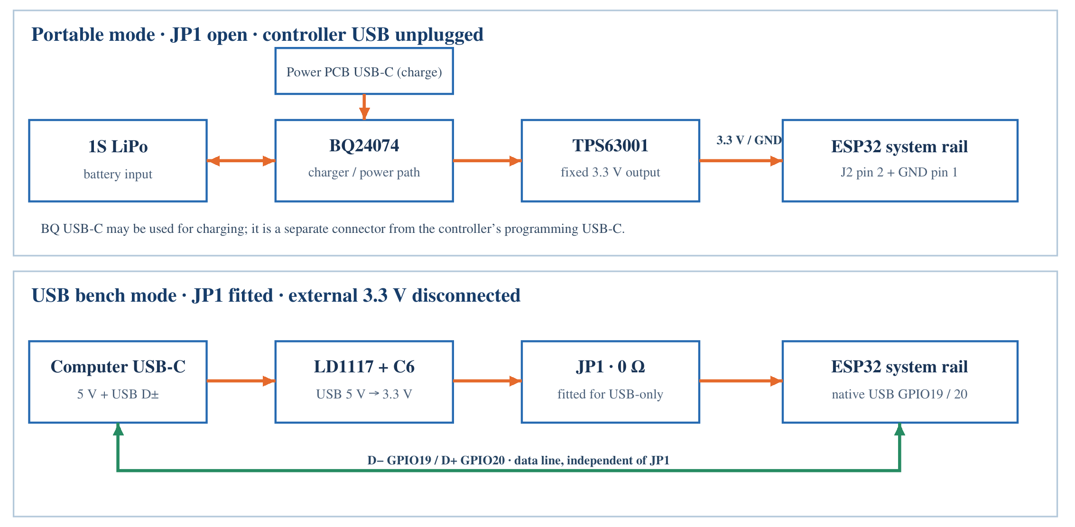
Figure 7b. Battery mode uses JP1 open and controller USB unplugged; USB-only bench mode uses JP1 fitted with external 3.3 V disconnected.

Appendix B ESP32 schematic
Figure 8 is the supplied Rev B KiCad schematic. U2 is the ESP32-S3-WROOM-1-N16 module; J1 is native USB; SW1/SW2 are reset/boot. U3 is the USB-only regulator. JP1 isolates it from external power; C6 is the tantalum output capacitor.
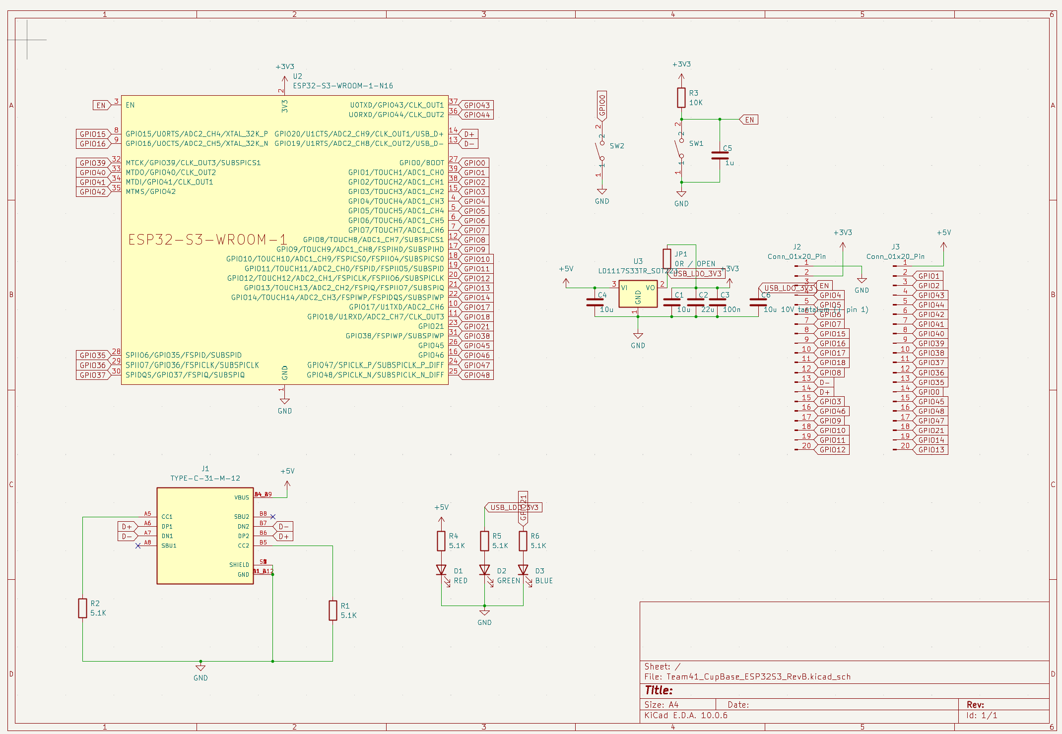
Figure 8. Submitted ESP32 Rev B schematic. Table 1 defines the core GPIO assignment. Figure 7b defines JP1 population for each power mode.

Appendix B ESP32 PCB layout
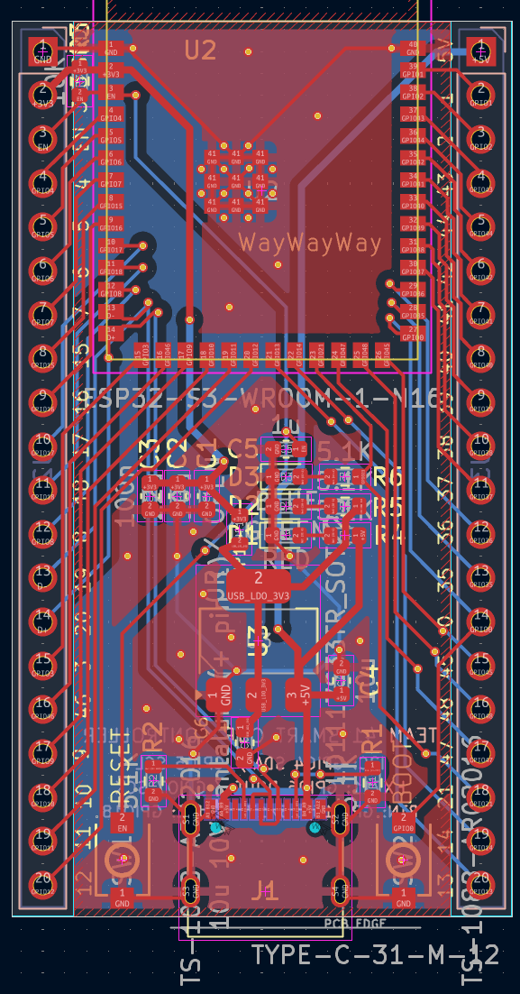
Figure 9. Supplied KiCad ESP32 Rev B layout, 29 × 51.9 mm. J2/J3 are GPIO headers; J1 USB; U2 ESP32; U3 LD1117; JP1 supply link; C6 output capacitor; SW1/SW2 reset/boot.
Verify EN continuity between the reset network and module, inspect solder joints, and run CTRL1–CTRL3 before system integration. Keep the antenna region clear; radios remain disabled during core tests.

Appendix C HX711 schematic and completion
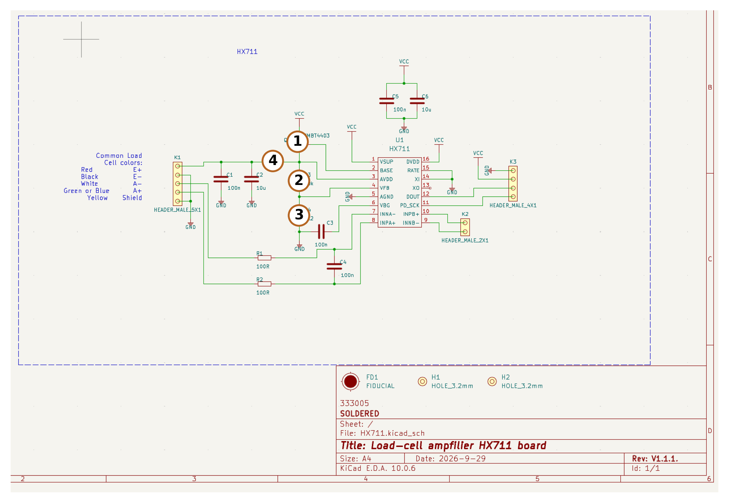
Figure 10. Supplied first-round HX711 schematic with completion callouts. 1: Q1 omitted and pads 2–3 bridged. 2: R3 omitted. 3: R4 replaced by 0 Ω. 4: R5 replaced by 0 Ω. The ordered PCB is retained.
Table 15. HX711 completion on the first-round PCB.
Location | Final 3.3 V assembly
Q1 | Omit transistor; bridge pads 2–3 only. Pad 1 stays open.
R3 | Omit 20 kΩ resistor.
R4 | Fit 0 Ω instead of 8.2 kΩ: VFB to ground.
R5 | Fit 0 Ω instead of 10 Ω: E+ follows AVDD.
U1 and supply | Retain HX711 and bypass capacitors. Supply VSUP/DVDD/AVDD at 3.3 V; BASE remains open.

Appendix C HX711 PCB and assembly checks
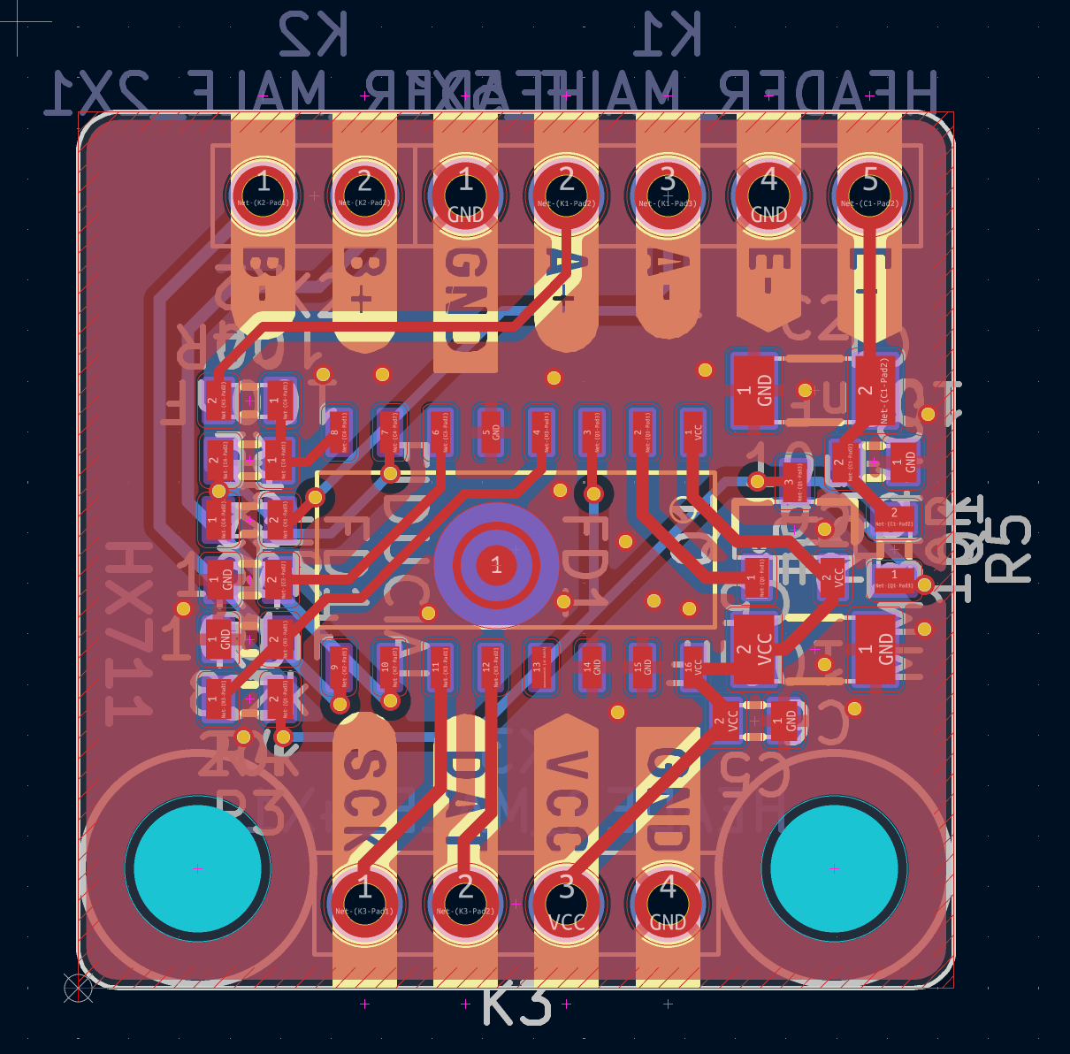
Figure 11. Supplied KiCad HX711 layout, approximately 22 × 22 mm. R3/R4 are left of U1; Q1/R5 are right. Apply Figure 10 and Table 15 to this first-round board.
K1: 1 shield/GND, 2 A+, 3 A−, 4 E−/GND, 5 E+. K3: 1 SCK, 2 DOUT, 3 VCC, 4 GND. K2 is the unused channel B input. Verify the Q1 jumper, open BASE, grounded VFB and no supply short. Then use current-limited 3.3 V and pass ADC1/ADC3 before connecting the load fixture.

