RoadSense
Road Condition Detection and Pothole Mapping System
ECE 445 Design Document - Fall 2026
Project #36
D’Angelo Manzo
Adam Moine
Jovan Kular
Professor: Arne Fliflet
TA: Shengkun Cui

1 Introduction

1.1 Problem
Many students rely on the roads and bike lanes around campus to get around using scooters, skateboards, and bikes. Poor road conditions such as potholes, cracks, large joints, and rough pavement can make these forms of transportation uncomfortable and potentially dangerous. These defects matter especially for bikes, scooters, and skateboards because their smaller wheels are affected more strongly by abrupt changes in road height than typical car tires. Current road-condition monitoring methods also have limitations: manual inspection is slow and subjective, and survey programs may prioritize major streets rather than side roads and bike-lane corridors. As a result, people traveling around campus may not have reliable information about which routes contain hazardous road conditions, particularly when they are unfamiliar with the area or when defects are difficult to see.

1.2 Solution
RoadSense is a compact embedded sensing system that can be rigidly mounted to a car or bicycle. While the vehicle moves, a BMI270 inertial measurement unit (IMU) measures acceleration and angular velocity, an analog high-g accelerometer measures short-duration vibration and impact content, and a MAX-M10S GNSS receiver supplies position, speed, and a timing reference. A standalone STM32F411CEU6 microcontroller synchronizes these data sources and performs the primary road-event detection and classification onboard in real time. Each detected event is assigned a type and severity, associated with location, speed, and time, and written to persistent storage. On later trips, stored hazard locations can be compared with the current position so the system can warn the rider or driver before reaching a known defect. The primary detection path does not require a laptop or Raspberry Pi; any higher-level computer is treated as an optional mapping, visualization, or model-development layer rather than a dependency for sensing and classification.

1.3 Visual Aid
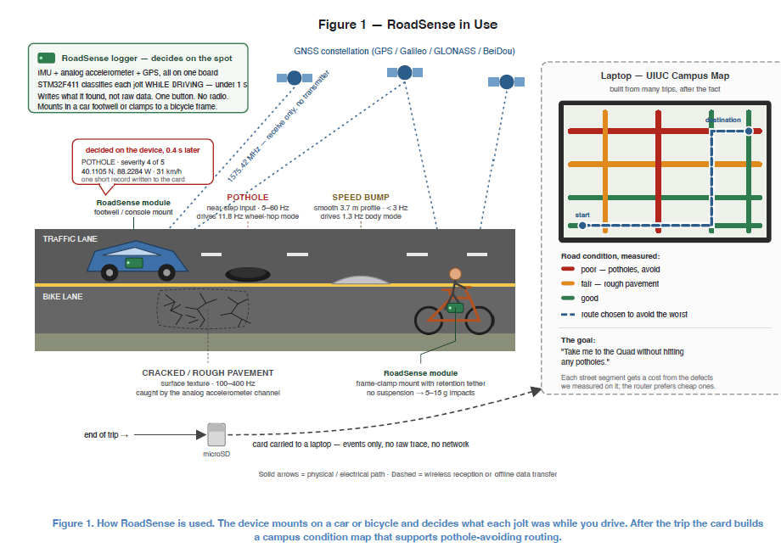
Figure 1 shows RoadSense mounted on either a car or bicycle and collecting vehicle-motion data during operation. The onboard sensors collect acceleration, rotation, and GNSS information, which the embedded system processes to detect and classify potholes, speed bumps, and rough pavement. When an event is detected, its classification, severity, position, speed, and timestamp are stored instead of continuously saving all raw sensor data. Over repeated trips, the stored events form a record of road condition that can be used to warn users about known hazards before they encounter them.

1.4 High-Level Requirements
- RoadSense shall acquire BMI270 motion data at no less than 400 samples/s and acquire the analog acceleration channel at no less than 1,000 samples/s after any software decimation. The embedded system shall classify each detected road event within 1 second of the event and shall operate continuously for at least 30 minutes without losing or corrupting recorded event data.
- When tested on a surveyed campus route containing at least 60 potholes and 30 speed bumps at multiple vehicle speeds, RoadSense shall detect at least 90% of the potholes, correctly classify at least 80% of detected pothole/speed-bump events, and produce no more than one false road event per kilometer of smooth road. Primary detection and classification shall execute on the STM32 without requiring a Raspberry Pi or laptop.
- Each detected road event shall be associated with a location within 10 m of its surveyed location. Data collected across trips shall preserve the location and severity of previously detected hazards and allow RoadSense to issue an audible warning before the vehicle reaches a stored hazard.

2 Design

2.1 Physical Design
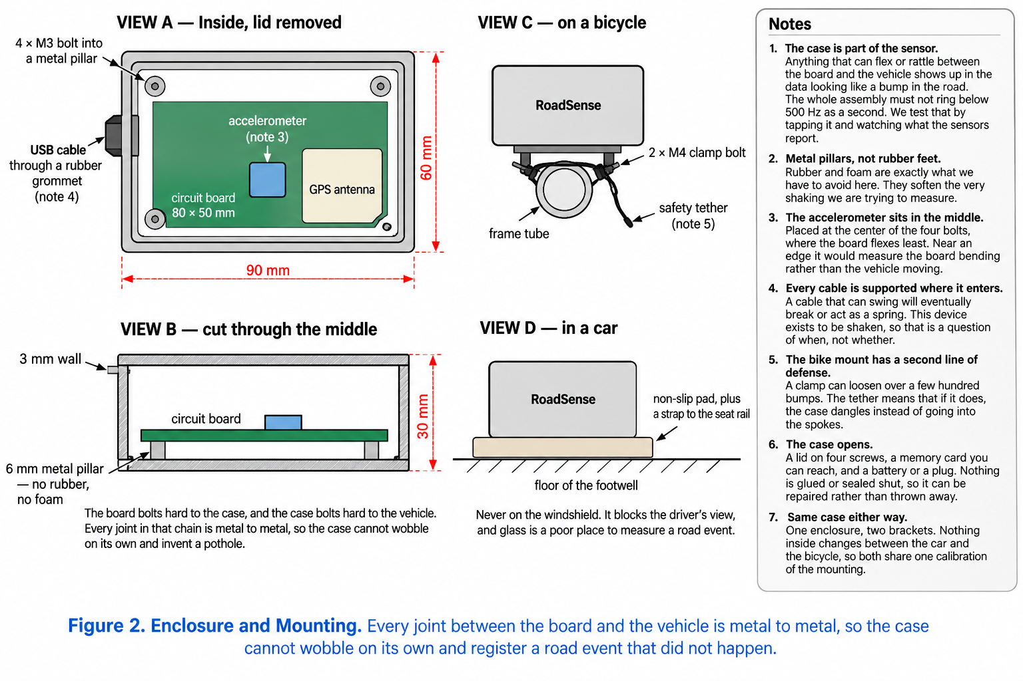
The RoadSense PCB is mounted rigidly inside an enclosure so that the measured vibration comes from the vehicle and road rather than from the electronics moving independently. The motion sensors are placed near a mechanically stiff area of the PCB, and the board is supported with metal standoffs to minimize flex between the sensor and enclosure. For bicycle testing, the enclosure is clamped to the frame and backed up by a safety tether. For vehicle testing, it is secured in the footwell using a non-slip pad and strap. Cable entry points require strain relief, and the GNSS antenna must be positioned so conductive enclosure material does not obstruct satellite reception.

2.2 Block Diagram
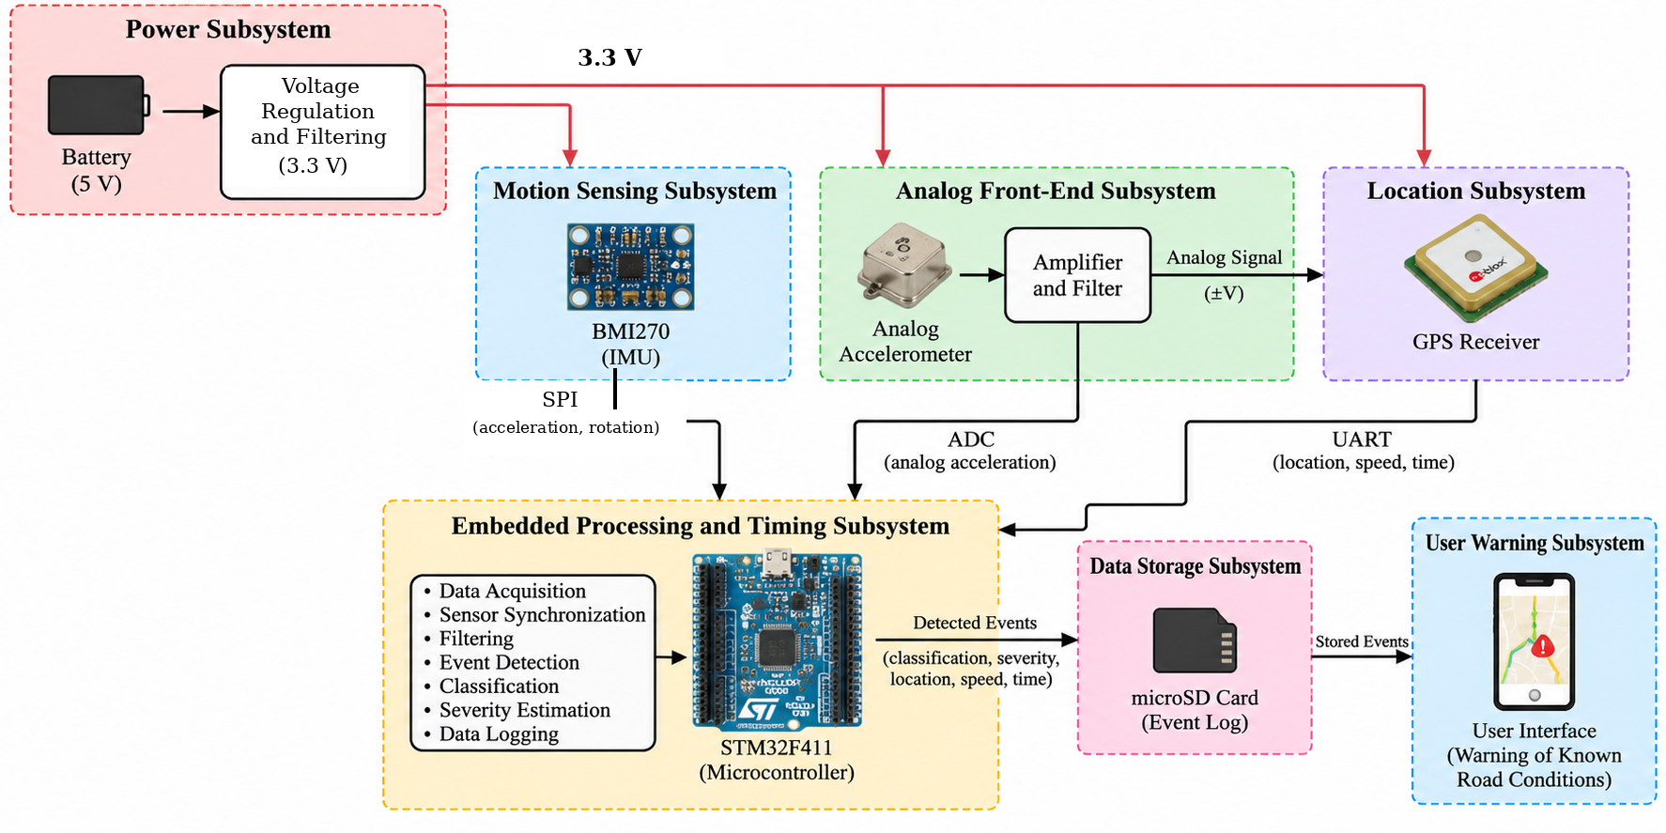
Figure 3. RoadSense system block diagram.
RoadSense is divided into seven functional blocks. The power subsystem supplies the digital and analog rails. Motion sensing and the analog front end measure complementary aspects of road-induced motion. The location subsystem supplies position, speed, and the one-pulse-per-second timing reference. The STM32 processing block synchronizes the sensors, performs detection and classification, and sends completed event records to storage. Stored hazards are queried during later trips and the user-warning subsystem generates an audible alert when a known hazard is approached. Separating the design this way allows each block to be unit-tested before full-system integration.

2.3 Subsystem Overview and Requirements
The subsystem descriptions below correspond directly to the blocks in Figure 3. Each section defines the interface to adjacent blocks, the design quantities that matter to system performance, and a measurable requirement and verification procedure. Circuit-level implementation is separated into Section 2.4 so that the functional requirements can be traced directly to the hardware design.
Subsystem | Primary interface | Target rate / level | Contribution
Power | 5 V input -> 3.3 V / 3V3_A | 3.3 V ±0.1 V | Keeps all blocks powered without resets or analog corruption
BMI270 motion | SPI + data-ready | 400 samples/s | Orientation and low-frequency vehicle motion
Analog acceleration | STM32 ADC | 8 ksample/s raw; >=1 ksample/s processed | Sharp impact / vibration content
MAX-M10S GNSS | UART + TIMEPULSE | 10 Hz position target; 1 PPS | Position, speed, absolute time
Processing | STM32F411CEU6 | 100 MHz MCU | Synchronization, detection, classification, logging
Storage | microSD interface | Event records, not continuous raw data | Persistent road-hazard database
Warning | GPIO -> buzzer driver | >=80 dB at 1 m target | Hands-free warning before stored hazard

2.3.1 Power Subsystem
The power subsystem accepts a nominal 5 V input and generates the rails required by the RoadSense PCB. Connector J1 feeds a resettable PTC fuse (F1) and a transient-voltage clamp (D1) before the AP2112K-3.3 regulator (U1). The regulator generates the main 3.3 V rail. A ferrite bead labeled 600 Ω at 100 MHz (FB1), together with local 1 µF and 100 nF capacitors, creates the filtered 3V3_A rail used by noise-sensitive analog circuitry. This partition reduces the amount of MCU and digital-bus switching noise coupled into the analog acceleration path.
A 1.65 V reference is generated from the analog 3.3 V rail using equal 10 kΩ resistors R1 and R2 and then buffered by MCP6004 section U2A. The ideal divider value is VREF = 3.3 V × 10 kΩ / (10 kΩ + 10 kΩ) = 1.65 V. Buffering the divider prevents downstream analog circuitry from loading the reference and moving its voltage. This rail and reference support the first high-level requirement because power disturbances or analog-reference movement can cause false events, ADC errors, or processor resets.
Requirement | Verification
The main digital rail shall remain at 3.3 V ±0.1 V during normal sensing, processing, storage activity, and warning output. | Power the complete system and monitor the STM32 VDD rail for 15 minutes using an oscilloscope or DMM. Verify the rail remains between 3.2 V and 3.4 V.
The filtered analog rail shall remain within 3.3 V ±0.1 V and shall have less than 10 mV peak-to-peak noise during normal operation. | Probe 3V3_A with an oscilloscope while the IMU, ADC, GNSS, and storage paths are active. Use AC coupling for the ripple measurement and verify peak-to-peak noise is below 10 mV.
The buffered analog reference shall remain within 1% of 1.65 V. | Measure VREF_1V65 with the analog sensor idle and during representative vibration. Verify the value remains between 1.6335 V and 1.6665 V.
The power subsystem shall operate the integrated device for at least 30 minutes without a brownout reset or corruption of previously written event data. | Run the integrated system continuously for 30 minutes, then inspect reset-cause flags and the recovered event log. Verify no unintended reset occurred and all completed records remain readable.

2.3.2 Motion Sensing Subsystem
The motion sensing subsystem uses the Bosch BMI270 to measure three-axis acceleration and three-axis angular velocity. The device is powered from the regulated 3.3 V supply and communicates with the STM32 over SPI. The BMI270 supports accelerometer output data rates well above the required 400 samples/s and supports SPI clock rates up to 10 MHz, leaving substantial communication margin for reading six motion channels at the selected rate [13]. A dedicated interrupt/data-ready line is used so the STM32 reads each sample at a known acquisition time instead of polling the device at an uncertain software interval.
The IMU is rigidly mounted to the PCB with a known axis orientation. Firmware combines the accelerometer and gyroscope data to estimate board orientation, removes gravity, and rotates acceleration into the vehicle frame. This prevents an enclosure mounted at an angle, braking on a slope, or normal turning from being interpreted as a vertical road defect. The SPI bus is routed directly to the STM32, with a separate interrupt line used for the BMI270 data-ready output.
Requirement | Verification
The BMI270 shall provide three-axis acceleration and three-axis angular velocity at 400 samples/s during normal operation. | Configure both sensors for 400 Hz, capture at least 60 s of timestamped data, and verify 24,000 ±1% complete sample sets are received.
The STM32 shall receive BMI270 samples without missing data-ready events during simultaneous ADC, GNSS, and storage activity. | Count BMI270 data-ready interrupts and successfully completed SPI reads over a 30-minute integrated test. Verify the counts agree except for explicitly logged startup/shutdown intervals.
The motion subsystem shall preserve the correct vertical acceleration direction for multiple enclosure mounting angles. | Mount the enclosure at several known static roll/pitch angles, apply repeated vertical impulses, run the orientation compensation, and verify the corrected vertical channel preserves impulse polarity and magnitude within 10% across orientations.

2.3.3 Analog Front-End Subsystem
The analog channel uses a single-axis high-g accelerometer centered at approximately VDD/2 and powered from the filtered 3.3 V analog rail. The selected ADXL1002-class sensor provides the dynamic range needed for short road impacts while keeping the nominal output inside the STM32 ADC range [12]. Using the 3.3 V supply, the expected zero-g level is near 1.65 V. The available headroom on either side of this midpoint allows both positive and negative vertical acceleration to be captured without a negative supply rail.
The sensor output, ACCEL_RAW, is buffered by MCP6004 section U2B before entering the active RC filter network. The filtered node, ACCEL_FILTERED, is routed to an STM32 ADC input. The filter uses 22 kΩ resistors with 22 nF and 10 nF capacitors as shown in the schematic. The ADC is timer-triggered at 8 ksample/s; the digital signal-processing stage then filters and decimates the stream to at least 1 ksample/s for event processing. Oversampling the analog channel moves the Nyquist frequency to 4 kHz and gives the analog anti-aliasing network more transition bandwidth than direct 1 ksample/s conversion.
The analog channel is intentionally complementary to the BMI270. The BMI270 provides orientation and lower-frequency rigid-body motion, while the high-g analog channel preserves the short-duration vibration content associated with sharp defects. During calibration, detections can be compared across both channels so electrical noise or enclosure resonance is less likely to be accepted as a road event.
Requirement | Verification
The analog acceleration signal presented to the STM32 ADC shall remain between 0.3 V and 3.0 V for the expected ±50 g operating range. | Mount the PCB on a vibration/shock test fixture and monitor ACCEL_FILTERED with an oscilloscope while applying increasing impulses. Verify no expected event drives the ADC input outside 0.3-3.0 V.
The raw ADC acquisition shall run at 8 ksample/s with hardware-timer triggering, and the processed analog stream shall be at least 1 ksample/s. | Toggle a diagnostic GPIO on ADC trigger or DMA half/full-complete events and verify the 8 kHz acquisition timing on an oscilloscope. Inspect the processed timestamp stream and verify at least 1,000 output samples/s.
The analog front end shall attenuate out-of-band content according to the measured hardware transfer function and shall not introduce ADC clipping or oscillation. | Inject a swept sine at the analog input, record input/output amplitude from 1 Hz through several kHz, and compare the measured response with the calculated circuit response. Confirm stable operation and no unexpected gain peak.
The analog front end shall remain centered and repeatable during a 30-minute run. | Record the stationary baseline at the beginning and end of a 30-minute test and verify the mean output shift is less than 50 mV unless a temperature correction is explicitly applied.

2.3.4 Location Subsystem
The location subsystem uses a u-blox MAX-M10S GNSS receiver to provide latitude, longitude, vehicle speed, and absolute time. The module communicates with the STM32 over UART and provides a separate TIMEPULSE output. The design target is a 10 Hz navigation update rate with the TIMEPULSE configured as a one-pulse-per-second reference. The MAX-M10 family supports UART communication and a time-pulse output [14]. The MAX-M10S RF_IN pin is connected to a coaxial antenna connector for a passive 1575.42 MHz GNSS antenna. The active-antenna control pins are intentionally unused for the passive-antenna configuration.
The TIMEPULSE signal is captured by an STM32 hardware timer. Each one-second edge ties the microcontroller timer count to GNSS time, and sensor timestamps between pulse edges are interpolated from the free-running timer. This means the IMU, analog ADC, and GNSS updates can be compared on one timeline even though they operate at different rates. The same position and speed values are attached to each completed road-event record and are used later when searching for nearby stored hazards.
Requirement | Verification
The location subsystem shall provide valid latitude, longitude, speed, and UTC time to the STM32 at an update rate of 10 Hz during outdoor operation. | Configure the receiver for the selected output message and rate, log UART packets for 5 minutes while moving, and verify at least 95% of expected 10 Hz epochs contain valid position and speed fields.
The location subsystem shall provide a one-pulse-per-second timing reference while GNSS time is valid. | Capture at least 300 consecutive TIMEPULSE edges with an STM32 timer or oscilloscope and verify the period remains one second within the receiver/timer measurement resolution.
Each detected road event shall be associated with a location within 10 m of its surveyed position. | Collect events at surveyed reference locations and compute horizontal distance between stored and reference coordinates. Verify each high-level test event meets the 10 m requirement or document the GNSS conditions that invalidate the trial.

2.3.5 Embedded Processing and Timing Subsystem
The embedded processing and timing subsystem is built around a standalone STM32F411CEU6. The MCU reads the BMI270 over SPI, samples the analog front end through the internal ADC, receives GNSS position and speed over UART, and captures the GNSS TIMEPULSE signal with a hardware timer. The STM32F411 provides a 100 MHz Cortex-M4 core with DSP/FPU support, hardware timers, SPI, UART, ADC, and sufficient SRAM for the acquisition and event buffers required by the design [15].
All sensor streams are converted to a common time base before event detection. The MCU performs filtering, orientation compensation, event detection, classification, severity estimation, event logging, and hazard lookup without requiring an external computer. The custom PCB also provides SWDIO, SWCLK, NRST, 3.3 V reference, and ground for ST-LINK programming and debug. BOOT0 is held low for normal Flash boot, and a dedicated reset switch is provided for board bring-up.
Requirement | Verification
The processing subsystem shall acquire all sensor sources concurrently for 30 minutes without silently losing data or corrupting completed event records. | Run a 30-minute integrated test. Compare expected and received sensor counters, then verify each stored block checksum and sequence number. Any overrun must be explicitly logged.
A completed event classification shall be available within 1 second of the event trigger. | Apply at least 20 repeatable impulses while recording the trigger timestamp and classification-complete timestamp. Verify every trial completes in under 1 second.
Average processor utilization during the complete sensing/classification pipeline shall remain below 25%. | Set a spare GPIO high while the processing task executes and low while idle. Measure duty cycle during representative operation and verify the average remains below 25%.
The firmware shall provide at least two 16 kB buffers for storage latency and shall report any overrun instead of discarding data silently. | Force the storage interface to stall for 800 ms and verify no event record is lost. Extend the stall until an overrun occurs and verify the overrun counter/status indicator changes.
Sensor timestamps shall remain locked to the GNSS one-pulse-per-second reference with less than 100 µs interpolation error between consecutive pulse captures. | Capture TIMEPULSE and local-timer timestamps over a full trip and compare timer-predicted pulse times with actual captures. Verify the absolute error remains below 100 µs.
The system shall commit pending event data within 500 ms after the user stop command. | Issue the stop command and remove power 500 ms later. Verify all events completed before the stop remain present and readable after reboot.

2.3.6 Data Storage Subsystem
The storage subsystem retains one compact record per detected road event rather than writing the continuous raw sensor streams. Each record contains classification, severity, latitude, longitude, vehicle speed, timestamp, a sequence number, and an integrity check. This keeps storage requirements small while preserving the information needed to build a hazard map and repeat the test-route verification. Double buffering decouples the sensor-acquisition timing from occasional memory-card write latency.
The storage architecture uses removable microSD storage on the embedded processing path. A Raspberry Pi may be used after a trip for mapping, visualization, or higher-level model development, but primary sensing and classification remain on the STM32. The microSD interface is treated as a required pre-fabrication integration item because the system-level requirements depend on persistent event storage and later hazard lookup.
Requirement | Verification
Every detected event shall produce one complete record containing classification, severity, latitude, longitude, speed, timestamp, sequence number, and integrity check. | Drive a known test route and compare the firmware event counter with recovered records. Verify all required fields are present and every record passes its integrity check.
The system shall retain at least 30 minutes of event records without corruption. | Run a continuous 30-minute test, recover the storage medium, and verify every sequence number and checksum.
Previously committed records shall remain readable after an unexpected power interruption. | Interrupt power at random times in at least ten tests. After each reboot, verify records committed before power loss remain readable.
A nearby-hazard lookup shall complete within 200 ms. | Populate storage with a known hazard set and time the query from request to result using a diagnostic GPIO or timer. Verify the worst measured value is below 200 ms.

2.3.7 User Warning Subsystem
The user-warning subsystem provides the real-time output used during a trip. When the processing subsystem finds a stored hazard within the configured look-ahead distance and above the severity threshold, the MCU activates an audible warning. An audible output is preferred to a display because it does not require the rider or driver to look away from the road. A visual status LED is useful for setup and debugging but is not the primary warning channel while moving.
The warning output is implemented as an audible transducer controlled from an STM32 GPIO through a dedicated driver stage. The driver isolates the GPIO from the transducer current and allows the warning amplitude to be set independently of the MCU pin drive capability. A separate status LED is retained for setup, logging state, and fault indication; it is not used as the primary in-motion warning.
Requirement | Verification
The subsystem shall issue an audible warning when the vehicle comes within 30 m of a previously stored hazard above the severity threshold. | Record a hazard at a known location, repeat the route, and use logged coordinates to verify the warning begins between 25 m and 35 m before the hazard.
The warning shall reach at least 80 dB at 1 m. | Measure sound level at 1 m using a sound-level meter and verify at least 80 dB. Repeat in the intended vehicle/bicycle environment to confirm the tone remains distinguishable from background noise.
At 30 km/h, the warning shall occur at least 2 s before reaching the stored hazard. | Drive past a stored hazard at 30 km/h and compare warning and hazard-position timestamps. Verify the lead time is at least 2 s.
No user interaction shall be required while the vehicle is moving. | Start a complete trip and confirm sensing, event storage, hazard lookup, and warnings operate without touching the device until the vehicle stops.

2.4 Hardware Design
Figure 4 shows the RoadSense system-level schematic. The design uses a standalone STM32F411CEU6 and places the power regulation, digital IMU, analog acceleration path, GNSS receiver, programming interface, reset circuit, and status indication on the custom PCB. The subsections below describe the implemented electrical interfaces and the remaining interfaces that must be closed before fabrication.
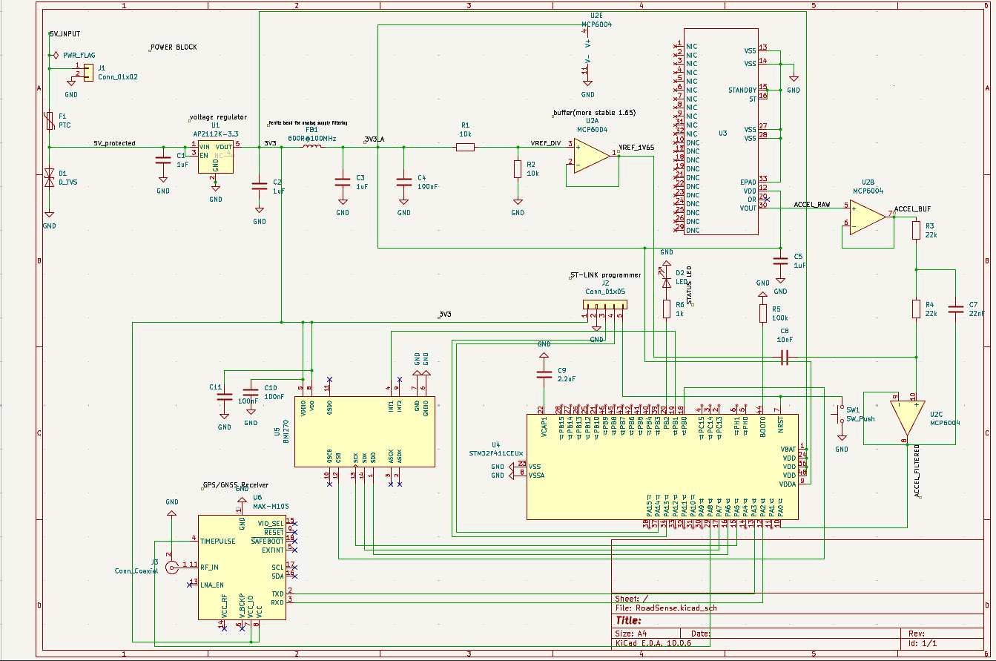
Figure 4. RoadSense system-level KiCad schematic.

2.4.1 Power Regulation and Protection
The PCB accepts a 5 V input at J1. F1 provides resettable over-current protection and D1 clamps input transients before the rail reaches the AP2112K-3.3 regulator. The AP2112 generates the 3.3 V digital rail used by the STM32, BMI270, and GNSS circuitry. C1 and C2 provide local input/output bulk capacitance at the regulator. A ferrite bead (FB1, 600 Ω at 100 MHz) separates the digital 3.3 V rail from the 3V3_A analog rail, with C3 and C4 providing local analog decoupling.
The analog midpoint is generated with R1 = R2 = 10 kΩ, giving 1.65 V from the 3.3 V analog rail, and is buffered by MCP6004 section U2A. The buffered VREF_1V65 node provides a low-impedance reference for the analog signal chain. This arrangement keeps switching noise from the MCU and SPI bus out of the analog path while maintaining the ADC signal near mid-supply.

2.4.2 STM32 Core, Reset, and Programming
The final PCB uses the STM32F411CEU6 directly rather than an STM32 development board. The MCU is powered from 3.3 V with the required VDD/VDDA decoupling placed close to the package. BOOT0 is held low during normal operation so the device boots from internal Flash. SW1 is connected to NRST for manual reset during bring-up and fault recovery.
Programming and debug are provided through the ST-LINK/SWD header. The header exposes SWDIO, SWCLK, NRST, target 3.3 V reference, and ground. Keeping this connector on the final board is required for first-power-up testing because it allows firmware download, breakpoint debugging, and inspection of reset/fault conditions without relying on a development board.

2.4.3 BMI270 Motion-Sensing Hardware
The BMI270 is connected as an SPI peripheral. SPI clock, MOSI, and MISO are routed to the STM32 SPI pins, with a dedicated chip-select signal and a separate interrupt/data-ready input. Local 100 nF and bulk decoupling are placed at the BMI270 supply pins. The IMU is mounted directly to the PCB with a fixed axis orientation so the firmware transformation from sensor coordinates to vehicle coordinates is deterministic.
SPI was selected instead of I2C because it provides deterministic full-duplex timing and ample bandwidth at the 400 sample/s target. The data-ready line is used as the acquisition trigger; the STM32 does not continuously poll the sensor. This makes the sample timestamp correspond to a hardware event rather than the scheduling delay of a software loop.

2.4.4 Analog Acceleration and Front-End Hardware
The analog acceleration path uses a single-axis high-g accelerometer on the 3V3_A rail. Its output is labeled ACCEL_RAW and is buffered with MCP6004 section U2B. The signal then passes through the MCP6004/RC filtering network before reaching the STM32 ADC as ACCEL_FILTERED. The 1.65 V buffered reference establishes the DC operating point needed for single-supply ADC acquisition.
The present filter network uses 22 kΩ resistors and 22 nF/10 nF capacitors. These values provide analog attenuation above the road-vibration band before the 8 ksample/s ADC stage. The exact transfer function will be verified with a swept-sine measurement rather than assumed from nominal component values; the measured response is part of the analog front-end R&V procedure. The analog sensor part number, symbol, footprint, and BOM entry must be kept consistent before fabrication.

2.4.5 MAX-M10S GNSS and Antenna Hardware
The MAX-M10S provides the location and timing interface. UART TX/RX connect directly to the STM32, and TIMEPULSE is routed to a timer-capable MCU pin for hardware timestamp capture. The RF_IN pin is routed to the coaxial antenna connector for the passive 1575.42 MHz GNSS antenna. Active-antenna supply/control pins are not required for the passive antenna configuration.
The RF trace is treated as a controlled-impedance path during PCB layout. The connection should be short, referenced continuously to ground, and kept away from fast digital edges. The antenna connector and surrounding copper keep-out must follow the selected connector and antenna recommendations to avoid unnecessary GNSS sensitivity loss.

2.4.6 Data Storage Hardware
RoadSense requires removable nonvolatile storage for event records and hazard lookup. The storage interface will use a microSD socket powered from 3.3 V and connected to the STM32 through a dedicated digital interface. The final schematic must include the socket, required pull resistors, local decoupling, and any card-detect or write-protect signals used by firmware. The interface assignment must also preserve enough MCU bandwidth for the concurrent BMI270, ADC, and GNSS acquisition paths.
Storage is event-based rather than continuous raw logging. This reduces write bandwidth and capacity requirements and makes it practical to use double buffering to tolerate occasional microSD write latency. The Raspberry Pi, if retained, is an offline mapping/visualization platform and is not part of the real-time classification dependency chain.

2.4.7 Warning and Status Hardware
The user-warning output is an audible buzzer or speaker driven through a transistor or dedicated driver stage controlled by an STM32 GPIO. The driver is required so the MCU pin only provides the control signal and does not source the full transducer current. The component choice will be made so the completed enclosure can meet the 80 dB at 1 m requirement.
A separate status LED is connected to the STM32 through a current-limiting resistor. The LED is used for power-up, logging, GNSS-lock, or error indication during testing. It does not replace the audible warning because the in-motion interface must not require the user to look at the device.

2.4.8 PCB Layout and Pre-Fabrication Integration
- Place the BMI270 and analog accelerometer in a mechanically stiff region of the PCB and document their axes on the silkscreen so the firmware coordinate transform is unambiguous.
- Keep ACCEL_RAW, VREF_1V65, and ACCEL_FILTERED short and separated from SPI, SWD, clock, and other fast digital traces. Maintain a continuous ground reference and avoid routing digital return current through the analog measurement path.
- Place regulator, MCU, BMI270, GNSS, and analog decoupling capacitors immediately adjacent to the associated supply pins. The filtered 3V3_A branch should feed only the analog chain.
- Route the GNSS RF path as a short 50 Ω trace with a continuous ground reference and antenna keep-out consistent with the selected antenna/connector geometry.
- Keep the SWD header and reset switch accessible after enclosure assembly. Add labeled test points for 5V_PROTECTED, 3V3, 3V3_A, VREF_1V65, ACCEL_RAW, ACCEL_FILTERED, TIMEPULSE, and at least one diagnostic GPIO.
- Before release to fabrication, close the microSD interface and audible-warning driver and reconcile the analog-sensor part number, reverse-polarity protection, status-LED resistor, and start/stop control with the BOM and schematic.

2.5 Software Design

2.5.1 Sensor Acquisition and Timing
The BMI270, analog ADC, and GNSS receiver operate at different rates, so the first software task is to place all measurements on one timeline. BMI270 data-ready interrupts initiate SPI reads at 400 samples/s. The ADC is started by a hardware timer at 8 ksample/s and transferred in blocks so high-rate acquisition does not depend on software-loop timing. GNSS UART data are buffered and parsed independently of the high-rate sensor path.
GNSS TIMEPULSE is captured by an STM32 timer once per second. The timer count at each pulse anchors the MCU time base to GNSS time, and the free-running counter is used to timestamp sensor samples between pulses. This synchronization is required because event classification combines motion features with the position and speed recorded for the same road event.

2.5.2 Signal Filtering and Orientation Compensation
The analog channel is digitally low-pass filtered before decimation from 8 ksample/s to at least 1 ksample/s. The high acquisition rate reduces sensitivity to analog-filter roll-off near the processing band and leaves margin for digital anti-alias filtering. Filter coefficients will be fixed in firmware after the analog front-end transfer function is measured on the assembled board.
The BMI270 accelerometer and gyroscope are combined with a complementary orientation filter. The accelerometer provides the long-term gravity reference, while the gyroscope tracks short-term rotation without being dominated by the instantaneous road impact. Gravity is removed and the remaining acceleration is rotated into the vehicle frame before event detection. This prevents mounting angle, braking, and cornering from directly appearing as vertical road acceleration.

2.5.3 Road Event Detection
Event detection runs continuously on the corrected vertical acceleration. A slowly varying baseline follows changes in average road roughness, and a candidate event is opened when the vertical signal exceeds the calibrated deviation threshold. The firmware preserves pre-trigger and post-trigger samples so the classifier receives the complete transient rather than only the peak sample.
A refractory interval suppresses repeated detections caused by suspension ringing after one defect. Events dominated by longitudinal or lateral acceleration can also be rejected as braking or turning. Thresholds and time windows are calibration parameters and will be selected using the surveyed-route dataset rather than fixed solely from simulation.

2.5.4 Event Classification and Severity
Each event window is evaluated in the frequency domain. The classifier integrates vertical-acceleration energy in a slow band from 0.8 to 3 Hz and a fast band from 8 to 40 Hz, then forms R = E_slow/E_fast. The quarter-car analysis in Section 2.6 predicts a large R for a speed bump and a small R for a pothole because the two inputs excite different vehicle modes.
Two secondary features are used to reduce ambiguous classifications. The sign of the first vertical motion distinguishes an initial wheel drop from an initial wheel rise, and event duration multiplied by GNSS speed estimates the physical length of the road defect. Severity is based on peak corrected vertical acceleration with speed compensation and is quantized to a small stored scale for comparison across trips.

2.5.5 Data Logging
The firmware writes one fixed-format record per accepted event. The record contains classification, severity, latitude, longitude, speed, timestamp, sequence number, and integrity check. Two RAM buffers are used alternately so sensor acquisition continues while the inactive buffer is being written to the microSD card. If both buffers become unavailable, the overrun is counted and reported instead of silently dropping data.

2.5.6 Hazard Lookup and User Warning
During a trip, the current GNSS position is compared against the stored hazard database. Hazards are grouped spatially so the MCU only evaluates records near the current position. A warning is generated when a stored event exceeds the severity threshold and falls inside the configured look-ahead distance.
The warning output is rate-limited so several nearby defects do not produce a continuous tone. At 30 km/h, the 30 m look-ahead distance corresponds to approximately 3.6 s of travel time, which provides margin over the 2 s minimum warning requirement when GNSS and lookup latency are within specification.

2.6 Tolerance Analysis
The classification margin is evaluated with a standard quarter-car model because the second high-level requirement depends on potholes and speed bumps producing measurably different motion. The model represents one vehicle corner as a sprung body mass and an unsprung wheel/hub mass connected through suspension and tire stiffness. The resulting body and wheel-hop modes define the frequency bands used by the classifier.
Quantity | Symbol | Value
Body mass over one wheel | m_s | 300 kg
Wheel and hub mass | m_u | 40 kg
Suspension spring rate | k_s | 20,000 N/m
Suspension damping | c_s | 1,500 N·s/m
Tire vertical stiffness | k_t | 200,000 N/m

Using these values, the approximate body mode is (1/2π)√(k_s/m_s) = 1.30 Hz and the wheel-hop mode is (1/2π)√((k_s+k_t)/m_u) = 11.80 Hz. The modes are separated by approximately a factor of nine. A speed hump therefore primarily excites the low-frequency body mode, while a short pothole edge can strongly excite the wheel-hop mode.
The classifier integrates spectral energy over 0.8-3 Hz (slow band) and 8-40 Hz (fast band) and forms R = E_slow / E_fast. The existing simulation used a 3.7 m, 90 mm speed hump at 15 mph and a 0.5 m, 60 mm pothole at 30 mph. The simulated energy values were:
Event | Slow-band energy | Fast-band energy | R
Speed bump | 3.71 × 10^-2 | 6.26 × 10^-4 | 59.3
Pothole | 4.94 × 10^-6 | 3.41 × 10^-4 | 0.01

The simulated R values are separated by roughly four orders of magnitude. A decision boundary near R = 1 places the speed-bump case at R = 59.3 and the pothole case at R = 0.01, leaving a large nominal separation before vehicle-to-vehicle variation is considered. The first-motion polarity gives a second independent cue because the wheel initially drops into a pothole but rises onto a speed bump. The useful classification energy extends to roughly 40 Hz, which is why the BMI270 target rate is 400 samples/s rather than the 100 samples/s minimum used in the earliest requirement draft.
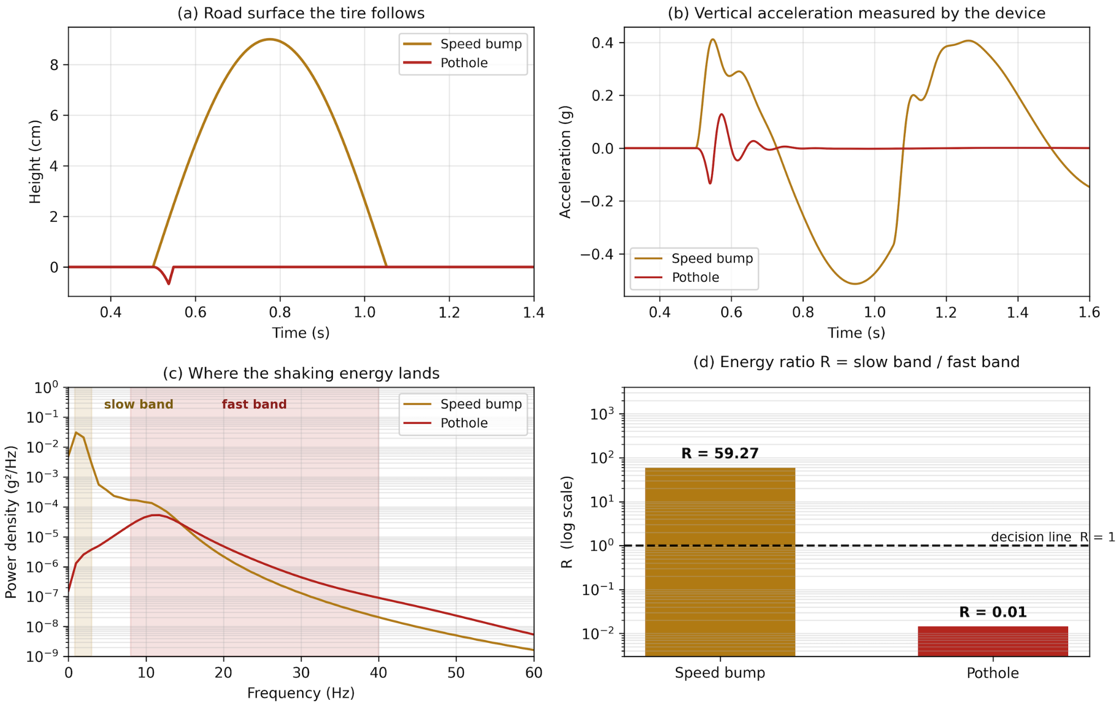
Figure 5. Quarter-car simulation used to compare the speed-bump and pothole response in the slow and fast frequency bands.
Known limitation: a bicycle does not have an automotive suspension, so its dominant structural and wheel frequencies differ from the quarter-car model. Bicycle operation therefore requires a separately calibrated decision boundary and validation dataset rather than assuming the automobile value of R transfers directly.

2.7 Engineering Risk Analysis
The analog front end and ADC chain remain the highest-risk hardware block because an analog error can produce data that appears numerically valid while representing the wrong physical motion. The main concern is aliasing or unintended filter behavior. A component-value or topology error can fold out-of-band vibration into the measured band and create events that the classifier cannot distinguish from real road signals.
This risk is reduced in three ways. First, the analog transfer function is measured with a swept-sine input before road testing and compared with the calculated response. Second, the ADC is sampled at 8 ksample/s and digitally filtered before any reduction to the 1 ksample/s processing rate, leaving more transition band than direct 1 ksample/s sampling. Third, the BMI270 supplies an independent measurement of the same event over an overlapping frequency range, so analog-only detections can be identified as suspect during calibration.
A second risk is loss of recorded data during storage latency or unexpected power removal. Double buffering, sequence numbers, integrity checks, and explicit overrun counters prevent silent data loss. A third risk is incomplete board integration. The microSD interface and audible-warning driver must be closed before fabrication, and the analog-sensor part number and protection components must match the BOM and footprint. These are pre-fabrication gates because they map directly to the storage, warning, and sensing requirements.

3 Cost and Schedule

3.1 Cost Analysis

3.1.1 Labor
Grainger reports an average starting annual salary of $87,429 for recent Illinois electrical engineering graduates [16]. Using 2,080 work hours per year gives an hourly rate of approximately $42.03. Following the ECE 445 design-document convention, labor cost is estimated as hourly rate × 2.5 × project hours. Assuming 10 hours/week for 12 project weeks gives 120 hours per team member:
Per-person labor = $42.03/hour × 2.5 × 120 hours = $12,609.
Three-person team labor = 3 × $12,609 = $37,827.
Team member | Primary responsibility used for planning | Estimated hours | Estimated labor cost
Adam Moine | Analog/board hardware: AFE, power, schematic, PCB, parts, assembly, bring-up | 120 | $12,609
D’Angelo Manzo | Embedded software: STM32 drivers, timing, event processing, logging | 120 | $12,609
Jovan Kular | Onboard-computer/map/model software, ground-truth data and accuracy analysis | 120 | $12,609
Total |  | 360 | $37,827

3.1.2 Parts and Materials
The project BOM contains a mix of course-stock components and outside purchases. The table below uses budgetary values for purchased items and treats course inventory as zero incremental project cost. Final unit prices will be replaced with E-Shop or vendor receipts after ordering. The analog-accelerometer line item must match the final schematic symbol and footprint before the BOM is frozen.
Item | Qty | Source | Budgetary project cost
STM32F411CEU6 | 2 | ECE Shop / TA SMD order | $0 incremental (course inventory/order)
BMI270 | 2 | ECE Shop / TA SMD order | $0 incremental (course inventory/order)
MAX-M10S-00B | 1-2 | ECE Shop / TA SMD order | $0 incremental (course inventory/order)
AP2112K-3.3TRG1 | 2 | ECE Shop / TA SMD order | $0 incremental (course inventory/order)
MCP6004T-I/SL | 2 | ECE Shop / TA SMD order | $0 incremental (course inventory/order)
ADXL1002BCPZ | 1 | Outside purchase | ~$40.88 budgetary list price [12]
Passives, protection parts, headers, LED, switches | 1 set | ECE Shop / inventory | $0 incremental; replacement value TBD
1575.42 MHz passive GNSS antenna + U.FL connector | 1 | Outside purchase | ~$12 budgetary
GNSS matching-network parts | 1 set | Outside purchase | ~$3 budgetary
10,000 mAh USB power bank | 1 | Retail | ~$25 budgetary
32 GB high-endurance microSD | 1 | Retail | ~$12 budgetary
Standoffs, tether, cables, mounting hardware | 1 set | Outside / ECE supply | ~$25 budgetary
Raspberry Pi (optional mapping/model layer) | 1 | Model not specified | TBD; excluded until model is selected

The present outside-purchase subtotal, excluding an optional Raspberry Pi, is approximately $118. Including the labor estimate gives a project estimate of approximately $37,945 before any non-course-funded PCB or enclosure expense. The parts values are budgetary and will be replaced by actual purchase prices in the final report.

3.2 Schedule
The schedule below follows the Fall 2026 ECE 445 milestones, including Design Review during the week of October 5, Breadboard Demo during the week of October 12, Progress Demo during the week of November 2, Mock Demo during the week of November 16, Final Demo/Presentation during the week of November 30, and the final paper during the week of December 7 [17].
Week of | Adam | D’Angelo | Jovan | Shared milestone
9/28 | Finalize power/AFE/PCB schematic; run ERC and PCB audit fixes | Freeze STM32 interfaces and sensor-rate/timing plan | Freeze event-record/map input format | Design document + first PCB order
10/5 | Apply Design Review PCB corrections; second-order board if needed | Bring up SPI BMI270, ADC timing, GNSS UART/PPS drivers | Implement event ingestion/map database prototype | Design Review
10/12 | Breadboard/bench verification of 3.3 V, VREF, analog filter | Integrated sensor acquisition and timestamp logging | End-to-end event parsing and visualization | Breadboard Demo
10/19 | Assemble/bring up first PCB; measure rails and analog path | Port firmware to standalone board; SWD debugging | Connect mapping software to recorded event format | Subsystem integration
10/26 | PCB revisions if required; finalize enclosure/mount | Complete real-time detector and buffered storage path | Ground-truth route tooling and map lookup | Final PCB order window
11/2 | Hardware verification data and PCB fixes | Integrated firmware demo and latency measurements | Map/accuracy pipeline and route dataset | Progress Demo
11/9 | Road-test hardware reliability and AFE transfer-function validation | Tune event thresholds and classification logic | Evaluate GPS/map matching and classification results | Surveyed road testing
11/16 | Resolve hardware failures; prepare spare/repair plan | Mock-demo firmware freeze and logging robustness | Mock-demo map/warning integration | Mock Demo
11/23 | Only critical repairs; organize measurement results | Only critical firmware fixes; export logs | Analyze final dataset and figures | Fall Break / documentation
11/30 | Final hardware checklist and demo setup | Final embedded firmware and requirement-verification scripts | Final map/analysis interface and metrics | Final Demo + Presentation
12/7 | Hardware/design sections of final paper | Embedded/results sections of final paper | Map/accuracy/results sections of final paper | Final paper + lab checkout

4 Societal Impact, Engineering Standards, Ethics, and Safety

4.1 Societal Impact
RoadSense is intended to improve awareness of poor road and bike-lane conditions using a low-cost portable measurement platform. Better identification of potholes and rough pavement can improve rider comfort, help users avoid hazardous routes, and provide structured data that can support maintenance decisions. The project is especially relevant to micromobility users because bicycles, scooters, and skateboards have smaller wheels and are more sensitive to abrupt road defects. The system is advisory, not a certified safety device, and its measured accuracy must be communicated clearly so users do not assume that an absent warning proves the road ahead is safe.

4.2 Engineering Standards
The device contains no intentional radio transmitter; the MAX-M10S receives GNSS signals only. The assembled digital electronics therefore fall under the ordinary unintentional-radiator considerations of FCC Part 15 Subpart B [6]. Battery selection is limited to commercially manufactured packs with appropriate safety certification such as UL 2054 / IEC 62133-2 [5]. Vibration/severity interpretation is referenced to ISO 2631-1 [7], while road-surface profile reporting can be compared with ISO 8608 [8]. These standards provide externally defined terminology and safety expectations rather than requiring the team to invent its own definitions.

4.3 Ethics and Privacy
The clearest ethical concern is location privacy. A continuous travel history can reveal where a person lives, studies, and spends time. Research on human mobility has shown that a small number of time-and-location points can uniquely identify individuals in a large dataset [1]. The IEEE and ACM codes of ethics therefore apply directly to how RoadSense stores and shares location data [2], [3]. The project should avoid wireless upload by default, keep the storage physically controlled by the user, and share road-event information rather than a continuous personal travel history. The existing plan to discard the first and last portion of a trip can further reduce the chance of exposing a home location.
A second ethical requirement is honesty about system accuracy. A 90% pothole-detection target and 80% classification target still imply missed and mislabeled events. Results should therefore be presented with measured error rates and test conditions. RoadSense should be described as an advisory road-condition instrument, not as a system that guarantees accident prevention or safe passage.

4.4 Safety
The largest safety risk is vehicle testing, not electric shock. Road tests shall use at least two people whenever practical: one person operates the vehicle and one person monitors the experiment. No one shall configure, read, or troubleshoot the device while driving. Illinois restrictions on handheld electronic-device use while driving reinforce this procedure [4]. Test defects should be surveyed before driving over them, and the team should not deliberately strike hazards at unsafe speeds. Bicycle tests should use low-traffic routes in daylight, helmets, and a positive enclosure tether.
The electronics operate from a low-voltage 5 V source, but the battery pack can still present fire and short-circuit risk. Only intact commercially manufactured packs should be used; damaged or swollen packs should be retired. The PCB input PTC and transient clamp reduce the effect of wiring faults and voltage spikes. The enclosure must prevent conductive debris from shorting the PCB and must be secured so it cannot interfere with pedals, steering, vehicle controls, or bicycle wheels.

5 References
[1] Y.-A. de Montjoye, C. A. Hidalgo, M. Verleysen, and V. D. Blondel, “Unique in the crowd: The privacy bounds of human mobility,” Scientific Reports, vol. 3, 1376, 2013. https://www.nature.com/articles/srep01376
[2] IEEE, “IEEE Code of Ethics,” 2020. https://www.ieee.org/about/corporate/governance/p7-8.html
[3] ACM, “ACM Code of Ethics and Professional Conduct,” 2018. https://www.acm.org/code-of-ethics
[4] Illinois General Assembly, Illinois Vehicle Code, 625 ILCS 5/12-610.2 and 625 ILCS 5/12-503. https://www.ilga.gov/legislation/ilcs/ilcs3.asp?ActID=1815
[5] UL 2054, Standard for Household and Commercial Batteries; IEC 62133-2, Secondary Cells and Batteries Containing Alkaline or Other Non-Acid Electrolytes.
[6] Federal Communications Commission, 47 CFR Part 15, Radio Frequency Devices. https://www.ecfr.gov/current/title-47/chapter-I/subchapter-A/part-15
[7] ISO 2631-1:1997, Mechanical Vibration and Shock - Evaluation of Human Exposure to Whole-Body Vibration - Part 1: General Requirements.
[8] ISO 8608:2016, Mechanical Vibration - Road Surface Profiles - Reporting of Measured Data.
[9] T. D. Gillespie, Fundamentals of Vehicle Dynamics. Warrendale, PA: SAE International, 1992.
[10] American Society of Civil Engineers, Report Card for America’s Infrastructure: Roads, 2025. https://infrastructurereportcard.org/
[11] National Highway Traffic Safety Administration, Traffic Safety Facts: 2023 Data - Bicyclists and Other Cyclists, 2025. https://crashstats.nhtsa.dot.gov/
[12] Analog Devices, “ADXL1001/ADXL1002 Low Noise, High Frequency MEMS Accelerometers,” Rev. A, 2024. https://www.analog.com/en/products/adxl1002.html
[13] Bosch Sensortec, “BMI270 Datasheet,” BST-BMI270-DS000. https://www.bosch-sensortec.com/media/boschsensortec/downloads/datasheets/bst-bmi270-ds000.pdf
[14] u-blox, “MAX-M10 Series GNSS Modules.” https://www.u-blox.com/en/product/max-m10-series
[15] STMicroelectronics, “STM32F411CE High-performance access line.” https://www.st.com/en/microcontrollers-microprocessors/stm32f411ce.html
[16] Grainger College of Engineering, “Electrical Engineering - Outcomes and Starting Salary,” 2024-2025 data. https://grainger.illinois.edu/academics/undergraduate/majors-and-minors/electrical-engineering
[17] ECE 445 Senior Design Laboratory, “Fall 2026 Calendar.” https://courses.grainger.illinois.edu/ece445/calendar.asp

Appendix A - Procurement List
The procurement list below is maintained with the design BOM. Before fabrication and final ordering, the analog accelerometer, status-indicator resistor, start/stop control, reverse-polarity device, and optional Raspberry Pi entries must be reconciled with the released schematic and PCB footprint set.
Item | Qty | Source | Notes
22 kΩ 1% 0805 resistor | 10 | E-Shop | Need 6 minimum; extras recommended
22 nF 0805 capacitor | 5 | E-Shop | Need 3 minimum
10 nF 0805 capacitor | 5 | E-Shop | Need 3 minimum
100 nF ceramic 0805 capacitor | 20 | E-Shop | General decoupling
1 µF ceramic 0805 capacitor | 10 | E-Shop | Decoupling
4.7-10 µF ceramic capacitor | 5 | E-Shop | Bulk rail decoupling
10 kΩ 1% 0805 resistor | 10 | E-Shop | Reference / pull resistors
330 Ω LED resistor | 6 | E-Shop | Reconcile with final status-LED resistor value
22 Ω resistor | 4 | E-Shop | USB D+/D- series resistors if used
5.1 kΩ resistor | 4 | E-Shop | Only if using USB-C
Indicator LEDs | 3 | ECE 445 Inventory / E-Shop | GPS lock, recording, error
Start/Stop pushbutton | 1 | E-Shop | Separate from NRST if used
SWD / debug header | 1 | E-Shop | Program/debug STM32
Board/power headers & connectors | 1 set | E-Shop | Match PCB/cables
8 MHz crystal / oscillator | 1 | E-Shop / TA order | Confirm footprint and whether used
Crystal load capacitors | 2 | E-Shop | Value depends on crystal
Ferrite bead | 1 | E-Shop / TA order | Filtered analog supply
PTC resettable fuse | 1 | ECEB 2070 / E-Shop | Input protection
P-channel MOSFET | 1 | ECEB 2070 / E-Shop | Planned reverse-polarity protection
TVS / spike clamp | 1 | E-Shop / TA order | Input transient clamp
AFE protection resistors/diodes | 3 sets | E-Shop | Analog protection
STM32F411CEU6 | 2 | E-Shop / TA SMD order | Main MCU + spare
BMI270 | 2 | E-Shop / TA SMD order | IMU + spare
MAX-M10S-00B | 1-2 | E-Shop / TA SMD order | GNSS receiver
AP2112K-3.3TRG1 | 2 | E-Shop / TA SMD order | 3.3 V regulator + spare
MCP6004T-I/SL | 2 | E-Shop / TA SMD order | Analog front end / reference
M3 screws, nuts, washers | 1 set | ECE Supply Center | PCB/enclosure hardware
M4 bolts, nuts, washers | 1 set | ECE Supply Center | Bike clamp hardware
Rubber cable grommet | 1 | ECE Supply Center | Cable strain relief
Velcro / mounting strap | 1 | ECE Supply Center | Car mounting
Cable ties / jumper wires | 1 set | ECE Supply Center | Prototype / strain relief
Prototype project box | 1 | ECE Supply Center | Optional early prototype
ADXL356CEZ | 1 | Online | Verify against final schematic symbol and footprint
1575.42 MHz passive GNSS antenna | 1 | Online | GPS/Galileo compatible
U.FL / IPEX PCB connector | 1 | Online | If using cabled GNSS antenna
GNSS matching-network parts | 1 set | Online | Final values depend on antenna/layout
USB ESD protection array | 1 | Online | Only if USB is retained
10,000 mAh USB power bank | 1 | Online / retail | Power source
32 GB high-endurance microSD | 1 | Online / retail | High-endurance removable storage
M3 6 mm metal standoffs | 4 | Online | Mechanical mounting
Bike safety tether / lanyard | 1 | Online / hardware store | Secondary retention
USB cables | 1-2 | Online / ECE Supply Center | Depends on final interfaces
Raspberry Pi | 1 | TBD | Optional map/model layer; model not specified

