Lab 0: Introduction to MATLAB and Equipment
Report by: [Enter your name]
Lab partner: [Enter partner name or “None”]
Lab TA: [Enter TA name]
Section: [Enter section]

Report guidelines
For this report, you will need the following three files:
- LabReport0.m (the main file that runs the other two files)
- StepResponseMetrics.m (the file you will edit to display overshoot, rise time, and settling time)
- controllerlab0.mdl (a Simulink model)
Save all three files in the same directory. You only need to edit StepResponseMetrics.m. Run all three files by entering LabReport0 in the MATLAB Command Window; LabReport0.m calls the other two files.

What to hand in
1. Completed report template. Replace the bracketed student-information placeholders above.
2. MATLAB M-file. Submit the M-file with the report.
3. Step-response printout. The printout must show overshoot (Mₚ), rise time (tᵣ), and settling time (tₛₛ), with titles, axis labels, values, and reference lines similar to the example below.
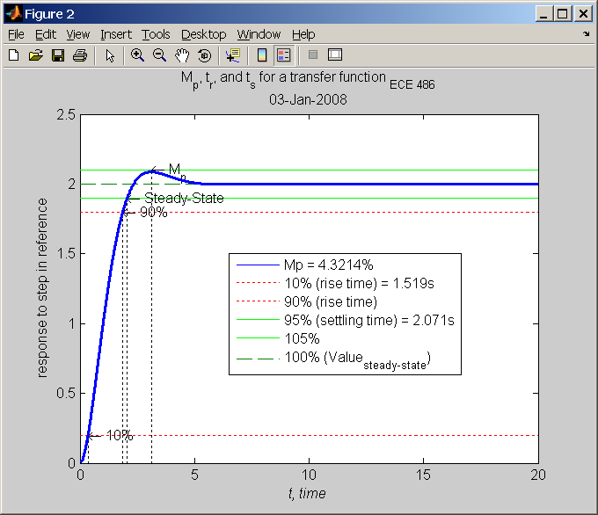
Figure 1. Example MATLAB step-response graph.
Figure description: The horizontal axis is time from 0 to 20 seconds, and the vertical axis is response to a step in reference from 0 to 2.5. The blue response rises above the steady-state value of 2.0, reaches an example overshoot of about 4.32 percent, and then settles. Dotted reference lines identify 10 percent and 90 percent rise-time levels; green lines identify the 95 percent, 100 percent, and 105 percent settling levels.
Required graph content: Show Mₚ, tᵣ, and tₛₛ values and use comparable titles, axis labels, and reference lines.

Grading rubric
Table 1. Lab 0 rubric showing each major section, its maximum score, and the point breakdown for its subcriteria.
Section | Section maximum | Subcriterion or requirement | Subcriterion points
Prelab | Not graded | None: No prelab is required. | --
Graph | 15 | Required graph with the specified title, axis labels, values, and reference lines. | 15
M-file | 15 | Required MATLAB M-file. | 15
Report | 20 | Correct value of Mₚ (percent overshoot). | 3
Report | 20 | Correct value of tᵣ (10–90% rise time). | 3
Report | 20 | Correct value of tₛₛ (settling time). | 3
Report | 20 | Ten correct graph and reference lines (1 point each × 10). | 10
Report | 20 | Student name and section information. | 1
Report subtotal | 20 | Correct values (3 + 3 + 3) + graph lines (10) + identification (1). | 20
Submission total | 50 | Graph (15) + M-file (15) + Report (20). | 50

