Name_________________________________

Topics covered in this lab:

- How to plot points
- Displacement and Distance
- How to represent motion with graphs
- Velocity
- Acceleration

Graphing Points:

These are the X and Y axes of a graph:

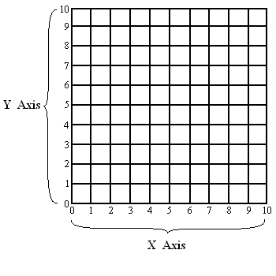
The axes can represent almost anything. For example, you could graph months on the X-axis, and the average temperature on the Y-axis, to show the change in temperature over a year.

Points on the axes can be expressed in the form: (X, Y) - where the first number corresponds to the X value and the second number corresponds to the Y value. Below is a list of points. Plot them on Graph 1 below. The first point is already done to get you started.

- (3, 5) (1, 2) (8, 10) (0, 4) (5, 5.5) (6.3, 8) (6, 2 ⅔)

Graph 1:

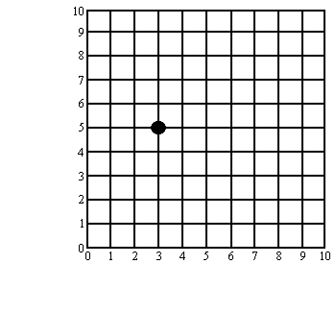
Now plot these on Graph 2 of the next page:

- (January, 32°F) (February, 39°F) (March, 47°F) (April, 54°F) (May, 65°F) (June, 73°F) (July, 78°F) (August, 76°F) (September, 64°F) (October, 51°F) (November, 40°F) (December, 35°F)

Graph 2:
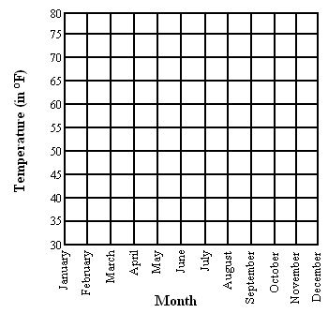

Displacement and Distance:

A girl walks 5 meters forward, then turns around and walks 4 meters backward, and then 7 meters forward again, as shown by the diagram below.

5m
7m
4m

How far did she walk?

How far from the starting point does she end up?

What the distinction is between these two ways of looking at her movement? Discuss as a class.

Experiment 1: Velocity

Materials:
- Balls
- People
- Stopwatches

The purpose of this experiment is to keep track of where a moving object is at various times. This can be done by noting the time when the object passes each of several
checkpoints. This experiment will be done in the hallway to provide lots of room. You will investigate several different kinds of moving objects. People, Balls and Pucks.

The class will split into two groups for the rest of the exercises in this lab. In each group there will be one person in charge of movement, one in charge of collecting and writing down the data, and ten or so checkpoint timers. You can switch people’s roles around for different experiments if you feel like it.

In each experiment there will be an object (a person, a puck, or a ball) that starts moving at the Start Line and then passes each of the checkpoints. The idea is to record how long it takes the object to reach each of the checkpoints and then use this information to learn about displacement, velocity, and acceleration.

Each checkpoint timer should be assigned a checkpoint along the path of the moving ball. Checkpoints should be spaced 5 floor-tiles apart. The first checkpoint should be 5 floor-tiles from the starting point. If you want to your team can put down some masking tape to help you keep track of where the starting line and checkpoints are.
Start
cp 1
cp 2
cp 3
cp 4
cp 5
cp 6
cp 7
cp 8
cp 9
cp 10

What does the number of each checkpoint tell you?

Each checkpoint timer should have a stopwatch. All the timers should push their start buttons at the same time when the object passes the starting point. Each timer should push their own stop button when the object passes their checkpoint.

What will the timer readings tell you?

Velocity: In this first trial, you will be measuring the velocity of various objects.
Step 1: Have your movement person walk slowly with constant speed from the starting line along the track, past the last checkpoint. She should start walking a few steps before the starting line so she is “up to speed” by the time she gets to the starting line. When she passes the starting line she should say “start” (or something like that) so that all of the checkpoint timers can start their stopwatches.

Practice a few times until you can repeat the experiment the same way each time. When you are able to obtain more or less the same clock readings repeatedly, have the data person write down the timing numbers from each checkpoint. There is a sheet of paper labeled Time Data Table at the end of the lab write-up you may find useful for this.

Step 2: Once you have data that seems good, display your data on the following graph. For each checkpoint, plot the distance from the start line to that checkpoint (in units of “tiles”) on the Y-axis and the clock reading at that checkpoint on the X-axis. Label your axes carefully before you start so that the data fits nicely on the graph.

Is the motion uniform? How can you tell? Discuss with the instructor.

Step 3: In this experiment the points should nearly form a straight line. Draw the best straight line that you can to represent your data. What does the straightness of the graph tell you about the motion?

Compute and Slope and Y-intercept of the line (Slope equals change in Y divided by change in X, and the Y-intercept is the Y value where the line crosses the Y axis).
Discuss the meaning of these two quantities as a class.

Now repeat steps 1 through 3, but this time have your movement person walk about twice as fast as last time.

How does the new graph compare to the first one? How do the slopes compare?
Discuss as a class.

Now repeat steps 1 through 3, but this time have your “movement person” roll a basketball down quickly the track rather than walking.

Is it easier to correctly time a slow object or a fast one? How did this affect your graphs?

How does the new graph compare to the first one? How do the slopes compare?
Discuss as a class.
Follow up Questions:

If a car goes 60mph for 1 hour, what is the distance it has traveled?

If a car goes 60mph for 2 hours, what is the distance it has traveled?

If a car goes 30mph for 2 hours, what is the distance it has traveled?

Can you write a mathematical equation that relates the Distance, Speed, and Time for an object that is moving with constant speed? Check this with your classmates.

Endnote: The terms velocity and speed are often used interchangeably, but they are not the same thing. Speed tells you how fast an object is moving. Velocity is the same, except it tells which direction the object is moving as well. For example, a car’s speed could be: 30 mph. That same car’s velocity could be: 30 mph North.

Experiment 2: Acceleration

Materials:
- People and Pucks
- Stopwatches

We will now repeat the timing experiment, only this time we will be changing the velocity of the object as the object moves.

Have the movement person start at rest from the starting line. As soon as she says “start” she should start walking, very slowly at first, then faster, until she is running by the time she is at the 10th checkpoint. Try this a few times until you feel that you have some data that accurately shows someone smoothly speeding up from zero to running in the span of the ten checkpoints. Graph your results below.

How does this graph look different from the ones you made in Experiment 1? Compare your result to the other group.
Now let’s investigate something that is slowing down rather than speeding up. The instructor will give you a puck made from dry ice. This slides along the floor with a small amount of friction. The movement person should give it a hard enough initial push that it makes it all the way past checkpoint 10. You will probably have to practice a few times.

Is a straight line still a good fit to the data, or do you need to use a more curvy shape?

Draw a smooth curve by hand that comes close to most of the data points and indicates their general trend. How does the slope (steepness) of that curve at various times (X axis position) correspond to the speed of the puck at those times?

Go back and think about the experiment where the person was speeding up. Does the same rule about slope and speed apply to that situation? Discuss as a class.
Finally, let’s investigate something that is slowing down even more rapidly. The instructor will give you a roller-hockey puck. This slides along the floor with more friction than the dry ice puck. The movement person should give it a hard enough initial push that it makes it all the way past checkpoint 10. You will probably have to practice a few times.

Draw a smooth curve by hand that comes close to most of the data points and indicates their general trend. By looking at slopes, compare the speed of the dry ice puck at the starting line to the speed of the roller-hockey puck at the starting line.

Do the shapes of the last two curves suggest any particular mathematical formula? Discuss this as a class.

Time Data Table

Trial | cp 1 | cp 2 | cp 3 | cp 4 | cp 5 | cp 6 | cp 7 | cp 8 | cp 9 | cp 10
1
2
3
4
5
6
7
8
9
10
11
12
13
14
15
16
17
18
19
20
21
22
23
24

