Physics/Global Studies 280

Nuclear Weapons, Nuclear War, and Arms Control

Frederick K. Lamb

Final Examination
2006 May 8

Full Name ________________________________________________________

UIUC ID No. ______________________________

• This is a closed book examination. Giving or receiving unauthorized help is a violation of the University’s rules on academic integrity.

• You have the full exam period (180 minutes) to complete it.

• Answer all the questions on all 10 topics. The point value of each topic is indicated by a boldface number in square brackets, e.g., [30].

• The point value of each question within a topic is indicated by a boldface number in square brackets, e.g., [2].

• Write your answers in the spaces provided below each question. Do not submit any additional pages. If you need more room, write on the back of the preceding page.

• To receive full credit for definitions, give numbers where relevant.

Scores
1. ______
2. ______
3. ______
4. ______
5. ______
6. ______
7. ______
8. ______
9. ______
10. ______

Total ________
1. Physics of Nuclear Weapons [30]

(a) In the panel below, sketch the curve of binding energy per nucleon from A=1 to A=240. [6]

(b) What are the two fundamental forces responsible for the shape of this curve? [4]

(c) What is the definition of reactor-grade plutonium? [8]

(d) List two properties of reactor-grade plutonium that would interfere with its use as a nuclear explosive. [8]

i.

ii.

(e) Is it possible to make a functioning a nuclear weapon using reactor-grade plutonium? [4]

2. Modern Nuclear Weapons [30]

Shown below is a schematic diagram of a modern nuclear weapon.

(a) Number the arrows in the diagram above from 1 to 6 to indicate the locations of the following major components: (1) the pit, (2) the tamper/reflector, (3) the boost gas (at the time the weapon is detonated), (4) the high-explosive lens assembly, (5) the neutron emitting trigger, (6) the secondary. [6]

(b) Draw three additional arrows on the diagram above and label them A, B, and C to indicate the locations where (A) fissile material must be used, (B) ⁶Li-D is always used, and (C) either U-238 or depleted Uranium (DU) may be used to increase the total energy yield. [6]

(c) Describe in one or two sentences one function of the tamper/reflector. [6]

(d) Describe in one or two sentences how boosting increases the yield of the primary. [6]

(e) Describe in one or two sentences the roles of the ⁶Li and the D in the part of the device that contains ⁶Li-D. [6]

3. Definitions [30]

Define the following terms in one or two sentences.

(a) Minimal deterrence [2]

(b) Mutual assured destruction [2]

(c) Crisis stability [2]

(d) First strike [2]

(e) Second strike [2]

(f) Preventive war [2]

(g) Preemptive war [2]

Explain in two or three sentences why the following phrases are illogical.

(h) “war on terror” [8]

(i) “war on terrorism” [8]

4. North Korea’s Nuclear Program [30]

(a) Did North Korea sign the Nuclear Nonproliferation Treaty (NPT)? [2]

(b) Did North Korea ever comply fully with the NPT? [2]

(c) What North Korean action led to negotiation of the “Agreed Framework”? [2]

(d) State one U.S. obligation under the “Agreed Framework”. [3]

(e) State one North Korean obligation under the “Agreed Framework”. [3]

(f) Is the “Agreed Framework” still in force? [2]

(g) When did North Korea start reprocessing material from its nuclear reactor at Yongbyon? [2]

(h) What nuclear weapon material is North Korea thought to have obtained from this reactor? [2]

(e) Approximately how many nuclear weapons is North Korea thought to have today? [2]

(i) What other nuclear weapon material is North Korea thought to be producing now? [2]

(j) What technology is North Korea using to produce this other nuclear weapon material? [2]

(k) What country gave North Korea this technology? [2]

(l) What weapon did North Korea provide in return? [2]

(m) What is the current status of negotiations to limit North Korea’s nuclear weapon program? [2]

5. Iran’s Nuclear Program [30]

(a) Did Iran sign the Nuclear Nonproliferation Treaty (NPT)? [2]

(b) Is Iran currently a party to the NPT? [2]

(c) Does Iran currently have an operating nuclear reactor? [2]

(d) What is the IAEA? [2]

(e) Are all of Iran’s nuclear facilities currently under full IAEA Safeguards? [2]

(f) What technology is Iran currently using to make special nuclear material? [2]

(g) From what source did Iran obtain this technology? [2]

(h) What type of special nuclear material is Iran currently producing using this technology? [2]

(i) About how many nuclear weapons is Iran thought to have today? [2]

(j) What is the range of the longest-range nuclear-capable ballistic missile Iran has tested? [2]

(k) Is it capable of reaching Israel? [2]

(l) Is it capable of reaching Europe? [2]

(m) With what state did Iran’s senior cleric recently offer to share Iran’s nuclear technology? [2]

(n) What country has Iran’s President recently threatened to destroy using nuclear weapons? [2]

(o) What action has the IAEA recently taken regarding Iran? [2]

6. The Nuclear Nonproliferation Regime [30]

(a) The NPT is essentially a grand bargain between two categories of states. What are these two categories? [6]

i.

ii.

(c) What is the bargain between these two categories of states? [4]

(d) Which of the following countries are currently parties to the NPT? [circle their names] [8]

Brazil China Pakistan India Iran Israel North Korea South Korea

(e) President Bush has recently signed a nuclear pact with India.

i. What is one thing India gains from this pact? [4]

ii. What is one thing the United States hopes to gain from this pact? [4]

(f) It has been claimed that this pact violates U.S. law as well as nonproliferation agreements to which the U.S. is a party. List two reasons for this claim. [4]

•

•

7. Nuclear Delivery Methods and Likely Consequences of Nuclear Events [30]

(a) Decode the following acronyms for delivery systems and state their ranges. [8]

• ICBM

• SRBM

• IRBM

• MRBM

(b) What is the approximate length and diameter a modern long-range cruise missile? [2]

(c) About how far can a modern, nuclear-tipped long-range cruise missile fly? [2]

(d) List two nuclear weapon delivery methods that are among the methods most likely to be used to attack the territory of the U.S., according to the U.S. intelligence community. [4]

•

•

(e) List two reasons an attacker is likely to prefer one of these methods. [4]

•

•

(f) List two likely consequences of exploding a 10 kiloton nuclear bomb in Manhattan. [5]

•

•

(g) List two likely consequences of exploding a radiological truck bomb in Manhattan. [5]

•

•

8. Attempts to Defend Against Ballistic Missiles [30]

(a) What year did the United States first begin work on a defense against ballistic missiles? [2]

(b) In what year did the United States first declare a missile defense system “operational”? [2]

(c) About how much did that missile defense system cost, in current U.S. dollars? [2]

(d) How long was that missile defense system operational? [2]

(e) What is the goal of the ground-based missile defense system being built today? [2]

(f) What year did this ground-based missile defense system become operational? [2]

(g) What is the hoped-for use of the Airborne Laser? [2]

(h) About how long has the Airborne Laser been under development? [2]

(i) How many successful intercepts has the Airborne Laser achieved in the past two years? [2]

(j) What is the current annual cost of the U.S. program to defend against ballistic missiles? [2]

(k) What are two of the supposed advantages of a boost-phase-intercept missile defense? [4]

•

•

(l) What are three major disadvantages of a boost-phase-intercept missile defense? [6]

•

•

•
9. Preventing Nuclear Terrorism [30]

In his book Nuclear Terrorism, Graham Allison lists three “No’s” that he argues must be accomplished to prevent nuclear terrorism. (i) List his three “No’s”, (ii) explain briefly what each means, and (iii) give an example of how each is currently being violated. [18]

(a)

•

•

•

(b)

•

•

•

(c)

•

•

•

In Nuclear Terrorism, Allison lists seven “Yes’s” that he argues must be accomplished to achieve his three “No’s”. (i) List three of his “Yes’s” and (ii) explain briefly what each means. [12]

(d)

(e)

(c)

10. Arms Control Agreements and Verification Technologies [30]
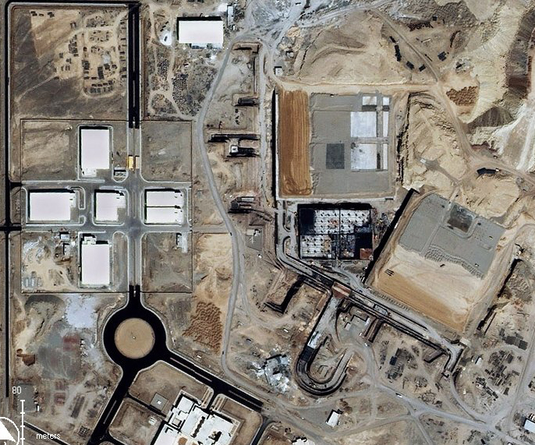
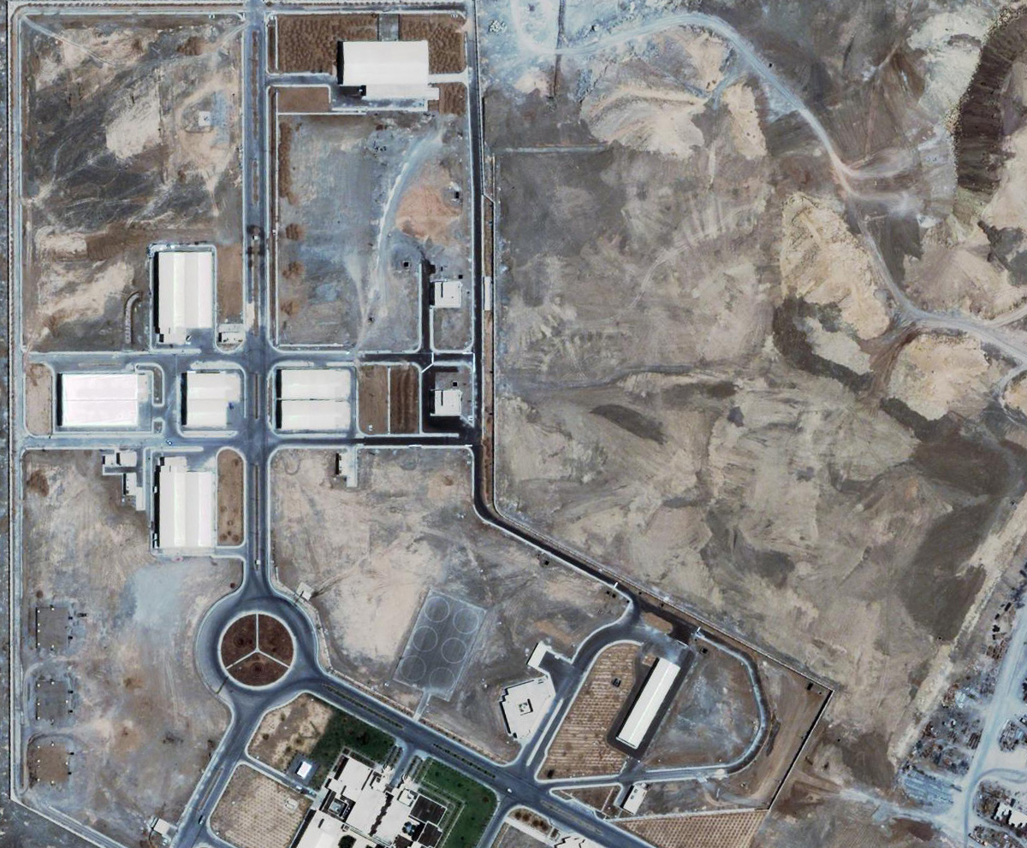

Consider the two photographs displayed above.

(a) These photographs are of a particular location. Where is this location? [4]

(b) Which photograph (the one on the left or the one on the right) was taken first? [2]

(c) What do the photographs show? [2]

(d) Why are they important? [4]

Answer the following questions about arms control treaties.

(e) According to the Law of Treaties, a state that has signed a treaty is not required to comply with it until it has gone into force. (Yes or no.) [2]

(f) What is the difference between an Executive Agreement and a Treaty? [4]

(g) What year was the Strategic Offensive Reductions Treaty (SORT) signed? [2]

(h) Which states are parties to SORT? [2]

(i) What year does SORT enter into force? [2]

(j) What year does SORT expire? [2]

(k) Which of the following types of weapons are banned by the Outer Space Treaty? [4]

• Anti-satellite weapons

• Intercontinental-range ballistic missiles

• Orbiting nuclear weapons

• Space weapons designed to attack targets on the ground

