Detecting Pesticides in UIUC Greenhouses
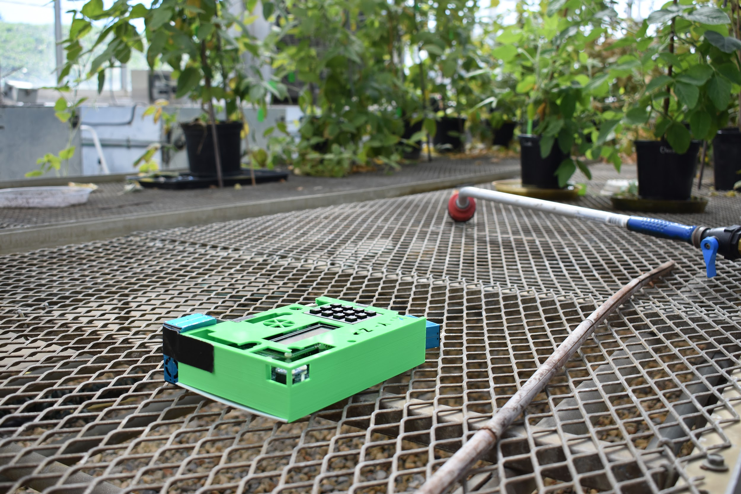

PHYS 398 DLP
Nat, Dav, Mat, Zac
Spring 2019
1. Abstract
Printed Circuit Board (PCB) devices were created from breadboard prototypes to detect airborne particles. Devices were created using Arduino compatible hardware. These devices were used in an separate greenhouse rooms to determine how long aqueous pesticides remained in the air. The four chemicals present in the pesticides are buprofezin, acetamiprid, azadirachtin, and capsicum oleoresin extract. This study was an initial test of the devices in a controlled greenhouse setting to eliminate environmental variables such as wind, dust from nearby roads, or pesticides from other fields. We found that particulate levels decrease similarly to a falling exponential curve after spraying was completed. This behavior suggests that chemical levels in the air fall to safe levels significantly before current guidelines allow re-entry into greenhouses.

2. Introduction
Various pesticides have been of concern to the public in recent years for being harmful to the environment. Some pesticides are suspected to contribute to the decrease of bee and other insect populations. For example, in the United States, the monarch butterfly population has dropped by 90% and the rusty-patched bumblebee dropped by 87% over the last 20 years^{[2].} A German entomology group, the Krefled Society, found that flying insect populations have decreased by 75% over the last 27 years in German nature reserves^{[2]}. Since the quantity of insect populations was not closely monitored, the data that approximates these decreases are very important. The exact problem has not yet been pinpointed, but the working hypothesis is that a combination of habitat loss and the overuse of pesticides are causing this drastic decline in population. Furthermore, the species that rely on insects as a primary food source, such as many fish and birds, have been suffering from this disturbance in the natural food chain^{[2]}. The purpose of this experiment was to acquire more data on pesticide use in order to learn more about their potential externalities. Buprofezin, acetamiprid, azadirachtin, and capsicum oleoresin extract are the chemicals tested in this study. Buprofezin is labeled as a health hazard and an environmental hazard, and is known to be very toxic to aquatic life as well. Acetamiprid is also known to be harmful to aquatic life with long-term effects. It is also classified as a moderately toxic or irritating substance. Safety data sheets say to “avoid release to the environment.” While Azadirachtin is not as hazardous as buprofezin or acetamiprid, it may cause eye, skin, and respiratory irritation when used in its pure solid form. Capsicum oleoresin extract can cause serious eye damage, but does not appear to have an environmental impact.
This study seeks to determine how these chemicals persist in the air. The motivation for this comes from a combination of the environmental and human impacts of airborne chemicals. Testing the volatility of these compounds will show how the air is affected after spraying the pesticides as well as the time-scales for the chemicals to reach safe levels.

3. Hardware
The PCBs utilized in the experiment were constructed from sensors compatible with an Arduino Mega 2560. The sensors used include a BME680, a PM 2.5 Air Quality Sensor, a Ultimate GPS, a Precision I2C RTC, a Micro SD Breakout, and an INA219 DC Current Sensor. These sensors and their functions are described in detail in Sections 3.1 through 3.7. In order for the PCB to run, we used ten 1.5 V batteries in series along with an on-off button. Combined, these Arduino-compatible sensors run alongside each other to collect atmospheric and air quality data at specific times.

3.1 Arduino Mega 2560: The Arduino is an open source microcontroller which is based around the ATmega2560 chip. It is equipped with 54 digital I/O pins, a USB connection, power jack, reset button and a 16 MHz quartz crystal. It has a flash storage of 256 KB.

3.2 BME 680: This sensor is capable of measuring a wide array of atmospheric data, including temperature, pressure, humidity, altitude, and concentrations of volatile organic compounds.
i. Temperature:
The temperature sensor measures the resistance of a particular material, which changes in resistance as it gets hotter or colder, and is accurate between -25 and 85 °C.
ii. Pressure:
The BME680 is an absolute barometric pressure sensor, meaning that it compares the pressure of the external atmosphere to a perfect vacuum. A chamber is vacuum sealed above a liquid source, and the liquid is allowed to be pushed by the outside atmosphere. The changes in the liquid indicate a change in pressure. The pressure sensor in the BME680 can operate between most accurately between 0 and 65 °C, and between 300 and 1100 hPa.
iii. Humidity:
Humidity is measured via a change in capacitance when a dielectric material capable of absorbing moisture changes its dielectric constant. By applying a constant voltage over the capacitor, the BME680 can measure when the capacitance changes and interpret the relative humidity in the atmosphere from previous calibrations. The humidity function can operate between -40 and 85 °C and a relative humidity of 0 to 100%, but only has full accuracy from 0 to 65 °C and a relative humidity of 10 to 90%.
iv. Gas Sensor:
To measure the volatile organic compounds (VOCs) in the air, the BME680 uses a small sheet of gas sensitive metal oxide based material. On one side is a hot plate that raises the temperature of the material, where the other side provides a voltage across the material. At higher temperatures (ranging from 200 °C and 400 °C) the metal oxide sheet can absorb gas molecules on its surface, creating free charge carriers and changing the resistance measured by the sensor. The VOC sensor can operate between -40 and 85 °C, and a relative humidity between 10 and 95%.

3.3 PM 2.5 Air Quality Sensor: The PM2.5 Air Quality Sensor is able to measure the number of particles in the air based on the size of the particle. A fan inside the sensor collects air from the surrounding atmosphere and passes it through a laser. The light scattered by particles in the air is read by a photodiode and the particles’ size is interpreted by the internal microprocessor. Data are returned in particle count of varying sizes per 0.1 L of air, which is calculated every second using the constant speed of air entering the PM2.5 and the set opening through which air enters. The numbers given are based on the number of recorded particles that were greater than .3, .5, 1.0, 2.5, 5.0, and 10.0 µm in diameter. With some simple analysis, it is possible to get the number of particles that have diameters between each of the above values.

3.4 Ultimate GPS Breakout: The GPS used is capable of tracking 22 satellites over 66 channels, with a refresh rate of up to 10 Hz. An LED on the sensor will visibly blink at 1 Hz while the GPS is searching for a signal and will blink around once every 15 seconds when a satellite signal has been obtained. During this tracking period, the current draw is 25 mA and 20 mA when navigating with an obtained signal, and is safe to use with 5 V. The GPS comes with an internal Real-Time Clock (RTC) to measure time accurately through the satellites it has connected to. For a stronger signal, it is possible to attach any external antenna that functions at 3 V.

3.5 Precision I2C RTC: The RTC can output second, minute, hour, day, date, month, and year data in either 24 or 12 hour format. It is accurate to ±2 ppm from 0-40° C but can still operate accurately from 0-70° C. The RTC can function on 3.3 V, and has a maximum clocking speed of 400 kHz. Since the crystal that provides the reading is temperature sensitive, there is a second crystal oscillator which adds or removes ppm as the temperature fluctuates to keep time accurately.
3.6 MicroSD Breakout: The MicroSD writer is capable of running at 5 V, and uses 150 mA on some more power- intensive cards. It is important to note how high the current is for a device as small as this one because it drains battery power quickly.

3.7 INA219 DC Current Sensor: The INA219 breakout board can be powered by the 5 V or 3 V pin on your Arduino and communicates through the I2C.

3.8 Keypad: This phone-style matrix keypad uses different resistances depending on the column and row so that each individual key can print out its respective character. The contact resistance is below 100 Ω

3.9 Liquid Crystal Display: The Liquid crystal display (LCD) used was a 16x2 sunlight readable character LCD. The operating temperature is -20℃ to 70 ℃, is controlled by a 10 kΩ potentiometer, and can function at 5 V.

4. Experiment
Data collection was performed in the Turner greenhouses on the University of Illinois at Urbana-Champaign campus. These greenhouses were part of a larger complex of rooms, each varying in size to fit a variety of plant sizes. The rooms used in this study were roughly 30 ft by 15 ft, with a 12 ft ceiling. Sprays took place in one room at a time after 4 pm on weekdays, lasting about 2 minutes per room. Greenhouse safety dictated that entering rooms sprayed with pesticides was forbidden for a 15 hour period. Four pesticides were sprayed as an aqueous solution in the greenhouse at the same time to combat two-spotted mites, broad mites, and western flower thrips: Talus, Trista, Aza-Direct Liquid, and Captiva Prime Liquid. The chemicals present in these pesticides are buprofezin, acetamiprid, azadirachtin, and capsicum oleoresin extract, respectively. Spraying involved a shower of water droplets containing the pesticides directed at individual plants. PCBs were spaced throughout the greenhouse room in areas that were likely to get a variety of readings. One was always placed as close to the door (and by extension further from the plants) while the others were placed near plants and near the ventilation system. Prior to the beginning of the spray, each PCB was turned on to collect atmospheric and air quality data. This allows us to observe and draw conclusions from the decay times of various environmental parameters, including particulate matter concentration, which is vital to the discussion at hand.

4.1 Initial Setup: The PCBs were prepared for data collection by first clearing the SD cards of existing files. This was to ensure that all data taken were from a single source and that there was no chance of a full SD-card causing problems with data collection. Fresh batteries were used for each data collection period, as a pack of 5 AA alkaline batteries would run down after an average of 3 hours. Due to the length of time required to produce conclusory findings and the constraints on greenhouse entry, longer battery life was imperative. An external pack of 5 identical batteries was connected to the device in parallel to increase the lifetime without increasing the voltage. Once new batteries were placed in the device and external battery pack, the device was turned off and the SD card was inserted. The PCBs were taken to the greenhouse room where spraying was scheduled to occur and were only turned on once in place. Synchronization of the PCBs was not required, as each device recorded real-time clock information that is used to match the time scales during analysis. The greenhouse room was then vacated to allow for spraying of pesticides. Only licensed professionals were able to perform the spraying in a safe and controlled manner. Once spraying happened, university policy did not allow re-entry until the following morning. The PCBs took data until the batteries reached a cutoff voltage of 6.7 V, at which point the files were closed. Figure 1 shows a piece of the code used to write data to the SD card. Data were written 20 times per second. Some information was not updated that frequently such as particulate data, which only sampled once per second. In this case, the previous recorded value was used until an update was available.
Figure 1. DAQ code to write measured data to the SD card

4.2 Data Collection and Analysis: The data acquisition code stopped taking data and closed the file when battery voltage dropped beneath a threshold, as seen in Figure 2. Data were written as comma separated variables into a .txt file with each line corresponding to a new time. Once the SD cards were removed, the .txt files were opened using Microsoft Excel to ensure no errors in the data and to clean up any anomalies that would prevent the offline analysis code from running. This cleanup included removing the first few seconds of data in which particulate information was not yet available. In addition, some lines got shifted, causing inaccuracies such as pressure data being shifted into particulate data.
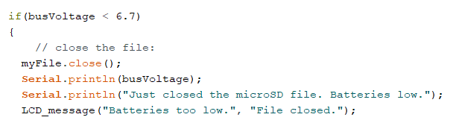
Figure 2. DAQ code to close files when voltage decreased below threshold of 6.7 V.

Lines that were shifted or corrupted were removed and the remaining data was saved as a .csv file. These .csv files were read into a Python Jupyter Notebook, where they were spliced down into 1/10th and 1/100th versions. These made simplified versions of the data, taking every 10th value and every 100th value, respectively. This was done to allow code to run faster, as the initial files included hundreds of thousands of lines. As data was taken 20 times per second, every 100th value corresponds to data at 5 second intervals. Particulate information changed over timescales significantly longer than this, so cutting the data down had negligible impact on results. Particulate data was output as the number of particles greater than a cutoff size as described in 3.3. Variations were most obvious using the broadest set of particles, which was all particles larger than 0.3 microns. This was used for all analysis. Other cutoffs, such as particles greater than 0.5 or 1 micron, also showed the large peaks and dropoffs, but missed smaller variations. Time data was used to match particulate information from different devices and the information was scatter plotted. For particles larger than 0.3 microns, the number recorded varied by approximately +/- 100 when measuring air without wind or ventilation present. This variation is small relative to the height of the peaks seen. Moving averages of the data were also calculated and plotted to provide a visual curve.

5. Results
The initial data taken showed an exponential drop off in airborne particulates after a spray, as seen in Figure 3. However, this data was taken before extra battery packs were implemented, and data collection was cut off shortly after spraying occured. The time scale of Figure 3 is five hours. The first four hours of data show a consistent baseline of particle readings. This baseline was used in the calculation of an exponential fit as seen in Figure 4.

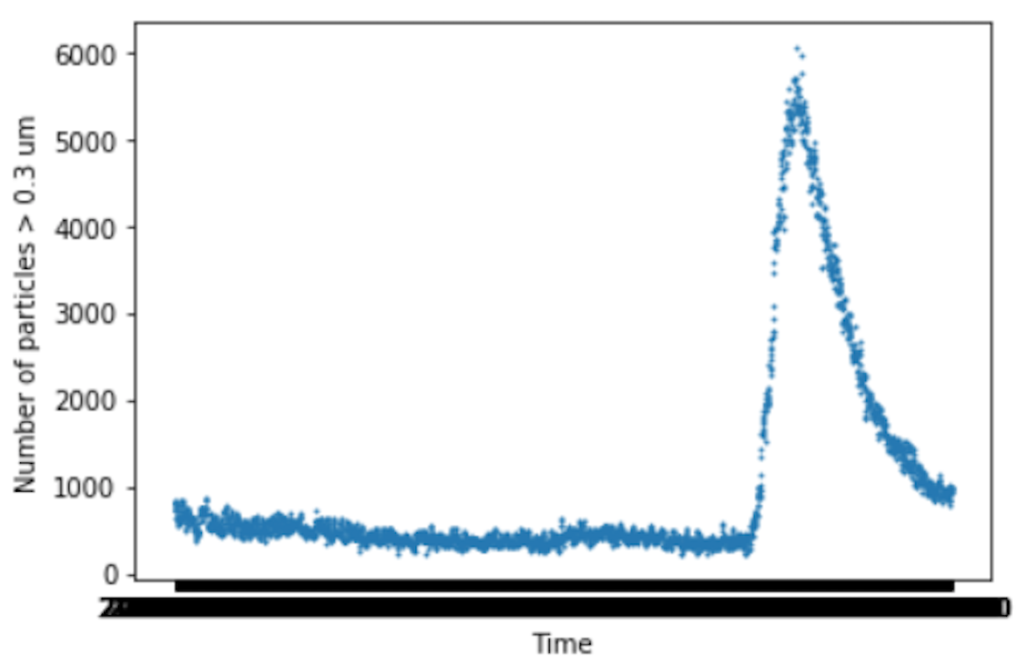
Figure 3. Particles appear to drop off exponentially following a spray.

The falling exponential portion of the data was isolated and an exponential curve was fit to see if there was a visible correlation. Data before the spike was considered to be a constant and was subtracted from data used to calculate the exponential. Figure 4 shows this fit. The exponential fit was ~ 5182e^(-5.5x10^-3). This exponential fit gives a half life of about 21 minutes.
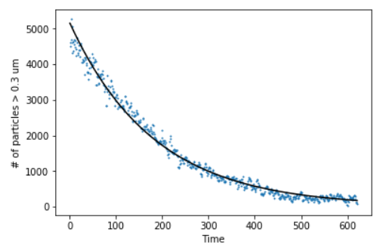
Figure 4. An exponential curve fit to falling particle data.

To prevent batteries from dying and cutting off data collection early, an extra battery pack was added in parallel to prolong the life of the device. The voltages from the batteries over time of a device without the extra battery pack (blue) and one with the extra battery pack (red) are shown in Figure 5. This is over a timescale of about 4.5 hours.
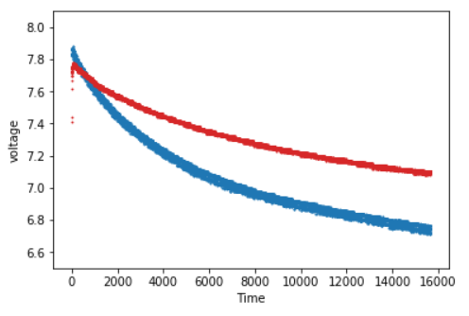
Figure 5. Voltage over time for a device with an extra battery pack in red and a device without an extra battery pack in blue.

Further data collection from all four devices over a longer time scale showed much lower peaks but a similar drop off. Variance in data was on the order of +/- 100 for measurements of particles greater than 0.3 microns. Figure 6 shows particulate data collected over a period of close to 11 hours, with each best fit line representing the data recorded by one of the PCBs. An initial spike is followed by an expected drop-off before the data unexpectedly shows particulates rising again. This rise begins close to 10 pm, so it is likely that this corresponds to the greenhouses heating system turning on and causing settled particles to move around.
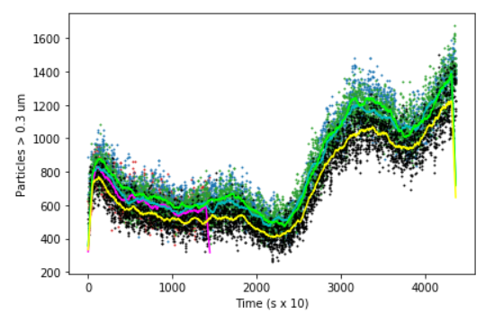
Figure 6. Particle data taken over 11 hours. The lines are moving averages of the data. Data reaches a minimum around 9:30 pm and peaks again shortly after midnight.

6. Discussion
To understand the rates of change in the number of particles found in our data, it is important to understand the evaporation rate of aqueous airborne particulate. Since the pesticides are mixed into water to be sprayed as an aerosol, the physical behavior of the particles is similar to that of pure water. Because the experiments were conducted in greenhouses, the PCBs were in the ideal environment with minimal air flow (talk about sealing greenhouse) present to not pick up on unwanted input such as dust from a crop field. So the setting was ideal to interpret as an isolated environment, and made calculations easy to perform without the concern of extra factors. It was theorized that the decreasing exponential curve found in the data was due to the water particles evaporating as time went on. The rate of decrease of the diameter of a water particle was accurately described in Holterman’s paper, in the equation:
$$\frac{dD}{dt}=\frac{-a}{D}(1+b\sqrt{Dv})$$
Where D is the diameter of the particle, v is the velocity. The variable a is:

$$a=\frac{4M_{L}D_{v,f}∆p}{ρ_{L}RT_{f}} \left[\frac{m^{2}}{s}\right]$$

In the variable a, M_{L} is the molecular weight of the evaporating liquid (for water it is .018 kg/mol), D_{v,f} is the average diffusion coefficient (which was interpreted in Appendix D to be 25.3), Δp is the difference between vapor pressure near the drop and the ambient atmosphere, ρ_{L} is the density of the liquid, R is the gas constant (8.3144 Jmol⁻¹K⁻¹), and T_{f} is the average absolute temperature in the particle film. The variable b is given as:

$$b=.276{\left(\frac{ρ_{a,f}}{μ_{a,f}{D_{v,f}}^{2}}\right)}^{1/6} \left[m^{-1}s^{1/2}\right]$$
Ρ_{a,f} is the density of air at temperature T_{f}, and µ_{a,f} is the air viscosity at temperature T_{f}. We gathered the following data from online sources or from data we took ourselves:

$$∆p=99250-3671=95579 Pa$$
$$ρ_{L}=997 {kg}/{m^{3}}$$
$$T_{f}=27.5 °C$$
$$ρ_{a,f}=1.17 {kg}/{m^{3}}$$
$$μ_{a,f}=1.864x{10}^{-5}$$
Using all of the above values, we can calculate values for a and b, which come out to be
$$a=.070 \frac{m^{2}}{2}$$
$$b=.593 m^{-1}s^{1/2}$$
To solve the given equation, we must first solve for velocity. Because these particles are so small, and are propelled from the nozzle of the hose they are sprayed through for such a short time, must of the particles’ time is spent suspended in the air, subject to drag force. As such, we must calculate the linear drag force using the fact that the particles are approximately spherical (due to surface tension) and the known density as a way to relate mass to known quantities.
$$F_{drag}=-bv=-\left(6πηr\right)v=-mg$$
$$v=\frac{mg}{6πηr}=\frac{ρVg}{6πηr}$$
Here, η is the water’s dynamic viscosity, and V is the volume of a water particle. Substituting in known values, we arrive at
$$v=\frac{\left(997\right)\left(\frac{4}{3}πr^{3}\right)(9.8)}{6π\left(1.861x{10}^{-5}\right)r}=\left(1.167x{10}^{8}\right)r^{2}=\left(2.917x{10}^{7}\right)D^{2} \left[\frac{m}{s}\right]$$
We may use this equation in the first to relate the diameter of a water particle to the time elapsed:

$$\frac{D}{-a(1+b\sqrt{cD^{3}})}dD=dt$$
Here we are temporarily simplifying, so c is equal to 2.917x10⁷. Finally, we may integrate to obtain a function that relates diameter of water particles and elapsed time:
$$\int{\frac{D}{-a\left(1+b\sqrt{cD^{3}}\right)}dD=\int{1}dt}$$
After many substitutions, we finally arrive at
$$t=\left(2.023x{10}^{-4}\right)\left[\sqrt{3}\tan^{-1}\left(17.018\sqrt{D}-\frac{\sqrt{3}}{3}\right)+\ln\left(\left|14.738\sqrt{D}+1\right|\right)\right]-\ln\left(\left|217.214D-14.738\sqrt{D}+1\right|\right)-.00894\sqrt{D}+C$$

Collecting data in a greenhouse does not take into account the large areas that are industrially sprayed. The size of the land tested may have an impact on the time it takes for the number of particles in the air to dissipate after spraying. In the greenhouses, the spray can be well approximated as a point source that falls off in all directions. On a field, spraying would occur on a large scale, and there would not be “empty” air for the particles to spread out into. Another experimental design constraint is time or the number of times a certain area was sprayed. The frequency of the spraying of pesticides can also impact the number or particles in the air in the long term, even if the data collected in the experiment goes down to the initial conditions before spraying.
Manufacturer data for the particle sensor shows that sensor to sensor measurements do not very enough for a significant error. Other errors of the particulate sensor include its counting efficiency, which is 50% at 0.3 micrometers and 98% at particles of 0.5 micrometers or greater. The response time can also be a source of error. However, it is a very small error, as the response time is less than 1 second. Overall, based on data from the particle sensor manufacturers, the sensor itself is fairly accurate and precise. The data presented in Figure 3 was only collected from one device. Therefore, the precision and accuracy of the device cannot be determined. The data displayed in Figure 6, however, shows that four devices agreed quite well over a long timescale, with variation likely due to the devices being placed in different locations throughout the greenhouse.
After running multiple experiments, these devices appear to perform well in recording particle data. While this can be very useful for measuring the level of aqueous pesticides in the air, there are many other applications that these could be used for. Any environment where particles could be released into the air is a good candidate for the use of this device. They could measure pollen levels, airborne pollutants, vapors from a stove, evaporation rates, and much more. The series of experiments performed here served as a good test to ensure the functionality of these devices, and applying them to other problems is now only a small step.

7. Conclusion
Overall, the experiment did well in measuring the number of aqueous particulates from spraying pesticides, allowing those working with pesticides to know when re-enter into the greenhouse is most dangerous. The PCB devices were also able to gauge the overall air quality by sensing dust particulates from the ventilation system. The results do not show any direct impact on humans or the environment due to the limitations of the PCB devices. Aside from collecting more data in greenhouses, further studies should expand on this experiment to measure photons from the sun and humidity with a control done outside the greenhouse for comparison. An outdoor experiment would also allow for the testing of variables unobserved in the greenhouse, such as wind and inconsistent sunlight. It would be best to expand these studies on larger spraying patches as well, as land area sprayed could make a difference on the time it takes for the number of particles in the air to dissipate after spraying. The area sprayed could also affect the number of particles in the air after spraying. The most important factor would be testing multiple spray outdoors for a large time length, such as months or years, in order to truly determine the environmental impact or the chemicals used in pesticides.

8. References
- Buprofezin [Online]. National Center for Biotechnology Information. PubChem Compound DatabaseU.S. National Library of Medicine: 2019.
- Jarvis, B. (2018, November 27). The Insect Apocalypse Is Here. Retrieved April 10, 2019, from https://www.nytimes.com/2018/11/27/magazine/insect-apocalypse.html
- https://pubchem.ncbi.nlm.nih.gov/compound/buprofezin#section=GHS-Classification [5 Apr. 2019]
- Safety Data Sheet Acetamiprid [PDF file]. Retrieved from https://www.caymanchem.com/msdss/24129m.pdf
- Safety Data Sheet Azadirachtin [PDF file]. Retrieved from https://www.caymanchem.com/msdss/21893m.pdf
- Safety Data Sheet Oleoresin Capsicum [PDF file]. Retrieved from https://msds.orica.com/pdf/shess-en-cds-010-000000032869.pdf
- Adafruit Industries. PM2.5 Air Quality Sensor and Breadboard Adapter Kit [Online]. adafruit industries blog RSS: 2019. https://www.adafruit.com/product/3686?gclid=Cj0KCQiA2L7jBRCBARIsAPeAsaN4qozjy [5 Apr. 2019].
- Adafruit Industries. PM2.5 Air Quality Sensor and Breadboard Adapter Kit [Online]. adafruit industries blog RSS: 2019. https://www.adafruit.com/product/3686?gclid=Cj0KCQiA2L7jBRCBARIsAPeAsaN4qozjyuLxfLdpO-dE31IJQPyuvRYtZbjMG7C8rUHCzPuiIaMC_X8aAipAEALw_wcB [5 Apr. 2019].
- Shipley, C. (2019, Feb.16). Personal interview
- Kinematics and Evaporation of Water Drops in Air [PDF file] retrieved from https://holsoft.nl/idefics/pdf/kinevap.pdf
- Houghton, H. G. (1933, December) A Study of the Evaporation of Small Water Drops. Retrieved April 15, 2019 https://aip.scitation.org/doi/pdf/10.1063/1.1745155
- Viscosity of Air, Dynamic and Kinematic (2019). Retrieved April 15, 2019 https://www.engineersedge.com/physics/viscosity_of_air_dynamic_and_kinematic_14483.htm

